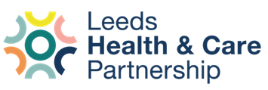

NHS Equality Delivery System (EDS22) 2024 report on Palliative and End of Life Care

Leeds Office of the ICB and Leeds NHS providers

November 2024

- Purpose

The purpose of this report is to:

- Provide context for the assessment undertaken as part of the NHS Equality Delivery System (EDS) for Domain 1.
- Share the EDS ratings that have been achieved for Domain 1, the priorities for improvement that this work has identified and feedback from stakeholders
- Provide assurance to Boards of the completion of the EDS framework in 2024/5 and the improvement plan for 2025/6.

- Background

The NHS Equality Delivery System (EDS) is the foundation of equity/equality improvement within the NHS, acting as an accountability and improvement tool for NHS organisations - in active conversations with patients, public, staff, staff networks and trade unions - to review and develop their services, workforce, and leadership.

In August 2022, NHS England published a new version of EDS, EDS 2022. Implementation of EDS 2022 supports NHS organisations to deliver on the Public Sector Equality Duty. EDS 2022 suite of documents and supporting resources can be found in the equality hub section of the NHS England website.

EDS has three domains: commissioned or provided services; workforce health and wellbeing and inclusive leadership. For each of these, NHS commissioners and provider services are required to undertake an EDS evidence collection and grading exercise on an annual basis, with the identification of an improvement plan.

This report focusses on Domain 1 for commissioned or provided services to consider and improve the following outcomes:

- Service users have required levels of access to the service
- Individual services users’ health needs are met
- Service users are free from harm
- Service users report a positive experience

The EDS has a remit to consider and improve these outcomes specifically for groups at risk of health inequalities, including people with protected characteristics, carers, and inclusion health groups such as people who are socially excluded and experience multiple risk factors for poor health such as poverty, violence, and complex trauma. This can include people who experience homelessness, drug and alcohol dependence, Gypsy, Roma and Traveller communities, sex workers, victims of modern slavery, refugees, asylum-seekers, and undocumented migrants.

- Approach

For Domain 1, which assesses equality performance for commissioned and provider services, the ICB and providers are required to engage, assess, develop, and deliver an improvement plan for three services each. Across West Yorkshire, it was agreed each place would take a partnership approach to focus improvements on specific clinical pathways:

- Palliative and End of Life Care
- Cancer (Early Diagnosis)
- Suicide Prevention

Leeds ICB and NHS providers chose to review services around Palliative and End of Life Care to:

- Respond to recent findings from local and national patient and carer feedback including West Yorkshire Healthwatch and Parliamentary and Health Service Ombudsman
- Support EDI improvement work with Leeds Palliative Care Network

It should be noted that the EDS is a review of a sample of services delivering care within the pathway, not a review of the whole pathway.

- Identifying priorities for improvement

Within the PEoLC pathway, the following services have been sampled in the EDS assessment:

- Respiratory EoLC (ICB in Leeds)
- Children’s Community Nursing (LCH)
- Homeless Health Inclusion Team (LCH)
- Neighbourhood Nights (LCH)
- Cancer Service (LTHT)
- In-hospital Palliative Care Team (LTHT)
- Dementia Wards (LYPFT)
- Care Homes Team (LYPFT)
- LTHT Easy Read material in the Learning Disability Team
- LYPFT Functional Ward

The service-specific self-assessments were reviewed by representatives from the ICB in Leeds, NHS provider trusts, third sector and the Leeds Palliative Care Network to consider previous patient, carer, and community insight alongside provider and population data to identify what is already known about the EDS outcomes in PEoLC and what gaps/improvements these identified.

The four outcomes for services delivering PEoLC were scored as follows:

Outcomes | Average score (0-3) | Meeting the following criteria | Examples of good practice
Service users have required levels of access to the service | 1.5 Developing (Range 1-2) | - Data to show those with protected characteristics and other groups at risk of health inequalities have fair access to the service.  - Organisations have identified barriers to accessing services | - Use of data and dashboards to review equity of referrals and waiting times, with comparisons to Leeds population, End of Life population and prevalence data.  - QI methodology to test improvements to access  - Consideration of unintended consequences on access for other groups/communities when undertaking targeted improvement work
Individual services users’ health needs are met | 2.2 Achieving  (Range 2-3) | - Patients at higher risk due to protected characteristic needs are met in a way that works for them.  - Consultation with patients with higher risks due to a protected characteristic  - Signposting to VSCE organisations and social prescribing.  - Personalised care is embedded into the care delivered for those with higher risks due to a protected characteristic by the organisations. | - Peer navigator working with people who experience homelessness across services (NHS and 3rd sector)  - Personalised and culturally competent approaches to achieve Preferred Place of Death  - Services supported by trust-wide focus on Accessible Information Standards, Reasonable Adjustments
Service users are free from harm | 2.2 Achieving  (Range 2-3) | - Procedures/initiatives are in place to enhance safety in services for patients in all protected characteristic groups where there is known H&S risks. Staff and patients feel confident, and are supported to, report incidents and near misses.  - Encouraging an improvement culture giving consideration to equality and health inequality themes in safety incidents and near misses | - Equity considered in Patient Safety and Incident Response Framework (PSIRF), risk assessments and safeguarding processes  - Learning from incidents involving groups at risk of inequity embedded into systems and processes  - Proactive approaches, for example in identifying deterioration
Service users report a positive experience | 1.6 Developing  (Range 1-3) | - Collating data from patients with protected characteristics about their experience of the service.  - Creating evidence-based action plans in collaboration with patients and relevant stakeholders and monitor progress.  - Showing understanding of the link between staff and patient treatment and demonstrate improvement in patient experiences | - Embedding learning from feedback into systems and processes  - Creative ways of gathering views from marginalised groups who are not well-represented in Friends and Family Test data

The EDS process and scoring for 2024 has evidenced that there are many strengths in the way PEoLC is delivered to marginalised groups at risk of inequity. The peer review identified opportunities for learning across services and partners to embed these strengths more consistently.

The EDS process has also helped the ICB in Leeds and NHS providers to identify the following areas for improvement across the PEoLC pathway:

Area of improvement | Suggested actions
Data collation and analysis | Development of equity data measures for use across LCH, LYPFT and LTHT dashboards or system-wide:  - ability to look at a pathway as well as individual services  - improve ease of use for services
Data collation and analysis | Improving data quality:  - citywide approach to updating data / consistency of demographic data  - recording religion, sexual orientation, homelessness, carers  - how to include transient populations where IMD does not apply
Data collation and analysis | Increasing staff skills and confidence to ask demographic/equity questions, including:  - debunking the myth that people won’t share information  - increasing staff understanding of how equity analysis relates to quality of care  - prompts for when to ask for information  - staff understanding and being able to explain how data is used
Data collation and analysis | Equity analysis of declined referrals to help understand who is trying to access services but can’t
Relationship between equity and quality | Increasing understanding of how equity relates to quality of clinical care
Relationship between equity and quality | Test out / more emphasis on quality improvement methodology when making changes to address inequity identified in EDS assessments
Relationship between equity and quality | Culturally competent and trauma-informed clinical care:  - Not making decisions based on assumptions about different cultures  - Updating cultural knowledge based on feedback about generational change in cultures  - Gap analysis and sharing of resources on EoLC in different cultures
Engagement with VCSE | Working with VCSE on processes to share feedback from marginalised communities
Engagement with VCSE | VCSE as contracted delivery partners in services
Engagement with VCSE | Signposting to VCSE
Patient experience | Extending who we gather feedback from:  - people not already in our services  - patient views as well as bereaved carers
Patient experience | Processes to capture informal qualitative feedback from groups at risk of inequity and applying same approach to learning and improvement as is taken with FFT and complaints.
Patient experience | Trauma-informed and culturally competent approaches to patient feedback and engagement  - Workforce skills to hold conversations to get feedback without creating more distress
Patient experience | Continue development of 2024/5 action to implement demographic analysis of patient feedback so that it is available for services undertaking EDS next year

The ICB in Leeds and NHS providers recognise that all the suggested actions above are key to addressing the areas for improvement that have been identified. A collective proposal has been reached to prioritise the following actions for 2025:

- Improving data collation and analysis

- Cultural competence, building on the 2023 focus

- Increasing and using feedback from groups and communities who experience inequalities, barriers to accessing services and are seldom heard.

- Engagement and feedback

Following the initial peer review in November, we held a period of further engagement with partners and communities to identify:
  - any other strengths or gaps that groups were aware of
  - whether the scoring fit with their knowledge of the palliative and EoL pathway for groups at risk of inequalities
  - what the priority actions should be and how the proposed priorities fit with their work/priorities for the next year
  - how we would continue to engage with those groups and coordinate any shared work

A summary of the stakeholders engaged and the feedback received is provided at Appendix 1. This is a working document, with engagement continuing through the delivery of the improvement plan in 2025/6.

Engagement has provided broad agreement with analysis of strengths, gaps and the priorities and that these are well-aligned with city-wide work to address inequalities in palliative and end-of-life care. Transferable learning with other equality work has also been identified, for example Accessible Information Standards, the Patient and Carer Race Equality Framework and focus on the 3Cs (communication, compassion and coordination).

- Conclusions for LCH

The individual assessment results for the three LCH services are provided in Appendices 2-4.

 | Access | Meeting needs | Safety | Experience
CCNS | Developing | Achieving | Achieving | Achieving
HHIT | Achieving | Achieving | Excelling | Excelling
NNS | Developing | Excelling | Achieving | Developing
Trustwide | Developing | Achieving | Achieving | Achieving

LCH has therefore been rated achieving in Domain 1.

The service-level improvements identified in those assessments, aligned to citywide improvement actions identified in section 4, are being taken forwards in LCH in the following way:

Theme | Action | Responsible | Date due
Data | Development of equity data measures for use across LCH, LYPFT and LTHT dashboards or system-wide | Consultant in Public Health | Jan 2026
Data | Test patient-led recording and inclusion in referrals of demographic/equity data to improve availability and accuracy of data | BI / Clinical Systems | Mar 2026
Data | Increase staff skills and confidence to ask demographic/equity questions and to be able to explain to patients why we collect this and how we use it | Health Equity Lead  Services to test | Sept 2025
Data | Test recording of vulnerably-housed on clinical systems to enable inclusion in equity data reports. | Clinical Systems,  Public Health Consultant, BI | Mar 2026
Equity and quality | Strengthen connections between equity and PSIRF, particularly around equity considerations in incidents and deteriorating patients. | Clinical Governance  CCNS | Mar 2026
Equity and quality | Delivery of cultural conversations training and service-led cultural conversations programme, including focus on people who are vulnerably housed | EDI lead and Health Equity lead  Service leads | Mar 2026
VCSE | Link with CBU VSCE sector event to engage with partners identified around EoLC | CCNS, CBU leadership | Jun 2025
VCSE | Include signposting to VCSE involved in PEoLC | Partnerships Manager | Sept 2025
Patient experience | Continue development of 2024/5 action to implement demographic analysis of patient feedback so that it is available for services undertaking EDS next year | Patient Experience Team | Jun 2025
Patient experience | Test and develop ways to gather and collate and use informal feedback from minoritised groups. Link to PCREF. | Patient Experience Team  Service leads | Mar 2026
Patient experience | Review accessibility of service literature and develop Easy Read materials. Link to development of Patient Information Hub. | CCNS | Mar 2026
Patient experience | Separate FFT for Nights Service from rest of Neighbourhood Teams | NNS | Mar 2026

- Next steps:

Final report and improvement plan to go through individual organisation governance processes in early 2025

Publish to organisational websites by 28 February 2025 along with EDS Domains 2 and 3

Delivery of improvement plans commencing April 2025

Appendix 1: stakeholder engagement

Group / community represented | Organisation / group | Date of engagement | Feedback
EoLC | LPCN EDI group | 1/10/24
EoLC | LPCN Exec Group | 12/12/24 | - How to combine different sources of information/data to give a whole picture rather than a patchwork of information  - Engagement priority – as Bereaved Carers survey is being stood down, who do we now creatively gather people’s experience in different communities  - Data priority – not just focussing on completeness of data but also support to understand it (example given of usefulness of input from Public Health Consultant)  - How does this link to other improvement work eg focus on respiratory EoLC in areas of high deprivation  - Cultural competency to be taken forward through Education Sub-group
EoLC | LPCN education subgroup | 10/12/24 | Discussion about cultural competency element of improvement plan. Action plan to start with leaders attending training and having some skills/exercises to take forwards informally in own teams. To also consider Train the Trainer model for wider roll-out of 3-hour ICB training model.
EoLC | LPCN Network Manager | 26/11/24 | - Cultural competence a high priority for delivery partners.  - Balancing the specialism of the EDI sub-group with influence from wider Exec Group.
EoLC | EoLC Board
EoLC | WYICB EoLC lead | 17/10/24 | - This work connects with and early findings well aligned to the WYICB Health Needs Assessment (available soon)  - Ensure workforce are confident and competent to provide care in diverse communities – there will be some workforce training mapping to the NHSE skills competency  - Financial sustainability, particularly the impact of scaling back of bereavement support in Leeds and the sustainability of St Gemma's inclusion offer  - When looking at data, consider not just how it is captured but also how it is sharable
Patient groups | People’s Voices Partnership
Patient groups | Healthwatch
Patient groups | Mental health People’s Voices Partnership subgroup | Rescheduled to 9/1/25
Carers | Carers Leeds
Carers | Young Carers
Children and Young People | CYP Population Board
Children and Young People | LCH Youth Board
Marginalised groups | Communities of Interest Network | 12/12/24 reschedule
People with Disabilities | International Day of People with Disabilities market place event | 3/12/24 | - Make sure the focus on data is meaningful – how does it improve people’s experience?  - “When talking to me about [Planning Ahead], be clear that you talk to everyone about this, not just me because I’m disabled.”
People with Disabilities | Staff networks
Global ethnic majority | Culturally Diverse Hub | 6/12/24 | - Staff should understand the benefits of data and how it connects with their roles. The presentation of data is important and consideration for how conversation is held with patients to obtain the right level and accurate information. Some culturally diverse groups would have preconceived ideas of sharing personal information and would not do this willingly, if data is obtained be clear how it is going to be used and what benefits it has on those participating. Use case studies or storytelling to give data meaning.  - Emphasis on community lead research with culturally diverse groups re end-of-life care. Having awareness of community norms and emotions attached to dying in a hospital setting (shame, abandonment, family duty of care).  - Work closely with communities to close the cycle, build trust, and know it will be a long process that require long term investments. Involve faith leaders to raise awareness, for families to understand the process to be more accepting of help.  - Emphasis on communication as a stand-alone action. Levels of communication, upskilling to have meaningful dialogue with different groups , having an inquisitive and exploratory approach when support patients and families
Global ethnic majority | LYPFT Race Equality Network | 9/12/24 | - Agreed with the scoring and priority actions suggested.  - Importance of engaging family members and the patient with information to support their dementia life and to understand their condition. What does this mean? What happens next?  - Family members who may not live near to the patient, communication is vital. Also managing expectations with regards to last stages of life and the level of support that is offered.  - Admission to an acute hospital with dementia and safeguarding for the patient and other patients who shares a bay.  - Offering personalise care, use of preferred name, making environment familiar.  - Work with communities to understand the best approach to culturally diverse communities
LGBTQIA+ | Rainbow Alliance | 9/1/25
LGBTQIA+ | LGBTQIA+ health and wellbeing network

Appendix 2: Children’s Community Nursing Service EDS assessment

Outcome | Examples of evidence (b) |  | Evidence (a) | Rating (c)
1A: Service users have required levels of access to the service | Underdeveloped activity (score 0) | No or little activity taking place:  - Organisations/systems have little or nothing in place to ensure patients with protected characteristics have adequate and appropriate access to the services they require.  - Feedback from patients is not acted upon.  - Organisations have not identified barriers facing patients | Currently working with BI to enrich our data and data quality. For example, all children receiving the service are being assessed for the complexity. A new CCNS service model provides a corresponding level of service provision in order to meet their needs. Complexities are health and development related and very often the community we are serving have protected characteristics.  A recent EQIA identified a potential barrier to people accessing the CIVAS service and actions from this have been and are being undertaken. | 1  *But on the way to 2
 | Developing activity (score 1) | Minimal/basic activities taking place:  - Data and evidence to show some protected characteristics (50%) have adequate access to the service.  - Patients consistently report fair or good (or the equivalent) when asked about accessing services.  - Demonstration that the organisation has identified barriers to accessing services |  | 1  *But on the way to 2
 | Achieving activity (score 2) | Required level of activity taking place:  - Data to show those with protected characteristics (100%), and other groups at risk of health inequalities, have adequate access to the service.  - Patients consistently report good or very good (or the equivalent) when asked about accessing services. Demonstration that the organisation has identified barriers to accessing services |  | 1  *But on the way to 2
 | Excelling activity (score 3) | Activity exceeds requirements:  - Data to show those with protected characteristics (100%), and other groups at risk of health inequalities, have tailored access to the service.  - Patients consistently report very good or excellent (or the equivalent) when asked about accessing services.  - Demonstration that the organisation has knowledge of barriers and have changed outcomes for people who experience those barriers in accessing services |  | 1  *But on the way to 2
1B: Individual service user’s health needs are met | Underdeveloped activity (score 0) | No or little activity taking place:  - Patients with higher risks due to a protected characteristic receive little or no support to self-manage care needs.  - The organisations do little or no engagement surrounding services. | Care within in CCNS is tailored around the patient to reflect their individuality. For example, use of the Paediatric Pain Profile, Nursing Assessment and One Page Profile.  Following complaints the service has worked with patients and their families to listen and improve with tangible changes. For example, work to SystmOne re skin pigmentation and training staff to provide new care as the patient’s complexity intensifies. For example, staff were trained in diabetic care to allow better quality respite for a parent.  CCNS works in partnership with organisations such as Martin House and Candlelighters to meet Patient need. | 2
1B: Individual service user’s health needs are met | Developing activity (score 1) | Minimal/basic activities taking place:  - Patients at higher risk due to a protected characteristic needs are met in a way that works for them.  - The organisations often consult with patients and the public to commission, de-commission and cease services provided. |  | 2
1B: Individual service user’s health needs are met | Achieving activity (score 2) | Required level of activity taking place:  - Patients at higher risk due to a protected characteristic needs are met in a way that works for them.  - The organisations often consult with patients with higher risks due to a protected characteristic to commission, designed, increase, decrease, de-commission and cease services provided.  - The organisations signpost to VSCE organisations and social prescribing. Personalised care is embedded into the care delivered for those with higher risks due to a protected characteristic by the organisations. |  | 2
1B: Individual service user’s health needs are met | Excelling activity (score 3) | Activity exceeds requirements:  - Patients at higher risk due to a protected characteristic and other groups at risk of health inequalities needs are met in a way that works for them.  - The organisations fully engage with patients, community groups, and the public, to commission, designed, increase, decrease, de-commission and cease services provided.  - The organisations work in partnership with VCSE organisations to support community groups identified as seldom heard. The organisations use social prescribing, where relevant.  - Personalised care is embedded into the care delivered for those with higher risks due to a protected characteristic by the organisations.  - The organisations work with, and influence partners, to improve outcomes for people with a protected characteristic and other groups at risk of health inequalities, across the system or where services connect |  | 2
1C: When service users use the service, they are free from harm | Underdeveloped activity (score 0) | No or little activity taking place:  - The organisation may or may not have mandated/ basic procedures/initiatives in place to ensure safety in services.  - Staff and patients are not supported when reporting incidents and near misses.  - The organisation holds a blame culture towards mistakes, incidents and near misses | Datix/Incident Forms are frequently completed. For any person not feeling confident then support is given if highlighted.  Most of the community we serve have protected characteristics – for all our children and young people safety is paramount and we are continuously striving to improve. For example, one area is improving recognition and early signs of deterioration. We are working closely and within the DPIG to ensure this is better for our community of patients. | 2
 | Developing activity (score 1) | Minimal/basic activities taking place:  - The organisation has mandated/ basic procedures/initiatives in place to ensure safety in services.  - The organisation has procedures/initiatives in place to enhance safety in services for patients in protected characteristic groups. |  | 2
 | Achieving activity (score 2) | Required level of activity taking place:  - The organisation has procedures/initiatives in place to enhance safety in services for patients in all protected characteristic groups where there is known H&S risks.  - Staff and patients feel confident, and are supported to, report incidents and near misses.  - The organisation encourages an improvement culture giving consideration to equality and health inequality themes in safety incidents and near misses |  | 2
 | Excelling activity (score 3) | Activity exceeds requirements:  - The organisation has procedures/initiatives in place to enhance safety in services for all patients in protected characteristic groups where there is known H&S risks.  - Staff and patients are supported and encouraged to report incidents and near misses.  - The organisation encourages and promotes an improvement culture actively including equality and health inequality themes in safety incidents and near misses.  - The organisations work with system and community partners to improve safety outcomes for people, using existing data and driven by service need/risk |  | 2
1D: Service users report positive experiences of the service | Underdeveloped activity (score 0) | No or little activity taking place:  - The organisations do not engage with patients about their experience of the service.  - The organisations do not recognise the link between staff and patient treatment. The organisations do not act upon data or monitor progress. | In terms of protected characteristics, a large proportion of our community of patients have disabilities from complex health needs. A lot of these children would struggle to be able to articulate their experience of the service, but their families are certainly asked for feedback.  We have example of collaborating with families to hear their concerns and worked with them to improve as well as in terms of actions regarding their care. One disabled patient and his parent were invited to an MDT meeting to be a part of the planning around their care and to understand their view points. | 2
1D: Service users report positive experiences of the service | Developing activity (score 1) | Minimal/basic activities taking place:  - The organisations collate data from patients with protected characteristics about their experience of the service.  - The organisation creates action plans, and monitors progress. |  | 2
1D: Service users report positive experiences of the service | Achieving activity (score 2) | Required level of activity taking place:  - The organisations collate data from patients with protected characteristics about their experience of the service.  - The organisations create evidence-based action plans in collaboration with patients and relevant stakeholders, and monitors progress.  - The organisation shows understanding of the link between staff and patient treatment and demonstrate improvement in patient experiences |  | 2
1D: Service users report positive experiences of the service | Excelling activity (score 3) | Activity exceeds requirements:  - The organisation actively engages with patients with protected characteristics and other groups at risk of health inequalities about their experience of the service.  - The organisation actively works with the VCSE to ensure all patient voices are heard.  - The organisations create data driven/evidence-based action plans, and monitors progress.  - The organisation shows understanding of the link between staff and patient treatment. The organisations use patient experience data to influence the wider system and build interventions in an innovative way. |  | 2

Score = 7

PART 2: Through doing the assessment in part 1, what gaps have you identified to take forwards for consideration as part of the action plan?
What gaps in data have you identified? What did your data or other insight show you was a gap in service? What training needs did you identify?
Trust-wide:
- Equality and health inequality themes in safety incidents and near misses need reflecting.
- Recognition of the deteriorating is both a much-needed improvement for the Trust and the CCNS Service. The CCNS clinical Lead sits within the DPIG and has hared the view that Sepsis Training, for example, should be mandatory. It also needs thought on recognition for children and young people who cannot articulate.
- BI – much needed improvements for data and data quality to understand and deliver better equity amongst may other advantages.
Service-specific:
- Need to improve our service leaflets by creating easy read and a process or library for language converted options.
- We need to be more proactive with engagement in terms of patient voice but have examples of how we may achieve this. For example, further improving and making more useful, the questions on FFT. We have already done this for CIVAS patients. Consulting with parents and a possible stay and play session in the planning for Hannah House.
- CCNS data is a big priority and has formed part of our Q&V programme. We have a wish list of many reports to gain more and better data quality in order to prioritise our improvements and identify where are care is needed.

Appendix 3: Homeless Health Inclusion Team EDS assessment

Outcome | Examples of evidence (b) |  | Evidence (a) | Rating (c)
1A: Service users have required levels of access to the service | Underdeveloped activity (score 0) | No or little activity taking place:  - Organisations/systems have little or nothing in place to ensure patients with protected characteristics have adequate and appropriate access to the services they require.  - Feedback from patients is not acted upon.  - Organisations have not identified barriers facing patients | - Quality Challenge assessment for 2024 scored team as excellent  - Compliant with NICE guidance for homelessness (1)  The Homeless and Health Inclusion Team (HHIT) are a service for people experiencing or at risk of homelessness.  Service is for people with an exceptional level of need  - Only exclusion criteria to the service is or those under 18 (2)  - Out of hospital model can be offered to those without recourse to public funds. 8 of the beds/ flats commissioned for intermediate care can be accessed by those without recourse.  - The model is not specifically for End-of-Life care; however, patients are accepted who may be in their last year of life. Team works closely with St Gemma’s Health Inclusion Team  - There is an inequality in service provision depending on where located for referrals to specialist palliative care service for inclusion health. St Gemma’s have specialist staff and service. Less certainty that patients within Wheatfields boundary are receiving same quality and bespoke service for people experiencing homelessness.  - Patients with protected characteristics have access to the Service. This includes all inclusion health groups. Team have commissioned Gypsy and Traveller Outreach (2)  - National independent evaluation by researcher with lived experience (3)  - Ethnicity recording indicates we see mainly white British men (85%) which is higher than National reporting, however, fits regional rough sleeping reporting (11) | 2  2  1  2  3
 | Developing activity (score 1) | Minimal/basic activities taking place:  - Data and evidence to show some protected characteristics (50%) have adequate access to the service.  - Patients consistently report fair or good (or the equivalent) when asked about accessing services.  - Demonstration that the organisation has identified barriers to accessing services |  | 2  2  1  2  3
 | Achieving activity (score 2) | Required level of activity taking place:  Data to show those with protected characteristics (100%), and other groups at risk of health inequalities, have adequate access to the service.  Patients consistently report good or very good (or the equivalent) when asked about accessing services. Demonstration that the organisation has identified barriers to accessing services |  | 2  2  1  2  3
 | Excelling activity (score 3) | Activity exceeds requirements:  Data to show those with protected characteristics (100%), and other groups at risk of health inequalities, have tailored access to the service.  Patients consistently report very good or excellent (or the equivalent) when asked about accessing services.  - Demonstration that the organisation has knowledge of barriers and have changed outcomes for people who experience those barriers in accessing services |  | 2  2  1  2  3
1B: Individual service user’s health needs are met | Underdeveloped activity (score 0) | No or little activity taking place:  - Patients with higher risks due to a protected characteristic receive little or no support to self-manage care needs.  - The organisations do little or no engagement surrounding services. | - High level of personalised care being evidenced by Independent evaluation of service (4)  - Team has outreach role, therefore includes people and groups often excluded by other services (12)  - The team refer to Social Prescribing organisation and to St Gemma’s health inclusion team  - Close relationship with all commissioned, non-commissioned services/ VSCEs in Leeds who work with people experiencing homelessness as part of Safer Leeds Partnership  - Integration Lead post sits on Safer Leeds Street Sex working board, Silver street support board. Role to consider barriers within systems for people experiencing homelessness  - Women’s census informs practice and scope of HHIT/ HHIB (5)  - Flexible approach to women evidenced 22.1% referrals 2023 were for women, which is higher than reported homelessness for women (6)  - 2023 evaluation PREM on OOH provision demonstrated 90% people reported they were always treated with respects and dignity. (4)  - LCPN, EDI forum; representatives who serve inclusion health groups. Informs practice, Commissioning, Barriers, Inequalities within systems | 2  2  3  2  2  3  3
1B: Individual service user’s health needs are met | Developing activity (score 1) | Minimal/basic activities taking place:  - Patients at higher risk due to a protected characteristic needs are met in a way that works for them.  - The organisations often consult with patients and the public to commission, de-commission and cease services provided. |  | 2  2  3  2  2  3  3
1B: Individual service user’s health needs are met | Achieving activity (score 2) | Required level of activity taking place:  Patients at higher risk due to a protected characteristic needs are met in a way that works for them.  The organisations often consult with patients with higher risks due to a protected characteristic to commission, designed, increase, decrease, de-commission and cease services provided.  The organisations signpost to VSCE organisations and social prescribing. Personalised care is embedded into the care delivered for those with higher risks due to a protected characteristic by the organisations. |  | 2  2  3  2  2  3  3
1B: Individual service user’s health needs are met | Excelling activity (score 3) | Activity exceeds requirements:  Patients at higher risk due to a protected characteristic and other groups at risk of health inequalities needs are met in a way that works for them.  The organisations fully engage with patients, community groups, and the public, to commission, designed, increase, decrease, de-commission and cease services provided.  - The organisations work in partnership with VCSE organisations to support community groups identified as seldom heard. The organisations use social prescribing, where relevant.  Personalised care is embedded into the care delivered for those with higher risks due to a protected characteristic by the organisations.  The organisations work with, and influence partners, to improve outcomes for people with a protected characteristic and other groups at risk of health inequalities, across the system or where services connect |  | 2  2  3  2  2  3  3
1C: When service users use the service, they are free from harm | Underdeveloped activity (score 0) | No or little activity taking place:  The organisation may or may not have mandated/ basic procedures/initiatives in place to ensure safety in services.  - Staff and patients are not supported when reporting incidents and near misses.  - The organisation holds a blame culture towards mistakes, incidents and near misses | - Incidents through Datix will capture people with protected characteristics and IMD  - Homelessness is not captured on Datix, or incidents related to insecure housing. Therefore, incidents from HHIT team will be captured, Datix from other LCH teams relating to homelessness will not be. Missing data organisationally for this population group.  - Patient safety incident response framework  - LCH hold Mortality reviews, never events and shared learning.  - HHIT team frequently refer to Exceptional Risk Forum  - Outstanding result in LCH Quality Challenge  - Homeless Integration Lead part of Multi Agency Risk Panel. Forum where patients are discussed who have an exceptional level of risk and experiencing homelessness. Multi agency panel, sits under Safer Leeds.  - Weekly MDT for all patients within Homeless service with wide range of professionals; Nursing, Social Worker, Primary Care, Accommodation Provider. Intermediate care model in CQC buildings  - HHIT/ HHIB service information is provided in Easy Read format (7) | 1  1  2  2  3  3  3  3  3
 | Developing activity (score 1) | Minimal/basic activities taking place:  - The organisation has mandated/ basic procedures/initiatives in place to ensure safety in services.  - The organisation has procedures/initiatives in place to enhance safety in services for patients in protected characteristic groups. |  | 1  1  2  2  3  3  3  3  3
 | Achieving activity (score 2) | Required level of activity taking place:  The organisation has procedures/initiatives in place to enhance safety in services for patients in all protected characteristic groups where there is known H&S risks.  Staff and patients feel confident, and are supported to, report incidents and near misses.  The organisation encourages an improvement culture considering equality and health inequality themes in safety incidents and near misses |  | 1  1  2  2  3  3  3  3  3
 | Excelling activity (score 3) | Activity exceeds requirements:  The organisation has procedures/initiatives in place to enhance safety in services for all patients in protected characteristic groups where there is known H&S risks.  Staff and patients are supported and encouraged to report incidents and near misses.  The organisation encourages and promotes an improvement culture actively including equality and health inequality themes in safety incidents and near misses.  The organisations work with system and community partners to improve safety outcomes for people, using existing data and driven by service need/risk |  | 1  1  2  2  3  3  3  3  3
1D: Service users report positive experiences of the service | Underdeveloped activity (score 0) | No or little activity taking place:  - The organisations do not engage with patients about their experience of the service.  - The organisations do not recognise the link between staff and patient treatment. The organisations do not act upon data or monitor progress. | - Patients not routinely asked about their experience in the way that LCH collects data from Friends and family  - There was an independent evaluation of Out of hospital model which was published alongside National models (4)  - Compliments and concerns are captured through Datix but currently not a robust system of capturing feedback.  - Feedback and case studies are taken from 10% of caseload (10)  - Some feedback sessions have occurred capturing views of wide range of patients by person with lived experience of homelessness. Have employed Navigator with lived experience of homelessness. She has held focus groups with our patients about their experience.  - Commissioned Poet (@surfing sofas) to do poetry sessions across the city to engage people experiencing homelessness creatively in their views of homelessness services. | 1  3  2  2  3  3
1D: Service users report positive experiences of the service | Developing activity (score 1) | Minimal/basic activities taking place:  The organisations collate data from patients with protected characteristics about their experience of the service.  The organisation creates action plans, and monitors progress. |  | 1  3  2  2  3  3
1D: Service users report positive experiences of the service | Achieving activity (score 2) | Required level of activity taking place:  - The organisations collate data from patients with protected characteristics about their experience of the service.  - The organisations create evidence-based action plans in collaboration with patients and relevant stakeholders, and monitors progress.  - The organisation shows understanding of the link between staff and patient treatment and demonstrate improvement in patient experiences |  | 1  3  2  2  3  3
1D: Service users report positive experiences of the service | Excelling activity (score 3) | Activity exceeds requirements:  The organisation actively engages with patients with protected characteristics and other groups at risk of health inequalities about their experience of the service.  The organisation actively works with the VCSE to ensure all patient voices are heard.  - The organisations create data driven/evidence-based action plans, and monitors progress.  The organisation shows understanding of the link between staff and patient treatment. The organisations use patient experience data to influence the wider system and build interventions in an innovative way. |  | 1  3  2  2  3  3

PART 2: Through doing the assessment in part 1, what gaps have you identified to take forwards for consideration as part of the action plan?
What gaps in data have you identified? What did your data or other insight show you was a gap in service? What training needs did you identify?
Trust-wide:
- Homelessness/ vulnerably housed is not captured on an LCH basis, currently no consistent coding for recording homelessness/ vulnerably housed across all teams. Therefore, absence of data trust wide for these groups.
- Homelessness/ vulnerably housed not included on Datix, therefore no system wide data on patient safety incidents relating to homelessness.
Service-specific:
- Needs for Specialist Palliative care for people experiencing homelessness met by St Gemma’s team. Less confidence in service being offered from part of city not covered by this team
- Evidence that that small amount of patients seen within LCH Homeless team have access to bespoke and specialist End of life care offer and barriers are not in place that exclude them on basis of any of the Inclusion Health characteristics. Less is known about the interdependence of people experiencing homelessness within other LCH services who also serve our patients such as Neighbourhood teams

HHIT Evidence:
- Overview | Integrated health and social care for people experiencing homelessness | Guidance | NICE
- Copied from HHIT Service Specification 2024
The team can identify people who may be in their last 12 months of life and refer and work collaboratively with St Gemma’s health inclusion team to engage these patients.
Staff funded to work in addition to those within the HHIT team with patients in out of hospital care are: Social Worker working for Leeds City Council; Leeds Housing Options officer, additional GP time from Bevan, and support workers who work in the THU settings. THU’s and St Georges Crypt have staffing 24 hours a day, 7 days a week.
The team are also commissioned to provide outreach and advocacy to Gypsy and Traveller communities to support equitable access to healthcare services.
Exclusions are:
- Under 18s
- Those whose primary reason for admission is a mental health problem
- People who are not homeless or at risk of homelessness
- People whose only requirement is medical rehousing
- People whose discharge is not impacted on by their homeless status

3.5 Interdependence with other services/providers
- Leeds Teaching Hospitals NHS Trust
- Bevan Healthcare
- St George’s Crypt
- Community Care
- Primary Care
- Voluntary Sector
- Housing Services
- Leeds GATE
- Other Council run services
- Leeds hospices

- Independent Evaluation link Health inequalities, violence and vulnerable groups
- Leeds Evaluation 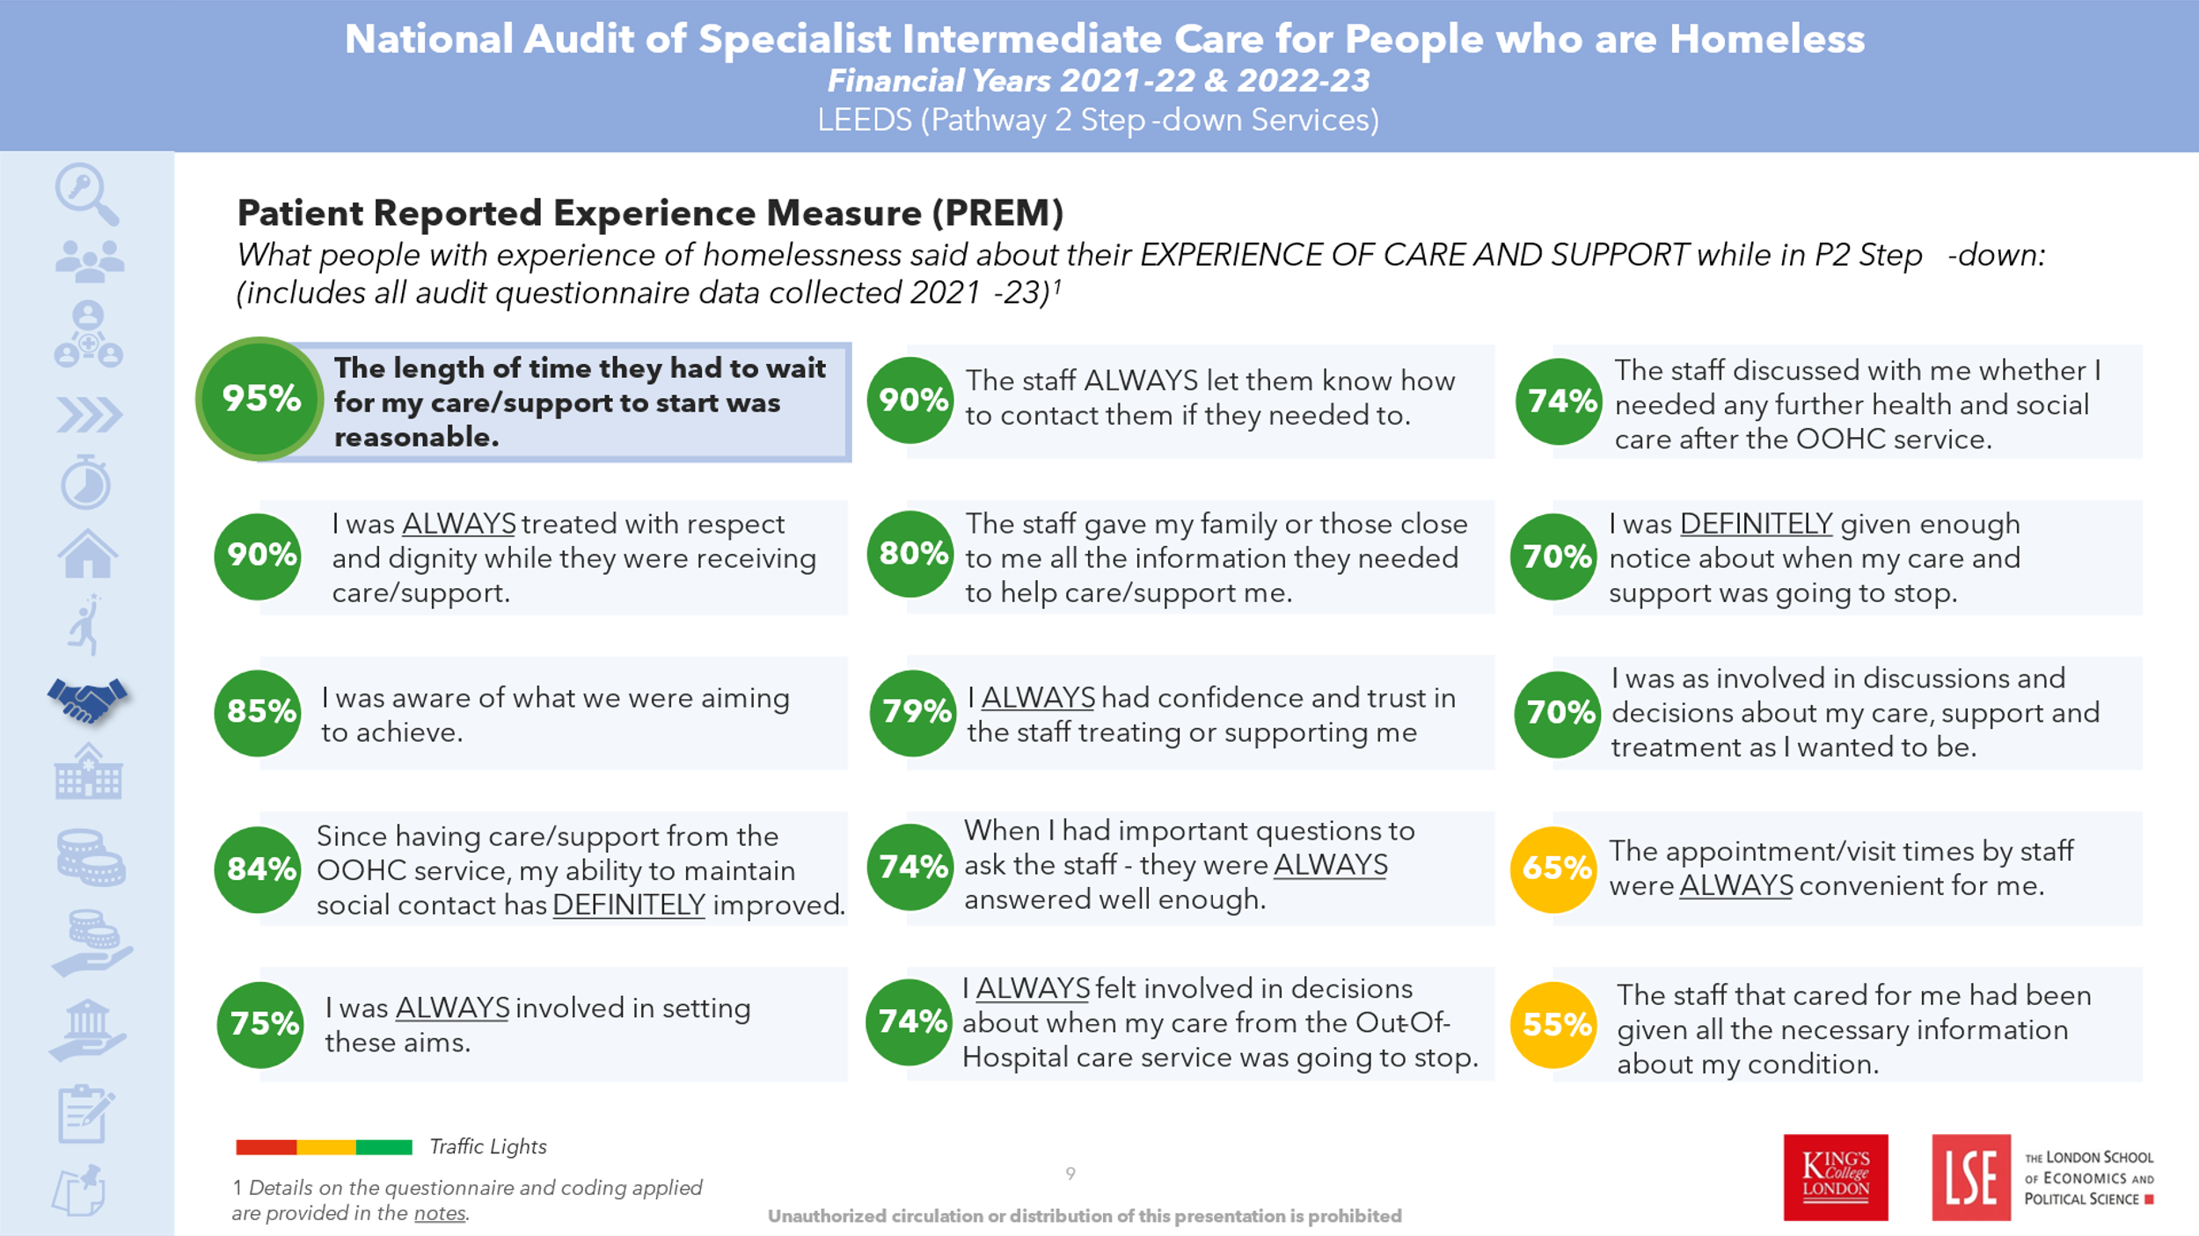
- Women's Census Leeds - Basis
- Taken from 2023 Pathway Report
 | Total | %
Male | 218 | 77.9%
Female | 62 | 22.1%
- Leeds Community Health Care - Learning Disability Service
- Ethnicity of referrals to HHIT 2023
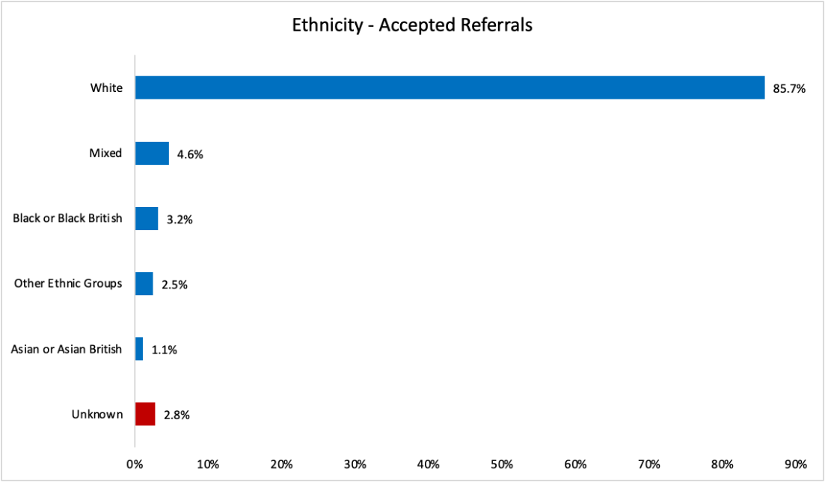
- Feedback is obtained from at least 10% of patients/focus groups are undertaken, to understand patient experiences and make appropriate quality improvements
The team, along with a lived experience peer, have collected feedback from a number of patients and is currently in the process of establishing lived experience led workshops to collect feedback on patients’ experiences of health and social care, as well as their experiences of the team.
As the quotes below show, patients’ feedback for the team was incredibly positive, particularly noting how the treatment they received from the team was much better than their experiences with mainstream healthcare services. The quotes also show some of the practical activities the team does to support patients.
“it’s the most anyone has done for me in a long time”
“You were the first person following the incident that didn’t treat me like an animal that deserved the frost bite in my feet, they (hospital staff) made me feel less than human. I remember you getting me some crisps and sweets and I believed you would help me. It gave me some hope, and I will never forget you; you helped me stay alive, believing in me, visiting me telling me everything will be ok – I cannot thank you enough especially as I am now living in my forever home.”
“Thank you for sorting out my benefits and for trying to sort out my settled status”
"You get to know the people you support and have compassion. Keep being you and keep doing the good work”
“I couldn’t have done this without you”
“I can tell you really care and listen, some of the other workers that work with you just tick boxes and think they have done their work with you.”
“I wasn’t expecting you to call me back. In the past I’ve been told (services) will call you back and then never get a call. This was a shock to be honest as all I’ve known is to be let down by people and services. I lost all trust in people, but getting a call and regular updates from you made me realize that there are caring people still around.”
- Ethnicity data from Pathway report
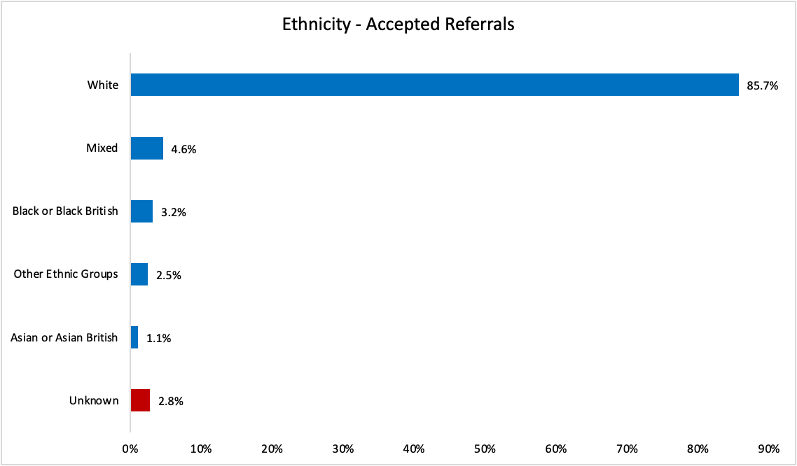

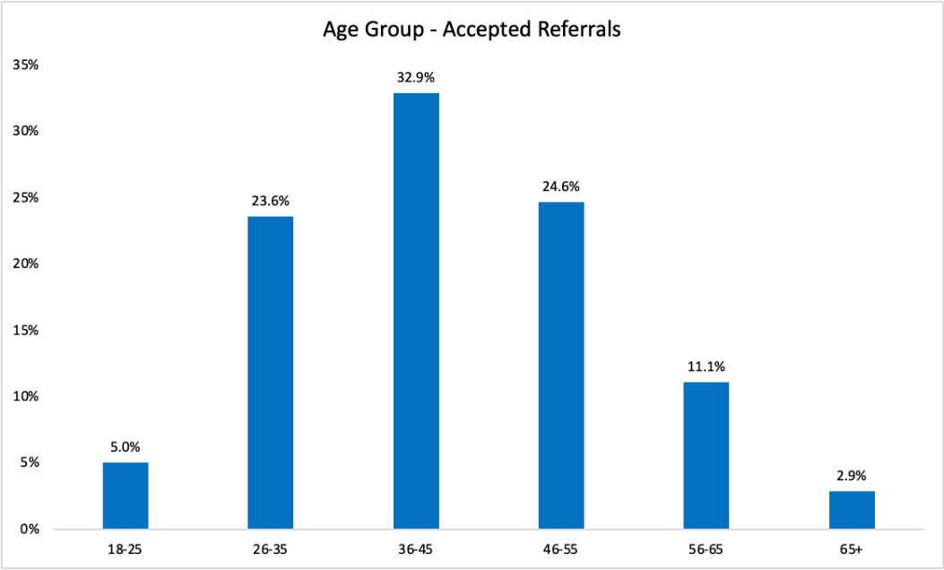

- LCH Homeless and Health Inclusion Team (HHIT)
 | % on admission | % on discharge | % Change
Sofa Surfing | 29.9% | 8.7% | - 71.1%
Rough Sleeping | 27.6% | 8.7% | - 68.8%
Temporary Housing | 8.7% | 22% | + 154.5%
Supported Accommodation | 7.1% | 7.1% | N/A
Private Rent | 7.1% | 15.7% | + 122.2%
LA/HA Rent | 1.6% | 6.3% | + 300%

Care Plan Audit
In line with Pathway’s recommendations, the team conducted a clinical audit of 20 sets of randomly selected notes from patients accepted over the year. The audit assessed the quality of the team’s clinical and social interventions, documentation and planning, and discharge effectiveness.
The table below shows that the team was able to effectively conduct holistic assessments with all patients, and that these assessments were appropriately recorded. Additionally, the team identified and contacted GPs for 95% of patients and engaged in housing work for 100% of patients.
 | Total Recorded | Total Yes | % Yes
Evidence of holistic assessment? | 20 | 20 | 100%
GP Identified? | 20 | 20 | 100%
GP Contacted? | 20 | 19 | 95%
Care and support needs met on discharge? | 20 | 14 | 70%
Housing work undertaken to facilitate discharge? | 20 | 20 | 100%

85% inpatients receive a holistic assessment (in line with Pathway recommendations on assessment) which covers housing, primary care engagement, mental health, addictions and safeguarding and have a resulting care plan documented in their hospital notes because of the assessment.

Appendix 4: Neighbourhood Nights EDS assessment
Outcome | Examples of evidence (b) |  | Evidence (a) | Rating (c)
1A: Service users have required levels of access to the service | Underdeveloped activity (score 0) | No or little activity taking place:  - Organisations/systems have little or nothing in place to ensure patients with protected characteristics have adequate and appropriate access to the services they require.  - Feedback from patients is not acted upon.  - Organisations have not identified barriers facing patients | Core 20 population (IMD1 and 2) is 41.2% compared to Leeds population 33.4%, identifying good access for people living in deprivation.  Minority ethnic groups have comparable access to Nights for EoLC (FT funded) with White British 93.4% compared to Leeds population who have died. 94%  40 patients were referred into the night service for a night assessment all were white British  Nights Service call out data suggests more ethnic diversity than 121 overnight care, however this is for all urgent care not only EoLC  Barriers identified included in mapping of patient journey  Caveat with data – small time period so doesn’t take into account trends  Service has developed picture cards to support communication with patients | 1
 | Developing activity (score 1) | Minimal/basic activities taking place:  - Data and evidence to show some protected characteristics (50%) have adequate access to the service.  - Patients consistently report fair or good (or the equivalent) when asked about accessing services.  - Demonstration that the organisation has identified barriers to accessing services |  | 1
 | Achieving activity (score 2) | Required level of activity taking place:  - Data to show those with protected characteristics (100%), and other groups at risk of health inequalities, have adequate access to the service.  - Patients consistently report good or very good (or the equivalent) when asked about accessing services. Demonstration that the organisation has identified barriers to accessing services |  | 1
 | Excelling activity (score 3) | Activity exceeds requirements:  - Data to show those with protected characteristics (100%), and other groups at risk of health inequalities, have tailored access to the service.  - Patients consistently report very good or excellent (or the equivalent) when asked about accessing services.  - Demonstration that the organisation has knowledge of barriers and have changed outcomes for people who experience those barriers in accessing services |  | 1
1B: Individual service user’s health needs are met | Underdeveloped activity (score 0) | No or little activity taking place:  - Patients with higher risks due to a protected characteristic receive little or no support to self-manage care needs.  - The organisations do little or no engagement surrounding services. | After assessment Nights ask NT and Health Case Management (HCM) to follow up e.g. to provide a two way monitor for family to use overnight, equipment to aid independence, signposting to 3rd sector for carer support.  Liaise with HCM re exceptions panel over and above clinical need eg  - carer strain due to behavioural changes referred to exceptions panel and accepted for overnight care despite not having a clinical need  - safeguarding concerns about a child’s delayed development and verbal abuse by his father – father had difficulty articulating that he was struggling, due to English not being his first language, to care for his wife who was confused due to a brain tumour and three year old son  - Family coming together overnight 12-2 – night support provided despite family being present for part of the night.  This personalised approach to care has increased over the last few years and driven internally and through working with partners – CHC and HCM.  Homelessness - work with St Gemma’s and HHIT: look at planned visits rather than stay if not safe for staff – this has applied to inclusion health groups including substance misuse.  Interpreter use – service has prebooked for whole night sit on occasion to support with communication of overnight needs and has access to on call interpreter for crisis calls.  Developed staff information on death and dying and questions to ask – to add to trust wide cultural competency work on MyLCH Cultural Resources (lch.oak.com) | 3
1B: Individual service user’s health needs are met | Developing activity (score 1) | Minimal/basic activities taking place:  - Patients at higher risk due to a protected characteristic needs are met in a way that works for them.  - The organisations often consult with patients and the public to commission, de-commission and cease services provided. |  | 3
1B: Individual service user’s health needs are met | Achieving activity (score 2) | Required level of activity taking place:  - Patients at higher risk due to a protected characteristic needs are met in a way that works for them.  - The organisations often consult with patients with higher risks due to a protected characteristic to commission, designed, increase, decrease, de-commission and cease services provided.  - The organisations signpost to VSCE organisations and social prescribing. Personalised care is embedded into the care delivered for those with higher risks due to a protected characteristic by the organisations. |  | 3
1B: Individual service user’s health needs are met | Excelling activity (score 3) | Activity exceeds requirements:  - Patients at higher risk due to a protected characteristic and other groups at risk of health inequalities needs are met in a way that works for them.  - The organisations fully engage with patients, community groups, and the public, to commission, designed, increase, decrease, de-commission and cease services provided.  - The organisations work in partnership with VCSE organisations to support community groups identified as seldom heard. The organisations use social prescribing, where relevant.  - Personalised care is embedded into the care delivered for those with higher risks due to a protected characteristic by the organisations.  - The organisations work with, and influence partners, to improve outcomes for people with a protected characteristic and other groups at risk of health inequalities, across the system or where services connect |  | 3
1C: When service users use the service, they are free from harm | Underdeveloped activity (score 0) | No or little activity taking place:  - The organisation may or may not have mandated/ basic procedures/initiatives in place to ensure safety in services.  - Staff and patients are not supported when reporting incidents and near misses.  - The organisation holds a blame culture towards mistakes, incidents and near misses | Policies are equity impact assessed  PSIRF incident reviews include equity considerations  Quality Challenge rating – outstanding  Quality Challenge –  Just culture  Recording of incidents  Shared learning through incident memos and from compliments/concerns  Debriefs and clinical supervision – have included reflections on how culture can impact on care e.g. use of controlled medications at end of life, wider family involvement, gender of care of staff, ethical issues around conversations about dying with the patient.  Skill mix and new leadership structure in 2023-24  - More B7 clinical oversight of complex care e.g. relating to social situation, family dynamics, carer strain, risk assessments  - Greater skills to work with diverse groups, assess and mitigate risk, respond to individual situations  - Shared Clinical record including information about individual circumstances | 2
 | Developing activity (score 1) | Minimal/basic activities taking place:  - The organisation has mandated/ basic procedures/initiatives in place to ensure safety in services.  - The organisation has procedures/initiatives in place to enhance safety in services for patients in protected characteristic groups. |  | 2
 | Achieving activity (score 2) | Required level of activity taking place:  - The organisation has procedures/initiatives in place to enhance safety in services for patients in all protected characteristic groups where there is known H&S risks.  - Staff and patients feel confident, and are supported to, report incidents and near misses.  - The organisation encourages an improvement culture giving consideration to equality and health inequality themes in safety incidents and near misses |  | 2
 | Excelling activity (score 3) | Activity exceeds requirements:  - The organisation has procedures/initiatives in place to enhance safety in services for all patients in protected characteristic groups where there is known H&S risks.  - Staff and patients are supported and encouraged to report incidents and near misses.  - The organisation encourages and promotes an improvement culture actively including equality and health inequality themes in safety incidents and near misses.  - The organisations work with system and community partners to improve safety outcomes for people, using existing data and driven by service need/risk |  | 2
1D: Service users report positive experiences of the service | Underdeveloped activity (score 0) | No or little activity taking place:  - The organisations do not engage with patients about their experience of the service.  - The organisations do not recognise the link between staff and patient treatment. The organisations do not act upon data or monitor progress. | Patient FFT feedback goes to NT currently. Unable to breakdown by protected characteristics. Now working to separate it to be specific to Nights so can better analyse, identify themes and action improvements.  Compliments and feedback from patients direct to team  - Recorded on Datix and shared  - E.g. verbal feedback from daughter on compromise achieved to meet father’s needs  Positive feedback from HHIT around collaborative working to help vulnerably housed people achieve PPD  Engagement with families and communities to understand culture and rituals around death and dying on an individual patient basis  Night service is diverse  - Cultural ‘board’ established – participation from the team  - Internal quarterly REN mtgs | 1
1D: Service users report positive experiences of the service | Developing activity (score 1) | Minimal/basic activities taking place:  - The organisations collate data from patients with protected characteristics about their experience of the service.  - The organisation creates action plans, and monitors progress. |  | 1
1D: Service users report positive experiences of the service | Achieving activity (score 2) | Required level of activity taking place:  - The organisations collate data from patients with protected characteristics about their experience of the service.  - The organisations create evidence-based action plans in collaboration with patients and relevant stakeholders, and monitors progress.  - The organisation shows understanding of the link between staff and patient treatment and demonstrate improvement in patient experiences |  | 1
1D: Service users report positive experiences of the service | Excelling activity (score 3) | Activity exceeds requirements:  - The organisation actively engages with patients with protected characteristics and other groups at risk of health inequalities about their experience of the service.  - The organisation actively works with the VCSE to ensure all patient voices are heard.  - The organisations create data driven/evidence-based action plans, and monitors progress.  - The organisation shows understanding of the link between staff and patient treatment. The organisations use patient experience data to influence the wider system and build interventions in an innovative way. |  | 1

PART 2: Through doing the assessment in part 1, what gaps have you identified to take forwards for consideration as part of the action plan?
What gaps in data have you identified? What did your data or other insight show you was a gap in service? What training needs did you identify?
Trust-wide:
- Data quality – confidence in reporting and ease of use for analysis; automated (currently done manually) and only based on referrals not caseload
- Cultural competency – sharing resources used in Nights with other areas

Service-specific:
- Engagement with NTs re referrals, identifying needs etc, cultural competence eg not making assumptions about understanding funding processes / language and whether overnight care required
- To gather FFT direct to service (separate out from NTs)
- Consider how learning from other sources eg bereaved carers survey and Healthwatch report could be reviewed in service and inform improvements
  - Bereaved carers survey - Leeds performing well re coordination of care and staff being skilled to care / area for improvement is personalisation of care.

