Community Stroke Team

Aphasia
Self- Management

QR Codes
To encourage this leaflet to be as resourceful as possible we have included some QR codes.
What are QR codes?
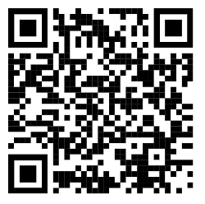
A QR code is a symbol – this is a QR code
QR codes take you directly to websites.
How to use QR codes:
Hover your Smartphone camera over the QR code.
A link to a website will appear on the screen
Click this link to be directed to the website

Aphasia
Following your Stroke you have been experiencing Aphasia.
*Please refer to the information leaflet for more information about this term.
This booklet aims to help you understand this condition and develop strategies to promote self-management.

What is self-management?
Self-management promotes knowledge and independence following your Stroke.

Stroke + Recovery
What is Stroke?
A stroke happens when a part of the brain loses its blood supply.
This can cause brain cells to die.
The impact of Stroke can vary depending on the part of the brain it has happened in, and the individual person.
For more information about the effects of Stroke please visit:
Effects of stroke | Stroke Association
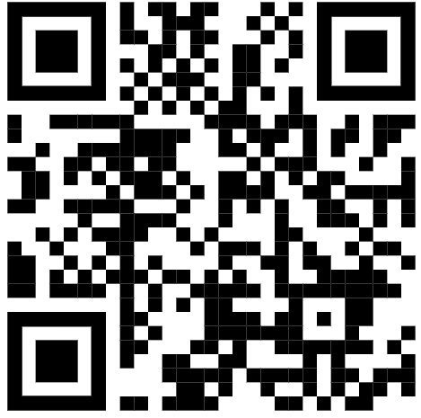
What is Stroke rehabilitation/recovery?
Stroke rehabilitation aims to re-wire your brain to relearn abilities that have been affected by the Stroke. Our brain’s ability to do this relies on neuroplasticity.
For more information on neuroplasticity please visit:
Neuroplasticity: re-wiring the brain | Stroke Association
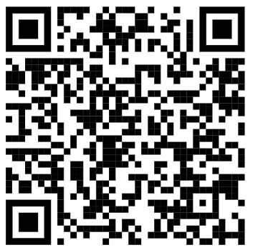

My Aphasia
What does Aphasia mean to you?
Use the space below to describe your communication changes in your own words.

________________________________________________________________
________________________________________________________________
________________________________________________________________
________________________________________________________________
________________________________________________________________
________________________________________________________________
________________________________________________________________
________________________________________________________________
________________________________________________________________
________________________________________________________________
________________________________________________________________
________________________________________________________________
________________________________________________________________
________________________________________________________________
________________________________________________________________
________________________________________________________________

Goal setting
If you could rate your communication out of 10 (10 being your communication is back to how it was before your Stroke), what would you rate it?
/10
What goal(s) are you working towards?
________________________________________________________________

________________________________________________________________

________________________________________________________________
What will help you achieve this goal?

________________________________________________________________

________________________________________________________________

________________________________________________________________

Barriers + Facilitators
Some situations can make things easier, or more difficult e.g. when you are tired you may notice increased difficulty. Use the space below to think about things that help and do not help you.

What things help me (facilitators)?

________________________________________________________________

________________________________________________________________

________________________________________________________________

________________________________________________________________
________________________________________________________________
What things do not help me (barriers)?
________________________________________________________________

________________________________________________________________

________________________________________________________________

________________________________________________________________
Strategies
Using the facilitators and barriers list above can help you identify strategies to support you.

________________________________________________________________

________________________________________________________________

________________________________________________________________

________________________________________________________________

________________________________________________________________

________________________________________________________________

________________________________________________________________

________________________________________________________________
________________________________________________________________

________________________________________________________________

Useful resources

More information about Aphasia:
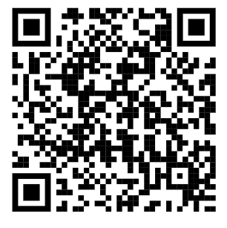  Aphasia Connect | 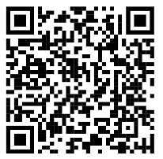  Stroke Association
Therapy resources:
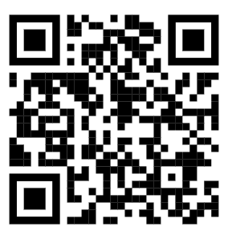  Free  online aphasia therapy | 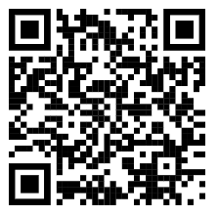  Aphasia therapy apps | Stroke Association
Support + groups:
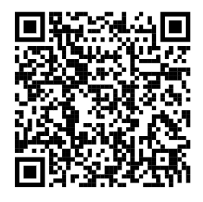
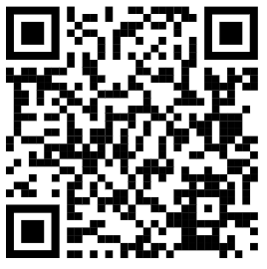
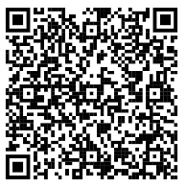

All Things Stroke Aphasia Support Different Strokes
Fatigue:

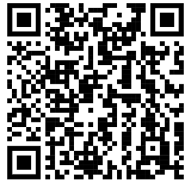
Managing post-stroke fatigue

