Community Stroke Team

Dysarthria
Self- Management

QR Codes
To encourage this leaflet to be as resourceful as possible we have included some QR codes.
What are QR codes?
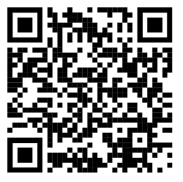
A QR code is a symbol – this is a QR code
QR codes take you directly to websites.
How to use QR codes:
Hover your Smartphone camera over the QR code.
A link to a website will appear on the screen
Click this link to be directed to the website

Dysarthria
Following your Stroke you have been experiencing Dysarthria.
*Please refer to the information leaflet for more information about this term.
This booklet aims to help you understand this condition and develop strategies to promote self-management.

What is self-management?
Self-management promotes knowledge and independence following your Stroke.

Stroke + Recovery
What is Stroke?
A stroke happens when a part of the brain loses its blood supply.
This can cause brain cells to die.
The impact of Stroke can vary depending on the part of the brain it has happened in, and the individual person.
For more information about the effects of Stroke please visit:
Effects of stroke | Stroke Association
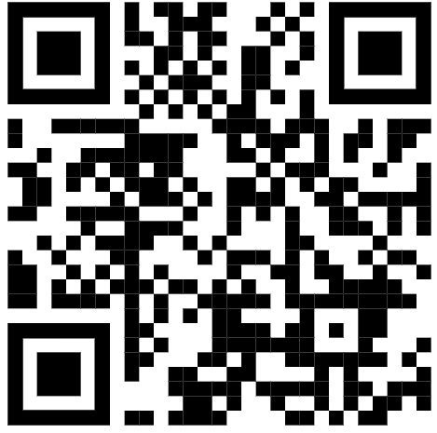
What is Stroke rehabilitation/recovery?
Stroke rehabilitation aims to re-wire your brain to relearn abilities that have been affected by the Stroke. Our brain’s ability to do this relies on neuroplasticity.
For more information on neuroplasticity please visit:
Neuroplasticity: re-wiring the brain | Stroke Association
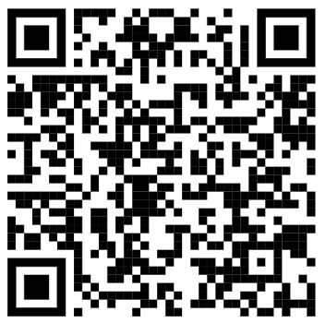

My Dysarthria
What does Dysarthria mean to you?
Use the space below to describe your speech changes in your own words.

________________________________________________________________
________________________________________________________________
________________________________________________________________
________________________________________________________________
________________________________________________________________
________________________________________________________________
________________________________________________________________
________________________________________________________________
________________________________________________________________
________________________________________________________________
________________________________________________________________
________________________________________________________________
________________________________________________________________
________________________________________________________________
________________________________________________________________
________________________________________________________________

Goal setting
If you could rate your communication out of 10 (10 being your communication is back to how it was before your Stroke), what would you rate it?
/10
What goal(s) are you working towards?
________________________________________________________________

________________________________________________________________

________________________________________________________________
What will help you achieve this goal?

________________________________________________________________

________________________________________________________________

________________________________________________________________

Barriers + Facilitators
Some situations can make things easier, or more difficult e.g. when you are tired you may notice increased difficulty. Use the space below to think about things that help and do not help you.

What things help me (facilitators)?

________________________________________________________________

________________________________________________________________

________________________________________________________________

________________________________________________________________
________________________________________________________________
What things do not help me (barriers)?
________________________________________________________________

________________________________________________________________

________________________________________________________________

________________________________________________________________
Strategies
There are a number of factors that may impact your speech in conversation. Use the space below to think of things that help and do not help your speech e.g. turn the TV off, when people give me time.
Helps:
_____________________________________________________________________
_____________________________________________________________________
_____________________________________________________________________
_____________________________________________________________________
_____________________________________________________________________
_____________________________________________________________________
_____________________________________________________________________
_____________________________________________________________________
_____________________________________________________________________

Hinders:
_____________________________________________________________________
_____________________________________________________________________
_____________________________________________________________________
_____________________________________________________________________
_____________________________________________________________________
CLEAR SPEECH STRATEGIES
Now that you have thought about what helps and hinders your speech, use the space below to identify what you (or others) can do to help you in conversation. Some examples are:
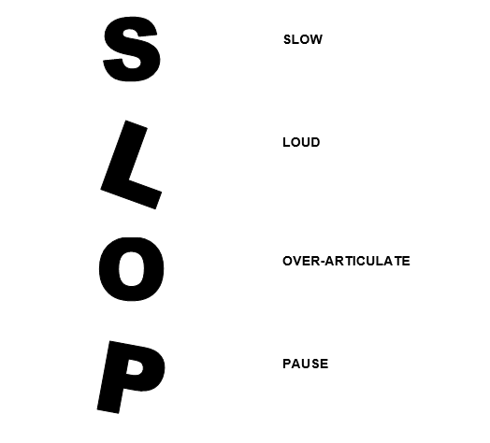
My strategies:
_____________________________________________________________________
_____________________________________________________________________
_____________________________________________________________________
_____________________________________________________________________
_____________________________________________________________________
FACIAL MASSAGE
A Stroke can cause facial weakness. The below massage may help:
- Maintain flexibility of muscles
- Identify areas that feel loose or too tight
- Keep you in touch with your facial muscles
- Preserve the idea of movement

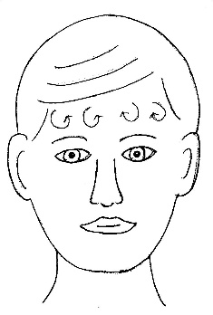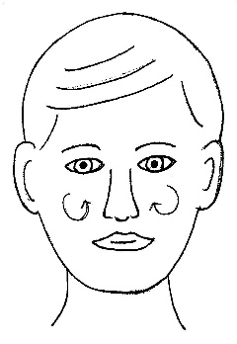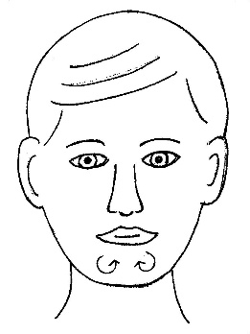
Make circles on the chin
Circular massage on cheeks

Make circles with the pads of your fingers over the forehead

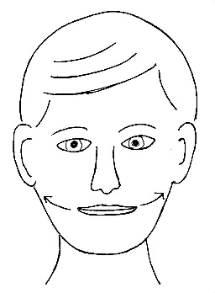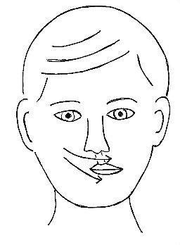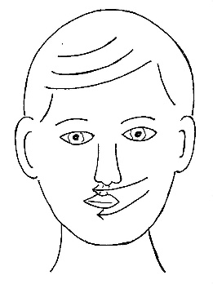
Sweeping movements from side to side on the chin
Tilt the head to opposite side
Make circular movements from jaw line down to collar bone
E Julie Stephens Physiotherapy Department CAH Updated March 2011

Use facial massage cream or moisturizer to prevent dragging of the skin. Repeat each movement 3-4 times

Make gentle sweeping stroke drawing corners of mouth out towards ears
Sweep across top lip, from alternate sides
Repeat under lips

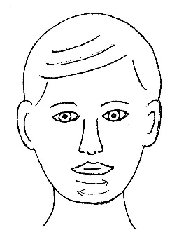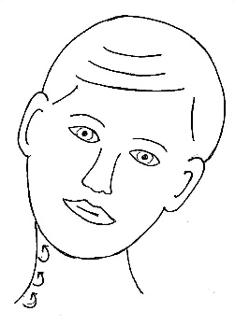
Tilt the head to opposite side
Gentle circular movements from jaw line down to collar bone

Sweeping movements from side to side on the chin

Use facial massage cream or moisturizer to prevent dragging of the skin.
Repeat each movement 3-4 times
Useful resources:

For more information about Dysarthria please visit:
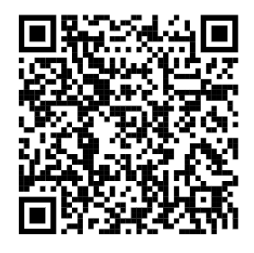
Communication :: All Things Stroke - West Yorkshire & Harrogate

Reading aloud resources:
Practising your speech and strategies in everyday conversation is a great way to promote your speech intelligibility. However, if you are struggling to find opportunities for conversation, reading aloud can also be useful. Reading anything that interests you works (such as newspapers, novels, magazines), but if you are struggling to find some reading material here are some resources:
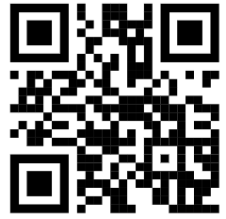
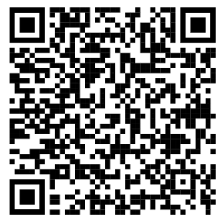
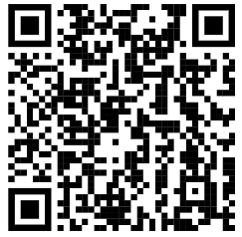
Harvard sentences Passages BBC News Articles

For more information about fatigue please visit:
Managing post-stroke fatigue | Stroke Association
