

Maintaining High Professional Standards
Policy Owner | Senior People Partner
Corporate Lead | Executive Medical Director
Date approved by Joint Negotiating and Consultation Forum  (JNCF) | 12 November 2025
Date ratified by Senior Leadership Team (SLT) | 17 December 2025
Date Issued | 26 January 2026
Review Date | December 2027

Executive summary
This policy document implements the national policy framework ‘Maintaining High Professional Standards in the Modern NHS’. In implementing this policy framework the Trust is acting in accordance with Directions on Disciplinary Procedures 2005 and the Restriction of Practice and Exclusion from Work Directions 2003.
This policy applies to all Medical and Dental employees of LCH. The policy will not apply to “workers” such as staff employed on an honorary contract or through an agency for which the responsibility rests with the individual’s statutory employer.
This policy should be read together with other relevant Trust policies, procedures, and local guidance. The Trust has also produced a toolkit to supplement this policy, which provides further information and templates.
The policy and procedure may be reviewed at the request of Management or Staff Side by giving four weeks’ written notice with reasons for the review.
This policy is arranged into a number of sections:
- A number of flow charts setting out an overview of the processes covered by this policy
- A Policy Information Section
- Part 1a – setting out a guide for low level concerns or when concerns are initially raised.
- Part 1b – sets out the formal investigation process under the MHP process
- Part 2 – sets out the process for clinical restriction, immediate exclusion and formal exclusion.
- Part 3 – sets out the process for dealing with misconduct and gross misconduct
- Part 4 – sets out the process for dealing with capability concerns after an investigation has happened
- Part 5 – sets out how to support a practitioner with their health

Equality Analysis
Leeds Community Healthcare NHS Trust's vision is to provide the best possible care to every community. In support of the vision, with due regard to the Equality Act 2010 General Duty aims, Equality Analysis has been undertaken on this policy (see Appendix 3).

Contents

Flow Charts 6
Flow Chart – Part 1a Action when a concern arises (Informal) 6
Flow Chart – Part 1b Action when a concern arises (Formal) 7
Flow Chart – Part 2 Restriction of practice 8
Flow Chart – Part 2 Exclusion 8
Flow Chart – Part 3 Process for dealing with conduct issues 9
Flow Chart – Part 4 Procedures for dealing with issues of capability 10
Policy information 12
- Introduction 12
- Aims and Objectives 12
- Definitions 12
- Responsibilities 13
Part 1a – Action when a concern arises (Informal) 18
- Introduction 18
- Performance Concerns for Doctors or Dentists in Training 18
- Performance Concerns for Workers 18
- Health Concerns 19
- Systems Errors 19
- Severity of concern 19
- Repeated or continuous low level concerns 20
- Outcome of first review 20
Part 1b – Action when a concern arises (Formal) 21
- Initial actions when serious concerns arise 21
- Formal MHPS Process 21
- Exclusion or Restriction 22
- Identifying if There is a Problem 22
- Unfounded/Malicious Allegations 22
- Defamation – the legal positions 23
- Protecting the Public 23
- The Investigation Process 23
22 Confidentiality 24
Part 2 – Restriction of practice and exclusion from work 25
- Introduction 25
- Managing the risk to patients 25
- Immediate Exclusion 26
- Informal Exclusion 26
- Formal exclusion 27
- Exclusion from Premises and IT Systems 28
- Keeping in Contact and Availability for Work 28
- Informing Other Organisations 29
- Keeping Exclusions Under Review: Informing the Board 29
- Regular Review 29
- First and Second Reviews (and Reviews After the Third Review) 30
- Third Review 30
- 6 Months Review 31
- The Role of the Board and Designated Member 31
Part 3 – Conduct hearings and disciplinary matters 32
- Introduction 32
- Action When Investigations Identify Possible Criminal Acts 32
- Cases Where Criminal Charges are Brought Not Connected With An Investigation by the Trust 32
- Dropping of Charges or No Court Conviction 33
- Terms of Settlement on Termination of Employment 33
Part 4 – Procedures for dealing with issues of capability 35
- Introduction 35
- How to Proceed Where both Conduct and Capability Issues are Involved 35
- Duties of Employers 35
- The Pre-hearing Process 36
- The Hearing Framework 37
- Representation at Performance Management Hearings 38
- Conduct of the Capability Hearing 38
- Decisions 39
- Appeals in Capability Cases 40
- The Appeal Process 40
- The Appeal Panel 41
- Powers of the Appeal Panel 42
- Conduct of Appeal Hearing 42
- Appeal Hearing Decisions 43
- Action Following Hearing 43
- Termination of Employment with Performance Issue Unresolved 43
Part 5 – Handling concerns about a practitioner’s health 45
- Introduction 45
- Retaining the Services of Individuals with Health Problems 45
- Reasonable adjustments 45
- Handling Health Issues 45
Appendices 49
Appendix 1 – Summary of rights of a practitioner under the maintaining high professional standards process 50
Appendix 2 – Supporting Colleagues back into work following exclusion 51
Appendix 3 - Equality Analysis Relevance Screening Form 56

Appendix 4 - Policy Consultation Responses Error! Bookmark not defined.

Flow Charts

Flow Chart – Part 1a Action when a concern arises (Informal)
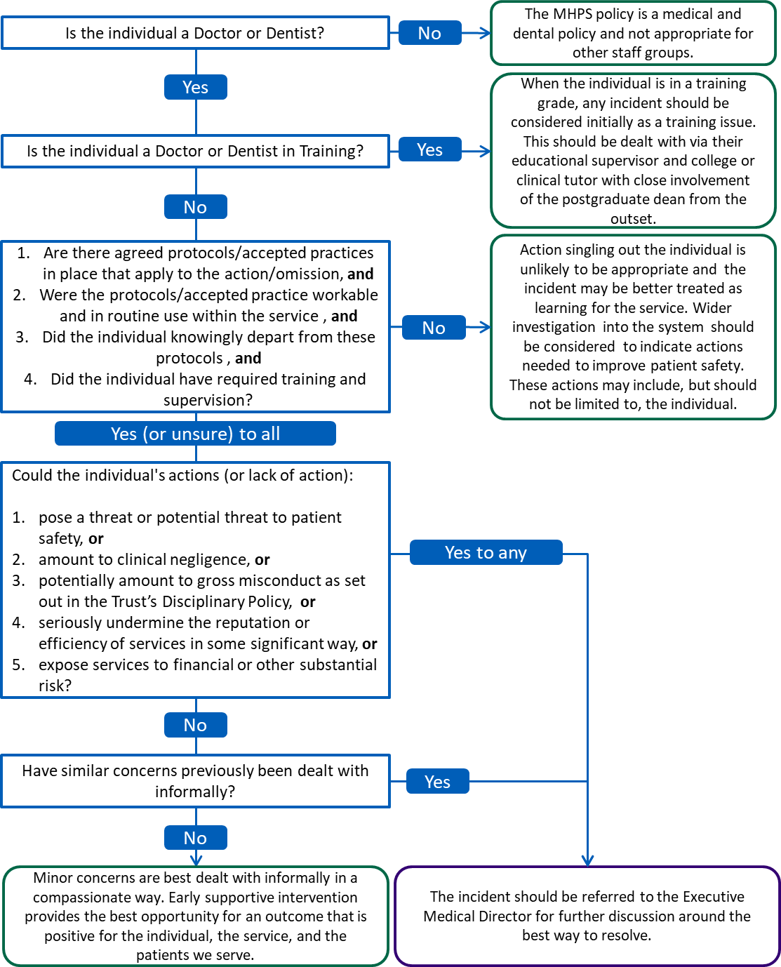

Flow Chart – Part 1b Action when a concern arises (Formal)
The below flow chart shows an overview of the process once the Executive Medical Director has decided that a formal MHPS process should be undertaken.
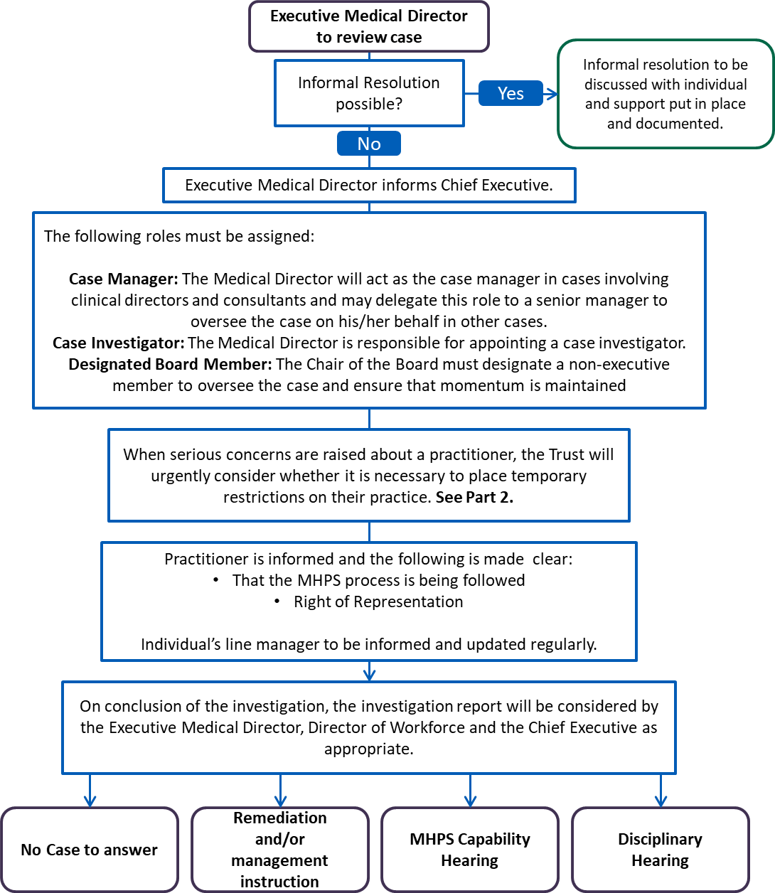

Flow Chart – Part 2 Restriction of practice
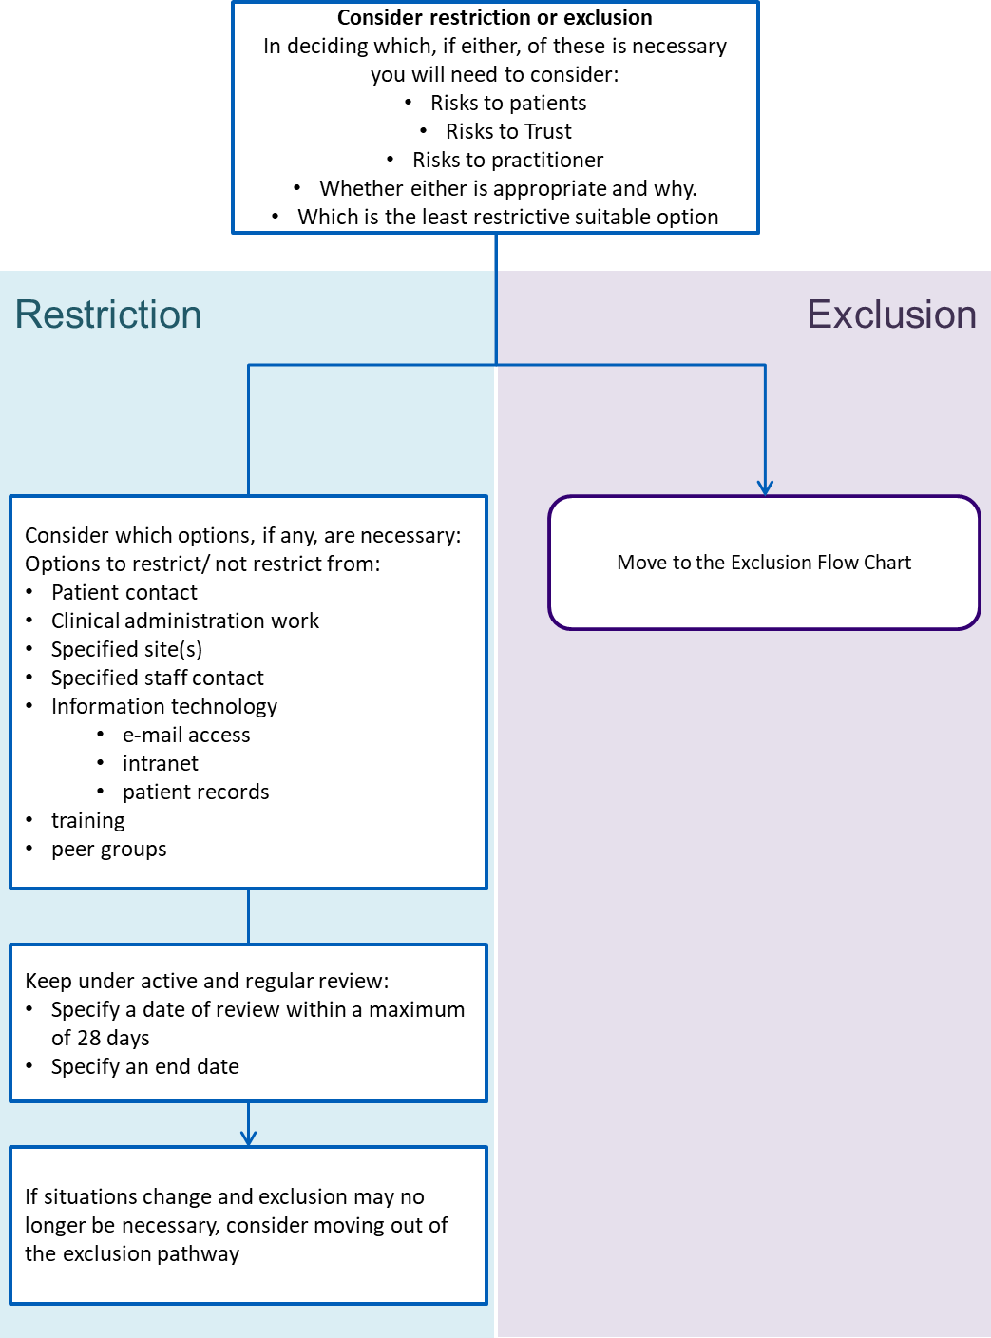

Flow Chart – Part 2 Exclusion
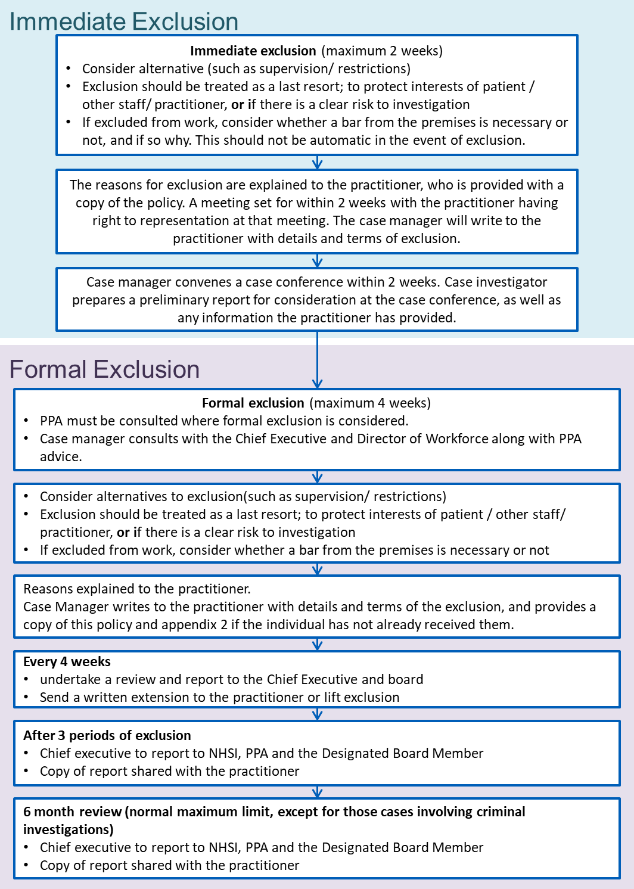

Flow Chart – Part 3 Process for dealing with conduct issues

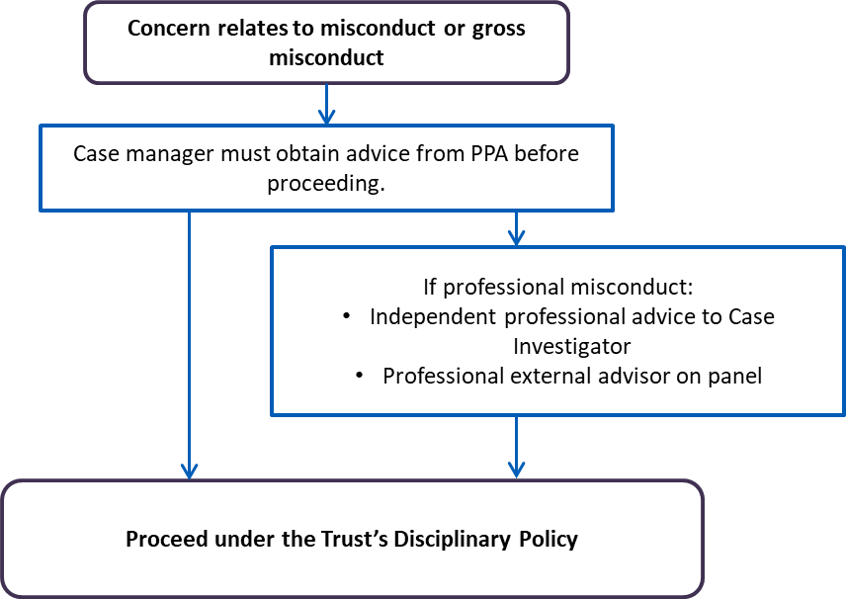

Flow Chart – Part 4 Procedures for dealing with issues of capability
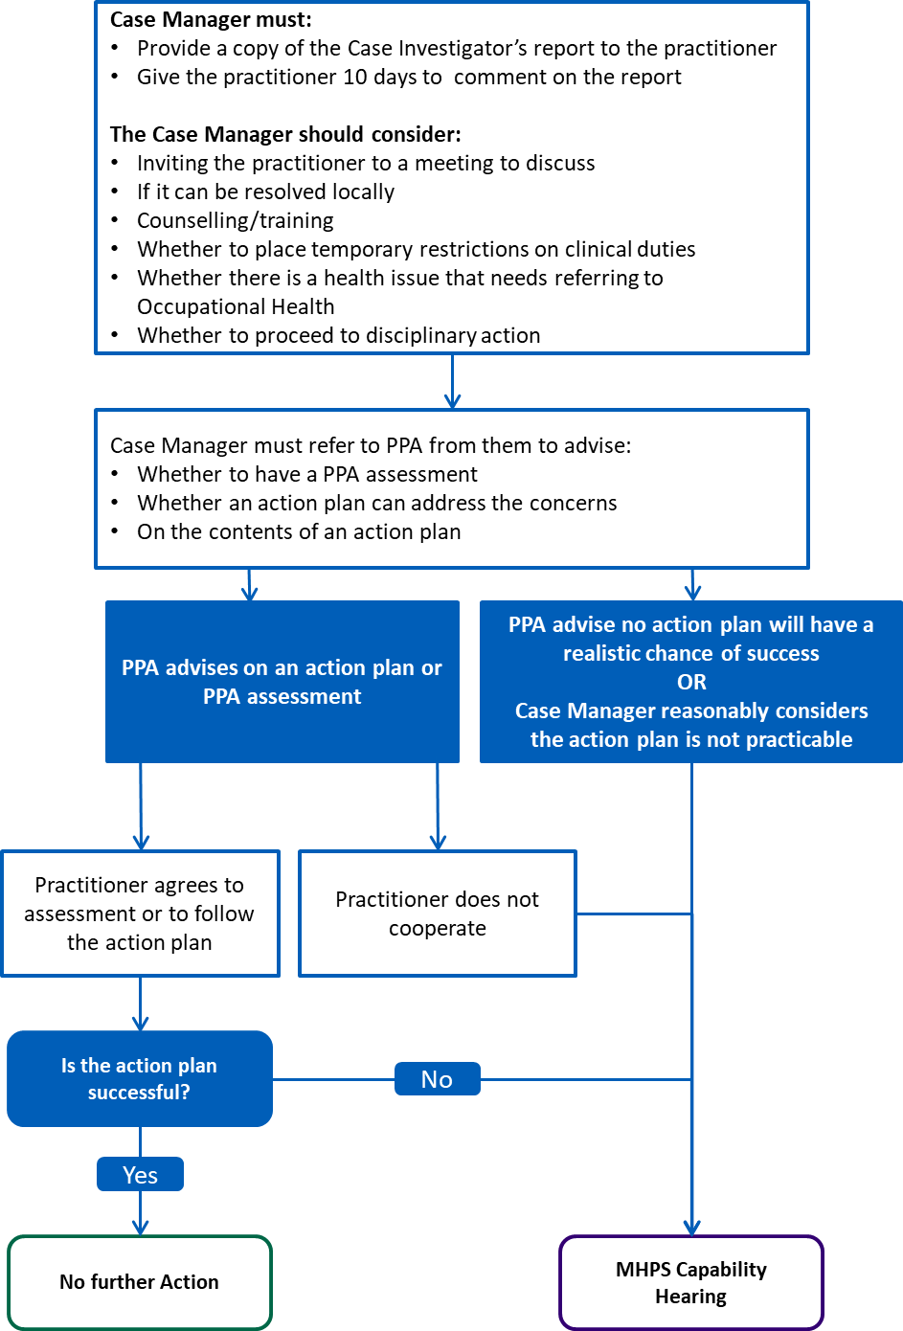

Policy information

Introduction
  - This policy implements the framework set out in Maintaining High Professional Standards in the Modern NHS, issued under the direction of the Secretary of State for Health in February 2005.
  - This policy applies to all Trust employed medical and dental staff for who the Trust is lead employer. For those who have a different lead employer, the Trust aims jointly with the lead employer to address the issues.
  - The document has been separated into a number of parts (parts 1 to 5) which align with the Maintaining High Professional Standards in the Modern NHS document. These parts are preceded by a number of flow charts providing an overview of the policy, and the Policy Information section (this section).

Aims and Objectives
  - The policy’s primary purpose is to set out the agreed procedures when concerns are raised about the performance or conduct of a Medical or Dental employee.
  - The procedure should not be viewed primarily as a means of imposing sanctions. It is designed to emphasise the need for and encourage improvements in individual conduct and performance.
  - Inappropriate exclusions or investigations for concerns which would be better resolved with informal supportive actions can be negative for the individual concerned and also for the service. This procedure is designed to provide guidance on when an informal approach would be better used.

Definitions
- Capability - where there is evidence of clinical practice outside that which is regarded as ‘standard and acceptable’ by a body of specialty opinion, eg NICE, and/or has implications for patient safety.
- Conduct – behaviour within the workplace or outside of the workplace.
- Exclusion – Removal from the workplace. The word exclusion is used to avoid confusion with suspension – when a practitioner is suspended from the GMC or GDC register.
- Misconduct – Inappropriate / unacceptable conduct. An act of misconduct that is not serious enough to be considered ‘gross misconduct’ but is more than minor. This may also be repeated minor misconduct that has not been resolved following informal action. Typically this is a result of failure to meet the expected standards of conduct as stipulated in the Trusts policies, procedures and reasonable management expectations. Examples can be found in the Trust’s Disciplinary Policy.
- Gross Misconduct – Act(s) of misconduct that is serious enough on its own to justify the employee's summary dismissal. Examples can be found in the Trust’s Disciplinary Policy.

- Practitioner Performance Advice (PPA) - Practitioner Performance Advice (formerly the National Clinical Assessment Service - NCAS) is a service delivered by NHS Resolution under the common purpose to provide expertise to the NHS on resolving concerns fairly, share from learning for improvement and preserve resources for patient care.
- NHS Improvement (NHSI) - now incorporates the former National Patient Safety Agency (NSPA) which leads and contributes to improved safe patient care by informing, supporting and influencing the health sector.

Responsibilities

Chief Executive and Trust Board
    - All serious concerns must be registered with the Chief Executive who must ensure that a case manager is appointed. The Trust’s Chief Executive has overall responsibility for managing exclusion procedures and for ensuring that cases are properly managed.
    - The Trust Board is responsible for:
      - ensuring these procedures are established and followed
      - ensuring the proper corporate governance of the organisation
      - designating one of its non-executive director (NED) members as the “Designated Board Member” when a serious concern arises which is escalated to the formal process set out in part 1b.

Designated Board Member (NED)
    - The Designated Board Member oversees the case which includes the right to a fair process and ensures momentum is maintained.
    - At any stage in the process, the practitioner may make representations to the Designated Board Member in regard to exclusion or investigation of a case. This is in addition to any right the practitioner may have to appeal against the exclusion under the Trust’s appeal procedure

Executive Medical Director
    - The Executive Medical Director is responsible for:
      - the practical implementation of this policy,
      - deciding on the category and level of concern,
      - deciding on the course of action required and who else to involve,
      - recording the decision whether or not to investigate,
      - The Executive Medical Director will act as the case manager in cases involving clinical directors and consultants or may delegate this role to a senior clinical manager in other cases,
      - Appointing a case investigator,

      - considering practice restriction/exclusion, referral to the regulator, involvement of other external agencies, duty of candour, discussion with PPA, immediate health intervention, support of the individual, including through professional representation and OH support, and confidentiality,
      - considering the result of the investigation report and recommending any further action to the Chief Executive and Workforce and Organisational Development on conclusion of the investigation.
    - The Executive Medical Director cannot be a member of any disciplinary, MHPS capability or appeal panel relating to the case.

Director for Workforce and Organisational Development
    - The Director for Workforce and Organisational Development is responsible for:
      - advising on process and assisting in decision making,
      - reviewing and maintaining this document in conjunction with the Local Negotiating Committee
      - collating the summary of number of cases for sharing with the board and JNC

HR Practitioners
    - HR Practitioners are responsible for:
      - Advising on the process and assisting in decision making
      - Advising and supporting on informal fact finding processes
      - Supporting the case investigator during the formal investigation

Case Manager
    - The Case Manager is responsible for:
      - clarifying what has happened and the nature of the problem or concern, identifying the nature of the initial problem or concern and assessing its seriousness
      - discussing with PPA, where appropriate, what the way forward should be
      - ensuring any investigation is conducted efficiently
      - acting as a co-ordinator between the practitioner, case investigator and others interviewed
      - ensuring confidentiality, proper documentation of the process and access to any documentation required by the case investigator
      - ensuring the practitioner and witnesses receive appropriate support
      - determining next steps on receipt of the report from the case investigator
      - preparing and presenting the management case to any panel hearing
      - supervising any formal remediation programme.

    - The Case Manager cannot be a member of any disciplinary, MHPS capability or appeal panel relating to the case.

Case Investigator
    - Case investigators are responsible for:
      - leading the investigation into any allegations or concerns about a practitioner within the Terms of Reference, establishing the facts and reporting the findings,
      - formally involving a senior member of the medical or dental staff where a question of clinical judgement is raised during the investigation process. Where no other suitable senior doctor or dentist is employed by the NHS body a senior doctor or dentist from another NHS body should be involved,
      - ensuring that safeguards are in place throughout the investigation so that breaches of confidentiality, including patient confidentiality, are avoided as far as possible.
      - to judge what information needs to be gathered and how (within the boundaries of the law) that information should be gathered.
      - ensuring that a written record is kept of the investigation, the conclusions reached, and the course of action agreed.
      - assisting the Designated Board Member in reviewing the progress of the case, ensuring a clear audit trail is established for initiating and tracking progress of the investigation, its costs and resulting action.
      - Informing the case manager if uncovering any further concerns outside the terms of reference who will consider widening the terms of reference, or revisiting any decisions on exclusion or restriction.
    - The case investigator does not make the decision on what action should be taken nor whether the practitioner should be excluded from work or restrictions to practice put in place and may not be a member of any disciplinary, MHPS capability or appeal panel relating to the case.
    - If, during the course of the investigation, the case investigator uncovers concerns outside the terms of reference, the case manager must be informed and only the case manager can then consider widening the terms of reference, or reconsidering exclusion or restriction.

Clinical Line Managers
  - Clinical line managers are responsible for:
- ensuring practitioners are aware of the standards of conduct expected of them
- providing help and support to assist their staff in achieving and maintaining these standards
- promptly dealing with issues of minor misconduct or poor performance
- ensuring the Medical Director is promptly made aware of any issues of
- misconduct or poor performance, requiring attention, as appropriate

- ensuring any concern related to patient safety is acted on immediately within a clinical framework, including Duty of Candour and informing commissioners/HLRO/NHSI as appropriate

Occupational Health Service
  - The Occupational Health and Counselling Service is responsible for:
- assisting practitioners and their clinical managers with professional, work related health advice in order to promote health and wellbeing at work
- where a referral is made (normally to the Occupational Health Consultant), agreeing a course of action with the practitioner and sending their recommendations to the Medical Director
- attending meetings with the Medical Director and/or case manager, Director for Workforce and Organisational Development, and the practitioner to agree a time-table of action and (where appropriate) rehabilitation
- where appropriate, providing reports to NHS Pensions regarding ill-health retirement applications.

Individual Practitioners
  - All practitioners are responsible for:
- ensuring they achieve and maintain the standard of performance required of them, including adherence to the Trust values (and associated behaviours), on a consistent basis
- ensuring they work within their professional guidelines
- ensuring they raise any issues, which may affect their performance, with their clinical line manager as soon as they occur so help and/or support can be given
- co-operating with any investigation into concerns about their performance or conduct and action taken under this policy, eg: attending appointments with Occupational Health, co-operating with a referral to PPA and/or restrictions on their practice/exclusion from work
- arranging representation, if desired, by an official or lay representative of their professional organisation or defence organisation, a work colleague or a friend, partner or spouse.
- in the case of exclusion from the Trust, they remain available for work during their normal contracted hours and inform their case manager of any other work (see Part 2)
- inform the Designated Board member (NED) or PPA if they have concerns about the MHPS process.

Individual staff members
  - All staff are responsible for:
- raising concerns where they believe that patient safety or care is being compromised (see also the Trust’s Freedom to Speak Up Policy)
- reporting concerns about a doctor’s conduct or capability

- attending any meetings as requested by an investigating officer and participating fully in an investigation process
- giving a full account of the circumstances of any case during an investigation and disciplinary or capability hearing.

Part 1a – Action when a concern arises (Informal)

Introduction
  - The management of performance is a continuous process, which is intended to identify problems. This process will allow any occasional minor lapse to be dealt with informally and in a supportive manner to quickly address any areas of concern.
  - This section should be read in partnership with the Trust’s Remediation, Reskilling and Rehabilitation Policy.
  - As a general principle, it is expected that the immediate clinical line manager of the practitioner will deal with issues of minor misconduct or performance (if necessary with HR support) without resort to the Executive Medical Director. In such circumstances, it may or may not be appropriate for the Executive Medical Director to be informed of the outcome.
  - Where performance issues are identified the manager should provide feedback in a timely manner and as close to the issue or incident as possible, ideally addressing issues as part of the appraisal process. This should enable the employee to make the necessary changes to their practice and demonstrate learning and improvement. Feedback should be a routine part of working for the Trust.
  - Where concerns become more serious it is important that the Trust does not instantly jump to a formal procedure when an informal process would be more likely to result in a satisfactory outcome. Flow chart 1 of this document as well as the guidance in this part of the policy can be used to help guide on identifying if a case needs to be escalated.
  - The HR team are available to support of this decision and you should consider any further expert guidance that may be required.

Performance Concerns for Doctors or Dentists in Training
  - Any performance concerns of an individual undergoing training should be initially considered as a training issue.
  - The service should work with the individual’s educational supervisor, college or clinical tutor, and postgraduate dean to ensure the individual has the support they need.

Performance Concerns for Workers
  - Performance concerns for “workers” such as staff employed on an honorary contract, secondment agreement or through an agency remain the responsibility of the individual’s statutory employer and any informal concerns should be worked through in partnership with them.
  - Where it is felt escalation of concerns is required for a “worker”, this should be done through their substantive employer.

Health Concerns
  - A wide variety of health problems can have an impact on an individual’s clinical performance. These conditions may arise spontaneously or be as a consequence of work place factors such as stress.
  - Where concerns around performance arise, it is important to ensure that appropriate support is given to any underlying health conditions. Further guidance on this can be sought from the HR Team and the Occupational Health Team.
  - Where concerns relate solely to health, the situation must be managed under the Trust’s Managing Attendance Policy and not this policy.

Systems Errors
  - It is sometimes too easy to assign errors that were caused by difficulties with complex systems to an individual failing to perform. Where systems and processes require improvement, solely focusing on the performance of a single individual will be unlikely to bring about a satisfactory outcome.
  - NHS Improvement in their A Just Culture Guide (NHS Improvement, 2018) have developed a “foresight test” which can be used to help make the decision on how best to proceed. The questions to ask are:
- Are there agreed protocols/accepted practices in place that apply to the action/omission?
- Were the protocols/accepted practice workable and in routine use within the service?
- Did the individual knowingly depart from these protocols?
- Did the individual have required training and supervision?

  - If you are confident that you can answer ‘no’ to any of the above questions then action singling out the individual may unlikely be appropriate and the incident may be better treated as learning for the service.
  - In these cases it may be more appropriate to look at a wider root cause analysis or treating as a patient safety incident as appropriate.
  - There may be some learning for the individual which may come through remediation, retraining or reskilling in these cases.

Severity of concern
  - If it has been decided that the concern does not relate to a systems failing it is important to then decide on the level of action taken.
  - If you can answer yes to any of the following questions escalation to the Executive Medical Director should be made:
- Could the individual's actions (or lack of action) pose a threat or potential threat to patient safety?

- Could the individual's actions (or lack of action) amount to clinical negligence?
- Could the individual's actions (or lack of action) potentially amount to gross misconduct as set out in the Trust’s Disciplinary Policy?
- Could the individual's actions (or lack of action) seriously undermine the reputation or efficiency of services in some significant way?
- Could the individual's actions (or lack of action) expose services to financial or other substantial risk?

Repeated or continuous low level concerns
  - Where issues have been dealt with informally but continue to occur or repeat and cause concern they should be escalated to the Executive Medical Director for consideration of whether the MHPS process would be better suited to tackle the issue.

Outcome of first review
  - Once you have reviewed the initial concerns using the above methodology, the outcome will be either:
    - That there is no substance in the allegation(s), no case to answer and no further action required
    - Remedial supportive action, which may include further training or modification of responsibilities if practicable, job plan review, referral to the occupational health department. Along with any remedial supportive action, a conversation should be had with the individual to set out clear expectations of performance requirements to ensure the individual is aware and to discuss the support required to meet these requirements. This should be followed up in writing
    - The matter needs further investigation which may be under a formal MHPS investigating process set out below. These cases should be escalated to the Executive Medical Director.
  - Where it is felt escalation of concerns is required for a “worker”, this should be done through their substantive employer.

Part 1b – Action when a concern arises (Formal)

Initial actions when serious concerns arise
  - Serious concerns must be escalated to the Trust’s Executive Medical Director and the individual informed that this has occurred.
  - The Medical Director will review the case and any actions undertaken before deciding on whether to escalate to the formal MHPS process or not.
  - The Medical Director will seek any guidance they deem necessary in making this decision, for example by contacting PPA or the Director of Workforce.
  - The Medical Director may also commission a fact finding process to gain more information into the situation. This fact find process will only seek readily available information in order to assist in informing and rationalising whether the issue can be dealt with informally or needs to be addressed via the formal procedure. It is not a formal investigation under the MHPS process.
  - In order to protect both the doctor/dentist concerned and patients, temporary restrictions to practice may be put in place in line with Part 2 of this document.
  - If the Medical Director believes the situation is best resolved through remedial supportive action, they will meet with the relevant individual to discuss requirements and instruct relevant individuals to put in place required supportive action(s). This will not be seen as a formal action and will be confirmed in writing to the individual.
  - If the Medical Director believes that further investigation is required, or the situation cannot be resolved through informal methods, or the individual does not accept remedial supportive action; the Medical Director will commence formal MHPS process as set out below.

Formal MHPS Process
  - The Medical Director will register the concern with the Chief Executive.
  - The Chair of the Board must designate a non-executive member "the designated member" to oversee the case and ensure that momentum is maintained.
  - The Medical Director will need to work with the Director of Workforce to decide the appropriate course of action in each case.
  - The Medical Director will act as the case manager in cases involving clinical directors and consultants and may delegate this role to a senior manager to oversee the case on their behalf in other cases.
  - A clear audit route will be established to track progress of the investigation, its costs and resulting action.
  - When dealing with concerns about the Medical Director who is practising medicine, then this will be referred to the Chief Executive who will appoint a case manager from outside the organisation.

Exclusion or Restriction
  - When serious concerns are raised about a practitioner, the Trust will urgently consider whether it is necessary to place temporary restrictions on their practice. This might be to amend or restrict their clinical duties, obtain undertakings or provide for the exclusion of the practitioner from the workplace. Part 2 of this Policy sets out the procedures for this action.
  - At any point in the process where the case manager has reached the clear judgement that a practitioner is considered to be a serious potential danger to patients or staff, that practitioner must be referred to the regulatory body, whether or not the case has been referred to PPA. Consideration should also be given to whether the issue of an alert letter should be requested.

Identifying if There is a Problem
  - The first task of the case manager is to identify the nature of the problem or concern and to assess the seriousness of the issue on the information available and the likelihood that it can be resolved without resort to formal disciplinary or MHPS procedures. This is a difficult decision and should not be taken alone but in consultation with the Director of Workforce and the Medical Director and the Practitioner Performance Advice Service (PPA) provided by NHS Resolution. PPA asks that the first approach to them should be made by the Chief Executive or Medical Director.
  - The case manager should explore the potential problem with PPA to consider different ways of tackling it themselves, possibly recognise the problem as being more to do with work systems than doctor performance, or see a wider problem needing the involvement of an outside body other than PPA.
  - The case manager should not automatically attribute an incident to the actions, failings or acts of an individual alone. Root-cause analyses of adverse events should be conducted as these frequently show that causes are more broadly based and can be attributed to systems or organisational failures, or demonstrate that they are untoward outcomes which could not have been predicted and are not the result of any individual or systems failure.
  - Having discussed the case with PPA, the case manager must decide whether an informal approach can be taken to address the problem, or whether a formal investigation will be needed. Where an informal route is chosen the PPA can still be involved until the problem is resolved.
  - Where it is decided that a more formal route needs to be followed (perhaps leading to conduct or capability proceedings) the Medical Director (or nominated person) must, after discussion between the Chief Executive and Director of Workforce, appoint an appropriately experienced or trained person as case investigator. The seniority of the case investigator will differ depending on the grade of practitioner involved in the allegation.

Unfounded/Malicious Allegations
  - Unfounded and malicious allegations can cause lasting damage to a practitioner’s reputation and career prospects. Therefore all allegations, including those made by relatives of patients, or concerns raised by colleagues, must be properly investigated to

verify the facts so that wherever possible the allegations can be shown to be true or false.

Defamation – the legal positions
  - The legal position of those who pass information is that an action for defamation is not likely to succeed against persons passing on information, which in their opinion should be brought to the notice of the recipients, since these persons would, unless actuated by malice, be able to rely on the defence of qualified privilege. This defence applies to a statement made in pursuance of a legal, moral or social duty to a person who has a corresponding duty to receive it. If proceedings are brought which establish that the defendants have acted in accordance with the recommended procedure, in good faith and with reasonable care, the Trust will meet the cost of their defence and of any damages or costs ordered to be paid in those proceedings

Protecting the Public
  - The Trusts duty to protect patients is paramount. Where the case manager has reached the clear judgement that the practitioner is considered to be placing the public or staff at serious risk, the practitioner may be referred to the regulatory body, whether or not the case has been referred to the PPA. Consideration will also be given to whether the issue of an alert letter should be requested

The Investigation Process
  - The case investigator will be an appropriately trained individual and will be supported by a member of the Trust’s HR Team. This Case Investigator must be up to date with all NHS mandatory Equality, Diversity, and Human Rights training.
  - The case investigator’s role is in leading the investigation into any allegations or concerns about a practitioner within the Terms of Reference, establishing the facts and reporting the findings. They are not involved in the decision on what action should be taken or whether the employee should be excluded from work or on restrictions being placed.
  - The practitioner concerned must be informed in writing by the case manager, as soon as it has been decided, that an investigation is to be undertaken, the name of the case investigator and made aware of the specific allegations or concerns that have been raised.
  - The practitioner must be given the opportunity to see any correspondence relating to the case together with a list of the people that the case investigator will interview. The practitioner must also be afforded the opportunity to put their view of events to the case investigator and given the opportunity to be accompanied.
  - The practitioner should be afforded sufficient time to consider the paperwork associated with the allegations and prepare a response. Investigations are stressful for those involved and so the practitioner should be supported with sufficient time to undertake preparation as well as provided with any other reasonable request for support.
  - At any stage of this process - or subsequent disciplinary action - the practitioner may be accompanied in any interview or hearing by a companion. In addition to

statutory rights under the Employment Act 1999, the companion may be another employee of the NHS body; an official or representative of the British Medical Association, British Dental Association and/or a defence organisation by agreement; or a friend, partner or spouse. The doctor is not permitted to bring a legally qualified person who they haveinstructed or retained independently.
Appendix 1 should be provided to the practitioner to ensure they are aware of their rights.
  - The case investigator has wide discretion on how the investigation is carried out but in all cases the purpose of the investigation is to ascertain the facts in an unbiased manner. Investigations are not intended simply to secure evidence against the practitioner as information gathered in the course of an investigation may clearly exonerate the practitioner or provide a sound basis for effective resolution of the matter.
  - If during the course of the investigation it transpires that the case involves more complex clinical issues than first anticipated, the case manager should consider whether an independent practitioner from another NHS body should be invited to assist.
  - The case investigator should complete the investigation within 4 weeks of appointment and submit their report to the case manager within a further 5 days. The report of the investigation should give the case manager sufficient information to make a decision whether:
- There is a case of misconduct that should be put to a conduct panel;
- There are concerns about the practitioner's health that should be considered by the Trusts occupational health service;
- There are concerns about the practitioner's performance that should be further explored by the PPA;
- Restrictions on practice or exclusion from work should be considered;
- There are serious concerns that should be referred to the GMC or GDC;
- There are intractable problems and the matter should be put before a capability panel;
- No further action is needed.

Confidentiality
  - The Trust and its employees will maintain confidentiality at all times. No press notice will be issued, nor the name of the practitioner released, in regard to any investigation or hearing into disciplinary matters. The employer should only confirm publicly that an investigation or disciplinary hearing is underway.
  - Personal data released to the case investigator for the purposes of the investigation must be fit for the purpose, nor disproportionate to the seriousness of the matter under investigation. The Trust will operate consistently with the guiding principles of the Data Protection Act 2018. (Refer to the Trust’s Data Protection Policy)

Part 2 – Restriction of practice and exclusion from work

Introduction
  - Please note: the phrase exclusion from work has been used instead of the word suspension which can be confused with action taken by the GMC or GDC to suspend the practitioner from the register pending a hearing of their case or as an outcome of a fitness to practice hearing.
  - Exclusion from work is on full pay.
  - The Trust will ensure that:-
- Exclusion from work is used only as an interim measure whilst action to resolve a problem is being considered;
- Where a practitioner is excluded, it is for the minimum necessary period of time: this can be up to but no more than four weeks at a time;
- All extensions of exclusion are reviewed and a brief report provided to the Chief Executive and the Board;
- A detailed report is provided when requested to a single non-executive member of the Board (the "Designated Board Member") who will be responsible for monitoring the situation until the exclusion has been lifted.

Managing the risk to patients
  - When serious concerns are raised about a practitioner, the Trust will urgently consider whether it is necessary to place temporary restrictions on their practice. This might be to amend or restrict their clinical duties, obtain undertakings or provide for the exclusion of the practitioner from the workplace. Exclusion should only be considered as a last resort if alternative courses of action are not feasible.
  - Exclusion of clinical staff from the workplace is a temporary expedient. Exclusion is a precautionary measure and not a disciplinary sanction. Exclusion from work ("suspension") will be reserved for only the most exceptional circumstances.
  - Exclusion will only be used:
- To protect the interests of patients or other staff; and/or
- To assist the investigative process when there is a clear risk that the practitioner's presence would impede the gathering of evidence.
  - It is imperative that exclusion from work is not seen as the only course of action that could be taken. The degree of action must depend on the nature and seriousness on the concerns and on the need to protect patients, the practitioner concerned and/or their colleagues.
  - Alternative ways to manage risks, avoiding exclusion, include:-
- Medical or clinical director supervision of normal contractual clinical duties;
- Restricting the practitioner to certain forms of clinical duties;

- Restricting activities to administrative, research/audit, teaching and other educational duties. By mutual agreement the latter might include some formal retraining or re-skilling;
- Sick leave for the investigation of specific health problems.
  - In cases relating to the capability of a practitioner, consideration should be given to whether an action plan to resolve the problem can be agreed with the practitioner. Advice on the practicality of this approach will normally be sought from PPA. If the nature of the problem and a workable remedy cannot be determined in this way, the case manager should seek to agree with the practitioner to refer the case to the PPA, which can assess the problem in more depth and give advice on any action necessary.
  - The case manager will take all reasonable steps to seek immediate telephone advice from PPA when considering restriction of practice or exclusion.

Immediate Exclusion
  - In exceptional circumstances, an immediate time-limited exclusion may be necessary for the purposes identified in paragraph 23.3 above following:
- A critical incident when serious allegations have been made; or
- There has been a break down in relationships between a colleague and the rest of the team; or
- The presence of the practitioner is likely to hinder the investigation.
  - Such an exclusion will allow a more measured consideration to be undertaken. This period should be used to carry out a preliminary situation analysis, to seek further advice from PPA and to convene a case conference.
  - Immediate exclusion must not last longer than two weeks.
  - The practitioner should be informed of the immediate exclusion by a face to face or virtual meeting. Only in exceptional circumstances should the exclusion be done via telephone.
  - The manager making the exclusion must explain to the practitioner why the exclusion is being made in broad terms (there may be no formal allegation at this stage) and agree a date up to a maximum of two weeks away at which the practitioner should return to the workplace for a further meeting.
  - The case manager must advise the practitioner of their rights, including rights of representation.
  - The reasons and terms of the exclusion, along with notification of the practitioner’s rights, should be provided in writing to the practitioner.

Informal Exclusion
  - No practitioner will be excluded from work other than through this procedure. The Trust will not use "gardening leave" or other informal arrangements as a means of resolving a problem covered by this procedure.

Formal exclusion
  - A formal exclusion may only take place after the case manager has first considered whether there is a case to answer and then considered, at a case conference, whether there is reasonable and proper cause to exclude. PPA must be consulted where formal exclusion is being considered. If a case investigator has been appointed they must produce a preliminary report as soon as is possible to be available for the case conference. This preliminary report is advisory to enable the case manager to decide on the next steps as appropriate.
  - The report should provide sufficient information for a decision to be made as to whether:-
- The allegation appears unfounded; or
- There is a potential misconduct issue; or
- There is a concern about the practitioner's capability; or
- The complexity of the case warrants further detailed investigation before advice can be given on the way forward and what needs to be inquired into.
  - Formal exclusion of one or more clinicians must only be used where:
- There is a need to protect the interests of patients or other staff pending the outcome of a full investigation of:
  - Allegations of misconduct,
  - concerns about serious dysfunctions in the operation of a clinical service,
  - concerns about lack of capability or poor performance of sufficient seriousness that it is warranted to protect patients;
or
- The presence of the practitioner in the workplace is likely to hinder the investigation.
  - Full consideration should be given to whether the practitioner could continue in or (in cases of an immediate exclusion) return to work in a limited capacity or in an alternative, possibly non-clinical role, pending the resolution of the case.
  - When the practitioner is informed of the exclusion, there should be a witness present and the nature of the allegations or areas of concern should be conveyed to the practitioner. The practitioner should be told of the reason(s) why formal exclusion is regarded as the only way to deal with the case. At this stage the practitioner should be given the opportunity to state their case and propose alternatives to exclusion (e.g. further training, referral to occupational health, referral to PPA with voluntary restriction).
  - The formal exclusion must be confirmed in writing as soon as is reasonably practicable. The letter should state the effective date and time, duration (up to 4 weeks), the content of the allegations, the terms of the exclusion (e.g. exclusion from the premises and/or IT systems, see section 27, and the need to remain available for work section 25) and that a full investigation or what other action will follow. The practitioner and their companion should be advised that they may make

representations about the exclusion to the designated board member at any time after receipt of the letter confirming the exclusion.
  - In cases when disciplinary procedures are being followed, exclusion may be extended for four-week renewable periods until the completion of disciplinary procedures if a return to work is considered inappropriate. The exclusion will still only last for four weeks at a time and be subject to review. The exclusion will usually be lifted and the practitioner allowed back to work, with or without conditions placed upon the employment, as soon as the original reasons for exclusion no longer apply.
  - If the case manager considers that the exclusion will need to be extended over a prolonged period outside of their control (for example because of a police investigation), the case must be referred to PPA for advice as to whether the case is being handled in the most effective way and suggestions as to possible ways forward. However, even during this prolonged period the principle of four-week "renewability" must be adhered to.
  - If at any time after the practitioner has been excluded from work, investigation reveals that either the allegations are without foundation or that further investigation can continue with the practitioner working normally or with restrictions, the case manager must lift the exclusion, inform NHS Improvement and make arrangements for the practitioner to return to work with any appropriate support as soon as practicable.

Exclusion from Premises and IT Systems
  - Practitioners will not be automatically barred from the premises upon exclusion from work. The case manager must always consider whether a bar from the premises is absolutely necessary. There are certain circumstances, where the practitioner should be excluded from the premises. This could be, for example, where there may be a danger of tampering with evidence, or where the practitioner may be a serious potential danger to patients or other staff. In other circumstances, however, there may be no reason to exclude the practitioner from the premises.
  - Where a practitioner is barred from the premises, the case manager will decide whether this exclusion extends to remote access to the Trust’s IT network, or whether specific exclusions should be applied (eg a requirement not to contact or email witnesses).
  - Exclusion from premises and the IT network should only be used in exceptional circumstances and must be clearly justified, with arrangements made to ensure the excluded practitioner has access to any resources needed to help in their defence.

Keeping in Contact and Availability for Work
  - The practitioner should where possible be allowed to retain contact with colleagues on professional developments, take part in Continuing Professional Development (CPD) and clinical audit activities with the same level of support as other doctors/dentists in their employment. A mentor could be appointed for this purpose if a colleague is willing to undertake this role.
  - Exclusion under this procedure is on full pay, therefore the practitioner must remain available for work with their employer during their normal contracted hours.

  - The practitioner must inform the case manager of any other organisation(s) with whom they undertake either voluntary or paid work and seek their case manager's consent to continuing to undertake such work or to take annual leave or study leave. The practitioner should be reminded of these contractual obligations but would be given 24 hours notice to return to work.
  - In exceptional circumstances the case manager may decide that payment is not justified because the practitioner is no longer available for work (e.g. abroad without agreement).
  - The case manager should make arrangements to ensure that the practitioner can keep in contact with colleagues on professional developments, and take part in Continuing Professional development (CPD) and clinical audit activities with the same level of support as other doctors or dentists in their employment. A mentor could be appointed for this purpose if a colleague is willing to undertake this role.

Informing Other Organisations
  - In cases where there is concern that the practitioner may be a danger to patients, the Trust may consider that it has an obligation to inform such other organisations including the private sector, of any restriction on practice or exclusion and provide a summary of the reasons for it. Details of other employers (NHS and non-NHS) may be readily available from job plans, but where it is not the practitioner should supply them. Failure to do so may result in further disciplinary action or referral to the relevant regulatory body, as the paramount interest is the safety of patients.
  - Where a NHS employer has placed restrictions on practice, the practitioner should agree not to undertake any work in that area of practice with any other employer.
  - Where the case manager believes that the practitioner is practising in other parts of the NHS or in the private sector in breach or defiance of an undertaking not to do so, they should contact the professional regulatory body and PPA to consider the issue of an alert letter.

Keeping Exclusions Under Review: Informing the Board
  - The Board must be informed about an exclusion at the earliest opportunity. The Board has a responsibility to ensure that the organisation's internal procedures are being followed. Therefore the board will:
- Require a summary of the progress of each case at the end of each period of exclusion will be provided to the Board, demonstrating that procedures are being correctly followed and that all reasonable efforts are being made to bring the situation to an end as quickly as possible;
- Receive a monthly statistical summary showing all exclusions with their duration and number of times the exclusion had been reviewed and extended will be provided with a copy sent to the Trust Development Authority.

Regular Review
  - The case manager must review the exclusion before the end of each four week period and report the outcome to the Chief Executive and the Board. This report is advisory and it would be for the case manager to decide on the next steps as appropriate.

  - The exclusion should usually be lifted and the practitioner allowed back to work, with or without conditions placed upon the employment, at any time the original reasons for exclusion no longer apply and there are no other reasons for exclusion.
  - The exclusion will lapse and the practitioner will be entitled to return to work at the end of the four-week period if the exclusion is not actively reviewed.
  - It is important to recognise that Board members might be required to sit as members of a future disciplinary or appeal panel. Therefore, information to the Board should only be sufficient to enable the Board to satisfy itself that the procedures are being followed. Only the designated Board member should be involved to any significant degree in each review.
  - Careful consideration must be given as to whether the interests of patients, other staff, the practitioner, and/or the needs of the investigative process continue to necessitate exclusion and give full consideration to the option of the practitioner returning to limited or alternative duties where practicable.
  - The Trust must take review action before the end of each 4-week period. After three exclusions, PPA must be called in. The information below outlines the activities that must be undertaken at different stages of exclusion.
  - The Trust will use the same timeframes to review any restrictions on practice that have been placed on a practitioner, although the requirements for reporting to the Board and Trust Development Authority do not apply in these circumstances.

First and Second Reviews (and Reviews After the Third Review)
  - Before the end of each exclusion (of up to 4 weeks) the case manager must review the position.
- The case manager decides on next steps as appropriate. Further renewal may be for up to 4 weeks at a time;
- The case manager submits an advisory report of outcome to Chief Executive and the Trust Board;
- Each renewal is a formal matter and must be documented as such;
- The practitioner must be sent written notification on each occasion.

Third Review
  - If the practitioner has been excluded for three periods:
- A report must be made to the Chief Executive outlining the reasons for the continued exclusion, why restrictions on practice would not be an appropriate alternative, and if the investigation has not been completed, a timetable for completion of the investigation;
- The Chief Executive must report to the NHS Improvement and the designated Board member;
- The case must formally be referred to PPA explaining why continued exclusion is appropriate and what steps are being taken to conclude the exclusion, at the earliest opportunity;

6 Months Review
  - If the exclusion has been extended over six months:-
- A further position report must be made by the Chief Executive to NHS Improvement indicating the reason for continuing the exclusion, the anticipated time scale for completing the process and the actual and anticipated costs of exclusion;
- PPA and/or NHS Improvement will form a view as to whether the case is proceeding at an appropriate pace and in the most effective manner and whether there is any advice they can offer to the Board.
- There will be a normal maximum limit of 6 months exclusion, except for those cases involving criminal investigations of the practitioner concerned. The employer and PPA will actively review such cases at least every six months.

The Role of the Board and Designated Member
  - The Board is responsible for designating one of its non-executive members as a “designated Board member" under these procedures. The designated Board member is the person who oversees the case manager and investigating manager during the investigation process and maintains momentum of the process.
  - Board members may be required to sit as members of a disciplinary or appeal panel. Therefore, information given to the Board should only be sufficient to enable the Board to satisfy itself that the procedures are being followed. Only the designated Board member should be involved to any significant degree in each review.
  - This member's responsibilities include:-
- Receiving reports and reviewing the continued exclusion from work;
- Considering representations from the practitioner about their exclusion;
- Considering any representations about the investigation;

Return To Work
  - If it is decided that the exclusion should come to an end, there must be formal arrangements for the return to work of the practitioner. It must be clear whether clinical and other responsibilities are to remain unchanged or what the duties and restrictions are to be and any monitoring arrangements to ensure patient safety.
    - Returning to work following a period of exclusion could necessitate a level of wellbeing support for the individual. The practitioner should be met with to discuss the need for any additional support or the need for a referral to occupational health as part of their formal return to work arrangements. Further guidance on supporting a return to work is available in the Trust’s Remediation, Reskilling and Rehabilitation Policy.

Part 3 – Conduct hearings and disciplinary matters

Introduction
  - Misconduct matters for doctors and dentists, as for all other staff groups, are dealt with under the Trust’s Disciplinary procedure. However, where any concerns about the performance or conduct of a medical/dental practitioner are raised, the Trust should contact PPA for advice before proceeding.
  - Where the alleged misconduct being investigated under the Trust’s Disciplinary Procedure relates to matters of a professional nature, or where an investigation identifies issues of professional conduct, the case investigator must obtain appropriate independent professional advice. Similarly where a case involving issues of professional conduct proceeds to a hearing under the employer’s conduct procedures the panel must include a member who is medically qualified (in the case of doctors) or dentally qualified (in the case of dentists) and who is not currently employed by the organisation. The selection of the medical/dental panel member will be done in consultation with the Local Negotiating Committee.
  - Any allegation of misconduct against a doctor or dentist in recognised training grades should be considered initially as a training issue and dealt with via the educational supervisor and college or clinical tutor with close involvement of the postgraduate dean from the outset.
  - Although it is for the Trust to decide upon the most appropriate way forward having consulted PPA and their own employment law specialist, if a practitioner considers that the case has been wrongly classified as misconduct, they (or their representative) is entitled to use the Trust’s Grievance procedure. Alternatively, or in addition they may make representations to the designated board member.

Action When Investigations Identify Possible Criminal Acts
  - Where an investigation establishes a suspected criminal action in the UK or abroad, this will be reported to the police. The Trust investigation will only proceed in respect of those aspects of the case which are not directly related to the police investigation underway. The Trust will consult the police to establish whether an investigation into any other matters would impede their investigation. In cases of fraud, the Local Counter Fraud & Security Management Service will be contacted.

Cases Where Criminal Charges are Brought Not Connected With An Investigation by the Trust
  - There are some criminal offences that, if proven, could render a doctor or dentist unsuitable for employment. In all cases, the Trust, having considered the facts, will need to consider whether the employee poses a risk to patients or colleagues and whether their conduct warrants instigating an investigation and the exclusion of the practitioner. The Trust will have to give serious consideration to whether the employee can continue in their job once criminal charges have been made. Bearing in mind the presumption of innocence, the Trust will consider whether the offence, if proven, is one that makes the doctor or dentist unsuitable for their type of work and whether, pending the trial, the employee can continue in their present job, should be allocated to other duties or should be excluded from work. This will depend on the

nature of the offence and advice will be sought from Human Resources/Trust’s legal adviser. The Trust should explain the reasons for taking any such action to the practitioner concerned.

Dropping of Charges or No Court Conviction
  - When the Trust has refrained from taking action pending the outcome of a court case, if the practitioner is acquitted but the employer feels there is enough evidence to suggest a potential danger to patients, then the Trust has a public duty to take action to ensure that the individual concerned does not pose a risk to patient safety. Similarly where there are insufficient grounds for bringing charges or the court case is withdrawn there may be grounds for considering police evidence where the allegations would, if proved, constitute misconduct, bearing in mind that the evidence has not been tested in court.
  - It must be made clear to the police that any evidence they provide and is used in the Trust’s case will have to be made available to the doctor or dentist concerned.
  - Where charges are dropped, the presumption is that the employee will be reinstated.

Terms of Settlement on Termination of Employment
  - In some circumstances, terms of settlement may be agreed with a doctor or dentist if their employment is to be terminated. The following principles will be used by the Trust in such circumstances:-
- Settlement agreements must not be to the detriment of patient safety.
- It is not acceptable to agree any settlement that precludes either appropriate investigations being carried out and reports made or referral to the appropriate regulatory body.
- Payment will not normally be made when a member of staff’s employment is terminated on disciplinary grounds or following the resignation of the member of staff.
- Expenditure on termination payments must represent value for money. For example, the Trust should be able to defend the settlement on the basis that it could conclude the matter at less cost than other options. A clear record must be kept, setting out the calculations, assumptions and rationale of all decisions taken, to show that the Trust or authority has taken into account all relevant factors, including legal advice. The audit trail must also show that the matter has been considered and approved by the remuneration committee and the Board. It must also be able to stand up to district auditor and public scrutiny.
- Offers of compensation, as an inducement to secure the voluntary resignation of an individual, must not be used as an alternative to the disciplinary process.
- All job references must be accurate, realistic and comprehensive and under no circumstance may they be misleading.
- Where a termination settlement is agreed, details may be confirmed in a Deed of Compromise that should set out what each party may say in public or write about the settlement. The Deed of Compromise is for the protection of each party, but it must not include clauses intended to cover up inappropriate

behaviour or inadequate services and should not include the provision of an open reference. For the purposes of this paragraph, an open reference is one that is prepared in advance of a request by a prospective employer.

Part 4 – Procedures for dealing with issues of capability

Introduction
  - There will be occasions where the Trust considers that there has been a clear failure by an individual to deliver an adequate standard of care, or standard of management, through lack of knowledge, ability or consistently poor performance. These are described as capability issues.
  - Concerns about the capability of a doctor or dentist may arise from a single incident or a series of events, reports or poor clinical outcomes. Advice from PPA will help the Trust to come to a decision on whether the matter raises questions about the
practitioner’s capability as an individual (health problems, behavioural difficulties or lack of clinical competence) or whether there are other matters that need to be addressed.
  - If the concerns about capability cannot be resolved routinely by management, the matter must be referred to PPA before the matter can be considered by a capability panel.

How to Proceed Where both Conduct and Capability Issues are Involved
  - It is inevitable that some cases will cover conduct and capability issues. If a case covers more than one category of problem, they should usually be combined under a capability hearing although there may be occasions where it is necessary to pursue a conduct issue separately. It is for the Trust to decide upon the most appropriate way forward.
  - The practitioner is also entitled to use the Trust’s grievance procedure if they consider that the case has been incorrectly classified. Alternatively, or in addition, he/she may make representations to the Designated Board member.

Duties of Employers
  - The procedures set out below are designed to cover issues where a doctor’s or dentist’s capability to practise is in question. Prior to instigating these procedures, the employer should consider the scope for resolving the issue through counselling or retraining and should take advice from PPA.
  - Capability may be affected by ill health and this will be considered in any investigation. Arrangements for handling concerns about a practitioner’s health are described in part 5 of this procedure.
  - The Trust will ensure that investigations and capability procedures are conducted in a way that does not discriminate on the grounds of race, sex, disability, age, belief, gender reassignment, sexual orientation, marriage and civil partnership, pregnancy and maternity, or indeed on other grounds.
  - The Trust will ensure that managers and case investigators receive appropriate and effective training in the operation of this procedure. Those undertaking investigations or sitting on capability or appeals panels must be up to date with Equality, Diversity, and Human Rights mandatory training. The Trust Board will

agree what training staff and Board members must have completed before they can take a part in these proceedings.

The Pre-hearing Process
  - When a report of the Trust investigation under Part 1 of the procedure has been received, the case manager must give the practitioner the opportunity to comment in writing on the factual content of the report produced by the case investigator. Comments in writing from the practitioner, including any mitigation, must normally be submitted to the case manager within 10 working days of the date of receipt of the request for comments. In exceptional circumstances, for example in complex cases or due to annual leave, the deadline for comments from the practitioner should be extended.
  - The case manager should decide what further action is necessary, taking into account the findings of the report, any comments that the practitioner has made and the advice of PPA. The case manager will need to consider urgently:
- Whether action under Part 2 of the procedure is necessary to exclude the practitioner; or
- To place temporary restrictions on their clinical duties.
  - The case manager will also need to consider with the Medical Director and Director of Workforce whether the issues of capability can be resolved through local action (such as retraining, counselling, performance review). If this action is not practicable for any reason the matter must be referred to PPA for it to consider whether an assessment should be carried out and to provide assistance in drawing up an action plan. The case manager will inform the practitioner concerned of the decision immediately and normally within 10 working days of receiving the practitioner’s comments.
  - PPA will assist the Trust in drawing up an action plan designed to enable the practitioner to remedy any lack of capability that has been identified during the assessment. The Trust must facilitate the agreed action plan (which has to be agreed by the Trust and the practitioner before it can be actioned). There may be occasions when a case has been considered by PPA, but the advice of its assessment panel is that the practitioner’s performance is so fundamentally flawed that no educational and/or organisational action plan has a realistic chance of success. In these circumstances, the case manager must make a decision, based upon the completed investigation report and informed by PPA advice, whether the case should be determined under the capability procedure. If so, a panel hearing will be necessary.
  - If the practitioner does not agree to the case being referred to PPA, a panel hearing will normally be necessary.
  - If a performance management hearing is to be held, the following procedure will be followed beforehand:-
- The case manager must notify the practitioner in writing of the decision to arrange a performance management hearing. This notification should be made at least 20 working days before the hearing and include details of the allegations and the arrangements for proceeding including the practitioner’s rights to be accompanied and copies of any documentation and/or evidence

that will be made available to the panel. This period will give the practitioner sufficient notice to allow them to arrange for a companion to accompany them to the hearing if they so choose;
- All parties must exchange any documentation, including witness statements, on which they wish to rely in the proceedings no later than 10 working days before the hearing. In the event of late evidence being presented, the employer should consider whether a new date should be set for the hearing;
- Should either party request a postponement to the hearing the case manager is responsible for ensuring that a reasonable response is made and that time extensions to the process are kept to a minimum. The Trust retains the right, after a reasonable period (not less than 30 working days), to proceed with the hearing in the practitioner’s absence, although the Trust will act reasonably in deciding to do so, taking into account any comments made by the practitioner where appropriate;
- Should the practitioner’s ill health prevent the hearing taking place the Trust will implement its usual absence procedures and involve the Occupational Health Department as necessary;
- Witnesses who have made written statements at the inquiry stage may, but will not necessarily, be required to attend the hearing. Following representations from either side contesting a witness statement which is to be relied upon in the hearing, the Chair will invite the witness to attend. The Chair cannot require anyone other than an employee to attend. However, if evidence is contested and the witness is unable or unwilling to attend, the panel will reduce the weight given to the evidence as there will not be the opportunity to challenge it properly. A final list of witnesses to be called must be given to both parties not less than two working days in advance of the hearing;
- If witnesses who are required to attend the hearing choose to be accompanied, the accompanying person cannot participate in the hearing.

The Hearing Framework
  - The hearing will be chaired by an Executive Director of the Trust. The panel will comprise a total of 3 people, normally 2 members of the Trust Board, or senior staff appointed by the Board for the purpose of the hearing. At least one member of the panel must be a medical or dental practitioner who is not employed by the Trust. The selection of the medical/dental panel member will be done in consultation with the Local Negotiating Committee.
  - As far as is reasonably practicable or possible no member of the panel or advisers to the panel should have been previously involved in the the investigation.
  - In the case of clinical academics a further panel member may be appointed in accordance with any protocol agreed between the Trust and the university.
  - Arrangements must be made for the panel to be advised by:-
- A senior member of staff from Human Resources, and
- A senior clinician from the same or similar clinical specialty as the practitioner concerned, but from another NHS employer;
- A representative of a university where appropriate

  - It is important that the panel is aware of the typical standard of competence required of the grade of doctor in question. If for any reason the senior clinician is unable to advise on the appropriate level of competence, a doctor from another NHS employer in the same grade as the practitioner in question will be asked to provide advice.
  - It is for the Trust to decide on the membership of the panel. The practitioner may raise an objection to the choice of any panel member within 5 working days of notification. The Trust will review the situation and take reasonable measures to ensure that the membership of the panel is acceptable to the practitioner. It may be necessary to postpone the hearing while this matter is resolved. The Trust must provide the practitioner with the reasons for reaching its decision in writing before the hearing can take place.

Representation at Performance Management Hearings
  - The practitioner will be given every reasonable opportunity to present their case, although the hearing should not be conducted in a legalistic or excessively formal manner.
  - The practitioner may be represented in the process by a friend, partner or spouse, colleague, or a representative who may be from or retained by a trade union or defence organisation. The practitionerr is not permitted to bring a legally qualified person who they have instructed or retained independently. The representative will be entitled to present a case on behalf of the practitioner, address the panel and question the management case and any witness evidence.
  - Where the case engages Article 6 of the European Convention on Human Rights because of the potentially grave effect of an adverse finding on the practitioner’s ability to practise their profession, the practitioner will be entitled to legal representation. It is to be noted that a possibility for dismissal for a doctor or dentist who is not in training would not engage this right.

Conduct of the Capability Hearing
  - The hearing should be conducted as follows:-
- The panel and its advisers, the practitioner, their representative and the case manager will be present at all times during the hearing. Witnesses will be admitted only to give their evidence and answer questions and will then retire;
- The Chair of the panel will be responsible for the proper conduct of the proceedings. The Chair should introduce all persons present and announce which witnesses are available to attend the hearing;
- The procedure for dealing with any witnesses attending the hearing shall be the same and shall reflect the following:-
  - The witness to confirm any written statement and give any supplementary evidence;
  - The side calling the witness can question the witness;
  - The other side can then question the witness;
  - The panel may question the witness;
  - The side which called the witness may seek to clarify any points which have arisen during questioning but may not at this point raise new

evidence.
  - The order of presentation shall be:-
- The Case Manager presents the management case including calling any witnesses. The above procedure for dealing with witnesses shall be undertaken for each witness in turn, at the end of which each witness shall be allowed to leave;
- The Chair shall invite the Case Manager to clarify any matters arising from the management case on which the panel requires further clarification.
- The practitioner and/or their representative shall present the practitioner’s case, calling any witnesses. The above procedure for dealing with witnesses shall be undertaken for each witness in turn, at the end of which each witness shall be allowed to leave;
- The Chair shall invite the practitioner and/or representative to clarify any matters arising from the practitioner’s case on which the panel requires further clarification;
- The Chair shall invite the Case Manager to make a brief closing statement summarising the key points of the case;
- The Chair shall invite the practitioner and/or representative to make a brief closing statement summarising the key points of the practitioner’s case. Where appropriate this statement may also introduce any grounds for mitigation;
- The panel shall then retire to consider its decision.

Decisions
  - The panel will have the power to make a range of decisions including the following:
•
•

•

•

•
No action required;
Oral agreement that there must be an improvement in clinical performance within a specified time scale with a written statement of what is required and how it might be achieved [stays on the employee’s record for 6 months]; Written warning that there must be an improvement in clinical performance within a specified time scale with a statement of what is required and how it might be achieved [stays on the employee’s record for 1 year];
Final written warning that there must be an improvement in clinical performance within a specified time scale with a statement of what is required and how it might be achieved [stays on the employee’s record for 1 year];
Termination of contract.
It is also reasonable for the panel to make comments and recommendations on issues other than the competence of the practitioner, where these issues are relevant to the case. For example, there may be matters around the systems and procedures operated by the employer that the panel wishes to comment upon.
  - A record of oral agreements and written warnings should be kept on the
practitioner’s personnel file but will be removed following the specified period.

  - The decision of the panel will be communicated to the parties as soon as possible and normally within 5 working days of the hearing. Because of the complexities of the issues under deliberation and the need for detailed consideration, the parties should not necessarily expect a decision on the day of the hearing.
  - The decision must be confirmed in writing to the practitioner. This notification must include reasons for the decision, clarification of the practitioner’s right of appeal and notification of any intent to make a referral to the GMC/GDC or any other external/professional body.

Appeals in Capability Cases
  - The appeals procedure provides a mechanism for practitioners who disagree with the outcome of a decision to have an opportunity for the case to be reviewed. The appeal panel will need to establish whether the Trust’s procedures have been adhered to and that the panel in arriving at their decision acted fairly and reasonably based on:-
•
•
•
A fair and thorough investigation of the issue;
Sufficient evidence arising from the investigation or assessment on which to base the decision;
Whether in the circumstances the decision was fair and reasonable, and commensurate with the evidence heard.
It can also hear new evidence submitted by the practitioner and consider whether it might have significantly altered the decision of the original hearing. The appeal panel, however, should not rehear the case in its entirety (but in certain circumstances it may order a new hearing).
  - A dismissed practitioner will potentially be able to take their case to an Employment Tribunal where the reasonableness of the Trust’s actions can be tested.

The Appeal Process
  - The predominant purpose of the appeal is to ensure that a fair hearing was given to the original case and a fair and reasonable decision reached by the hearing panel. The appeal panel has the power to confirm or vary the decision made at the capability hearing, or order that the case is reheard. Where it is clear in the course of the appeal hearing that the proper procedures have not been followed and the appeal panel determines that the case needs to be fully re-heard, the Chair of the panel shall have the power to instruct a new hearing.
  - Where the appeal is against dismissal, the practitioner should not be paid during the period of appeal, from the date of termination of employment. Should the appeal be upheld, the practitioner should be reinstated and must be paid backdated to the date of termination of employment. Where the decision is to rehear the case, the practitioner should also be reinstated, subject to any conditions or restrictions in place at the time of the original hearing, and paid backdated to the date of termination of employment.

The Appeal Panel
  - The panel will consist of three members. The members of appeal panel must not have had any previous direct involvement in the matters that are the subject of the appeal, for example they must not have acted as the designated board member. These members will be:-
- An independent member (trained in legal aspects of appeals) from an approved pool. This person will be appointed from the national list held by NHS Employers for this purpose (see Annex A to ‘Maintaining High Professional Standards in the Modern NHS’). This person is designated Chair;
- The Chair (or other non-executive director) of the employing organisation who must have the appropriate training for hearing an appeal;
- A medically qualified member (or dentally qualified if appropriate) who is not employed by the Trust who must also have the appropriate training for hearing an appeal. The selection of the medical/dental panel member will be done in consultation with the Local Negotiating Committee.
  - The panel should call on others to provide specialist advice. This should normally include:-
- A consultant from the same specialty or subspecialty as the appellant, but from another NHS employer. Where the case involves a dentist this may be a consultant or an appropriate senior practitioner;
- A senior human resources representative
It is important that the panel is aware of the typical standard of competence required of the grade of doctor in question. If for any reason the senior clinician is unable to advise on the appropriate level of competence, a doctor from another NHS employer in the same grade as the practitioner in question should be asked to provide advice.
  - The Trust should make the arrangements for the panel and notify the appellant as soon as possible and in any event within the recommended timetable in paragraph
55.4. The practitioner may raise an objection to the choice of any panel member within 5 working days of notification. The Trust will review the situation and take reasonable measures to ensure that the membership of the panel is acceptable to the practitioner. Where in rare cases agreement cannot be reached upon the constitution of the panel, the appellant’s objections should be noted carefully.
  - It is in the interests of all concerned that appeals are heard speedily and as soon as possible after the original capability hearing. The following timetable will apply in all cases:-
•

•
•
Appeal by written statement to be submitted to the designated appeal point (normally the Director of Workforce) within 25 working days of the date of the written confirmation of the original decision;
Hearing to take place within 25 working days of date of lodging appeal; Decision reported to the appellant and the Trust within 5 working days of the conclusion of the hearing.

  - The timetable will be agreed between the Trust and the appellant and thereafter varied only by mutual agreement. The case manager should be informed and is responsible for ensuring that extensions are absolutely necessary and kept to a minimum.

Powers of the Appeal Panel
  - The appeal panel has the right to call witnesses of its own volition, but must notify both parties at least 10 working days in advance of the hearing and provide them with a written statement from any such witness at the same time.
  - Exceptionally, where during the course of the hearing the appeal panel determines that it needs to hear the evidence of a witness not called by either party, then it shall have the power to adjourn the hearing to allow for a written statement to be obtained from the witness and made available to both parties before the hearing reassembles.
  - If, during the course of the hearing, the appeal panel determines that new evidence needs to be presented, it should consider whether an adjournment is appropriate. Much will depend on the weight of the new evidence and its relevance. The appeal panel has the power to determine whether to consider the new evidence as relevant to the appeal, or whether the case should be reheard, on the basis of the new evidence, by a capability hearing panel.

Conduct of Appeal Hearing
  - All parties should have all documents, including witness statements, from the previous capability hearing together with any new evidence 10 working days before the Appeal Hearing.
  - The practitioner may be represented in the process by a friend, partner or spouse, colleague or a representative who may be from or retained by a trade union or defence organisation. The practitioner is not permitted to bring a legally qualified person who they have instructed or retained independently. The representative will be entitled to present a case on behalf of the practitioner, address the panel and question the management case and any written evidence.
  - Where the case engages Article 6 of the European Convention on Human Rights because of the potentially grave effect of an adverse finding on the practitioner’s ability to practise his profession, the practitioner will be entitled to legal representation. It is to be noted that a possibility for dismissal for a doctor or dentist who is not in training would not engage this right.
  - Both parties will present full statements of fact to the appeal panel and will be subject to questioning by either party, as well as the panel. When all the evidence has been presented, both parties shall briefly sum up. At this stage, no new information can be introduced. The appellant (or their companion) can at this stage make a statement in mitigation.
  - The panel, after receiving the views of both parties, shall consider and make its decision in private.

Appeal Hearing Decisions
  - The decision of the appeal panel shall be made in writing to the appellant and shall be copied to the Trust’s case manager such that it is received within 5 working days of the conclusion of the hearing.
  - The decision of the appeal panel is final and binding.
  - There shall be no correspondence on the decision of the panel, except and unless clarification is required on what has been decided (but not on the merits of the case), in which case it should be sought in writing from the Chair of the appeal panel.

Action Following Hearing
  - Records must be kept, including a report detailing the capability issues, the practitioner’s defence or mitigation, the action taken and the reasons for it.
  - Records must be kept confidential and retained in accordance with the capability procedure and the Data Protection Act 2018 (enacting the General Data Protection Regulations). These records need to be made available to those with a legitimate call upon them, such as the practitioner, the Regulatory Body, or in response to a Direction from an Employment Tribunal.

Termination of Employment with Performance Issue Unresolved
  - Where an employee leaves employment before disciplinary procedures have been completed, any outstanding disciplinary investigation will be concluded and capability proceedings will be completed where possible.
  - Where employment ends before investigation or proceedings have been concluded, every reasonable effort will be made to ensure the former employee remains involved in the process. If contact with the employee has been lost, the Trust will invite them to attend any hearing by writing to both their last known home address and their registered address (the two will often be the same). The Trust will make a judgement, based on the evidence available, as to whether the allegations about the practitioner’s capability are upheld. If the allegations are upheld, the Trust will take appropriate action, such as requesting the issue of an alert letter and referral to the professional regulatory body, referral to the police, referral to the Local Authority Designated Officer (LADO) and the Disclosure and Barring Service.
  - If an excluded employee or an employee facing capability proceedings becomes ill, they will be subject to the Trust’s Managing Attendance Policy and Procedure. The Managing attendance procedure takes precedence over the performance procedures and the Trust will take reasonable steps to give the employee time to recover and attend any hearing. Where the employee's illness exceeds 4 weeks, they must be referred to the Occupational Health Service. The Occupational Health Service will advise the Trust on the expected duration of the illness and any consequences it may have for the capability process and will also be able to advise on the employee's capacity for future work, as a result of which the Trust may wish to consider retirement on health grounds. Should employment be terminated as a result of ill health, the investigation should still be taken to a conclusion and the Trust form a judgement as to whether the allegations are upheld.

  - If, in exceptional circumstances, a hearing proceeds in the absence of the practitioner, for reasons of ill-health, the practitioner will have the opportunity to submit written submissions and/or have a representative attend in the practitioner’s absence.

Part 5 – Handling concerns about a practitioner’s health

Introduction
  - A wide variety of health problems can have an impact on an individual’s clinical performance. These conditions may arise spontaneously or be as a consequence of work place factors such as stress.
  - The Trust’s key principle for dealing with individuals with health problems is that, wherever possible and consistent with reasonable public protection, they should be treated, rehabilitated or re-trained (for example if they cannot undertake exposure prone procedures) and kept in employment, rather than be lost from the NHS.

Retaining the Services of Individuals with Health Problems
  - Wherever possible the Trust will attempt to continue to employ individuals provided this does not place patients or colleagues at risk.

Reasonable adjustments
  - At all times the practitioner will be supported by the Trust and the Occupational Health Service (OH) which will ensure that the practitioner is offered every available resource to get back to practice where appropriate. The Trust will consider what reasonable adjustments could be made to their workplace or other arrangements, in line with the Equality Act 2010.
  - In some cases retirement due to ill health may be necessary. Ill health retirement should be approached in a reasonable and considerate manner, in line with NHS Pensions Agency advice. Further guidance on ill health retirement can be found in the Trust’s Managing Attendance Policy. However, any issues relating to conduct or performance that have arisen will be resolved, using the appropriate agreed procedures.

Handling Health Issues
  - Where there is an incident that points to a problem with the practitioner’s health, the incident may need to be investigated to determine a health problem. If the report recommends OH involvement, the nominated manager must immediately refer the practitioner to a qualified occupational physician (usually a consultant) with the Occupational Health Service.
  - PPA should be approached to offer advice on any situation and at any point where the employer is concerned about a doctor or dentist. Even apparently simple or early concerns should be referred as these are easier to deal with before they escalate.
  - The occupational health physician should agree a course of action with the practitioner and send their recommendations to the Medical Director and a meeting should be convened with the Director of Workforce, the Medical Director or case manager, the practitioner and case worker from the OHS to agree a timetable of action and rehabilitation (where appropriate) . The practitioner may wish to bring a support companion to these meetings. This could be a family member, a colleague

or a trade union or defence association representative. Confidentiality must be maintained by all parties at all times.
  - If a doctor or dentist’s ill health makes them a danger to patients and they do not recognise that, or are not prepared to co-operate with measures to protect patients, then exclusion from work and referral to the professional regulatory body must be considered, irrespective of whether or not they have retired on the grounds of ill health.
  - In those cases where there is impairment of performance solely due to ill health, disciplinary procedures will be considered only in the most exceptional of circumstances, for example if the individual concerned refuses to co-operate with the employer to resolve the underlying situation e.g. by repeatedly refusing a referral to the OH or PPA. In these circumstances the procedures in part 4 should be followed.
  - There will be circumstances where an employee who is subject to disciplinary proceedings puts forward a case, on health grounds, that the proceedings should be delayed, modified or terminated. In such cases the Trust will refer the doctor or dentist to the OH for assessment as soon as possible. Unreasonable refusal to accept a referral to, or to co-operate with, the OH under these circumstances, may give separate grounds for pursuing disciplinary action.

Monitoring Compliance and Effectiveness
Explain how you will monitor compliance with, and effectiveness of, the policy, this may include auditing. Give clarity on who is leading with what and how actions will be implemented.

Minimum requirement to be monitored / audited | Process for monitoring / audit | Lead for the monitoring/audit process | Frequency of monitoring / auditing | Lead for reviewing results | Lead for developing / reviewing action plan | Lead for  monitoring action plan
Number of formal cases undertaken as part of this policy | Through Human Resources ER case reports
Number of formal cases of individuals with a protected characteristic | Through Human Resources ER case reports
Timeliness of formal processes | Through Human Resources ER case reports

Approval and Ratification process
This policy will be approved by the JNC and ratified by the Trusts’ Senior Management Team.

Dissemination and Implementation
A copy of the policy will be stored electronically on the Trust’s Internet site.
A copy of the policy will be circulated to the HR Team to enable them to participate in and support the implementation of the policy.
A clear communication will be sent to the Trust’s senior managers, including the Medical Director and other executive directors, to make them aware that the new policy has been issued and that they are responsible for cascading the information to the clinical line managers they are responsible for.
The Chairs of the JNC and JNCF will be advised of the issue of the revised policy.

Review arrangements
The policy will be reviewed no less than every three years.
This procedure may be amended earlier to reflect any future national advice or guidance but only by agreement with the JNC. Where there is any conflict or lack of clarity the existing nationally agreed guidance will take precedence.
The operation of the procedure in practice will be reviewed regularly as it is deployed and where operational issues arise that potentially require a revision of the provisions.
The policy may be reviewed at the request of management or staff side by giving four weeks’ written notice to the Director of Workforce with reasons for the review.
Where early revisions are significant and the overall policy is changed, the revised policy will be taken through the standard consultation, approval and dissemination processes. Where early revisions are minor, e.g. amended job titles or changes in organisational structure, approval will be sought from the Director responsible for signatory approval so that the policy can be amended and the changes reported without the need for full consultation.

Appendices

Appendix 1 – Summary of rights of a practitioner under the maintaining high professional standards process
If a practitioner is subject to formal action under the policy for Maintaining High Professional Standards for Medical and Dental Staff, their rights (once formal action is initiated) are:
- to be accompanied and/or represented from the outset, by an official or lay representative of a professional organisation or defence organisation, a work colleague or a friend, partner or spouse.
- Sufficient time will be allowed for the representative or companion to offer advice and prepare the case. Management will give the maximum assistance in securing representation promptly so the matter can be resolved without unnecessary delay
- to be advised of the details of the alleged misconduct in writing prior to the interview
- to be told of the category of the alleged misconduct
- entitlement to all information relating to the allegations
- to be given on request a copy of any disciplinary action which is retained on the employees’ personal file
- to be reminded in writing of their right of appeal in matters classed as serious or gross misconduct.
Any investigative report commissioned by the case manager remains the property of the Trust. Summary of the findings and recommendations may be made available to give the opportunity to modify actions/behaviours. Any documents may eventually be disclosed in the event of a dispute being referred to in a court of law.
It should be noted that different rights apply in processes administered by other agencies (for example the police and the counter fraud service). The procedures operated by these agencies are governed by legislation over which the Trust has no control.

LIST OF SUITABLE CONTACTS FOR ADVICE AND SUPPORT
BMA National Helpline - 0300 123 1233 support@bma.org.uk
Occupational Health – 01924 316031 occupationalhealth.lypft@nhs.net
Employee Assistance Program – 0800 030 5182 https://healthassuredeap.co.uk/
Username: Leeds Password: NHS

Appendix 2 – Supporting Colleagues back into work following exclusion
The Trust recognises that colleagues returning to work after exclusion can experience a range of emotions and reactions that require line managers to be thoughtful and practical with regards to the colleagues return to work.

Aims:
- To ensure colleagues returning to work feel both psychologically and physically safe and the ‘Health and Well Being’ of the returning colleague is considered.
- To provide opportunities for colleagues to rebuild relationships and reintegrate into the team.
- To provide opportunities for colleagues to refresh knowledge and skills.
- To ensure both the ‘Return to Work’ conversation and ‘Return to Work’ plan is heavily influenced by what the returning colleagues needs and feel will support them to be successful.

Below are some guidelines/suggestions/resources for managers to support with achieving the aims above.

Before return - planning
Consider what ‘phased return’ options you and your service could/may need to accommodate.
Consider how best to communicate the return of your colleague to the team and the principles you all may wish to adopt to welcome the team member back
Consider which members of your team may need 1:1 conversations to support the above
Consider what Team Meetings/Group training could be planned in order to facilitate rebuilding of relationships/reintegration into the team
Consider what practical aspects need attention – SMARTCARD, IT/E-mail/Other system access, Uniform
Consider what changes have taken place within the service and what training the returning colleague may require

Before return - conversations with colleague
Meet with colleague to understand:
What do they feel they need to support a successful return? What is their responsibility and action in this?
What is your responsibility (as line manager) and action in this? What further support is needed? (For you both)
Agree practicalities – Return date, phased return (complete form below), equipment/uniform collection/IT, training plan Agree Day 1 agenda and activities to ensure colleague is clear and feels comfortable with ‘first day back’
Assign colleague a ‘buddy’ if appropriate
Agree weekly ‘Check-in’s’

On return
Ensure Day 1 Agenda
Consider which members of your team may need 1:1 conversations to support the above
Consider what Team Meetings/Group training could be planned in order to facilitate rebuilding of relationships/reintegration into the team
Consider what practical aspects need attention – SMARTCARD, IT/E-mail/Other system access, Uniform

After return -
Mutually agree what the colle
Consider which members of your team may need 1:1 conversations to support the above
Consider what Team Meetings/Group training could be planned in order to facilitate rebuilding of relationships/reintegration into the team
Consider what practical aspects need attention – SMARTCARD, IT/E-mail/Other system access, Uniform

Return to work plan for Expected date of

return…………………………………………….

Length of phased return……………………………………………………………

Week | Mon | Tues | Wed | Thu | Fri | Amended Duties
w/c | e.g  10am – 1pm |  | e.g  9am – 1pm |  |  | e.g  Update stat and man training Clear inbox  Team meeting
w/c
w/c
w/c

On your first day back at work please report to (person with responsibility for managing return
to work)
at (time).

One to one meetings during your phased return will be held on: Week 1…………………………………………………………………… Week 2…………………………………………………………………… Week 3…………………………………………………………………… Week 4……………………………………………………………………

Appendix 3 - Equality Analysis Relevance Screening Form

1. Name of the document | Maintaining High Professional Standards
2. What are the main aims and objectives of the document | This policy document implements the national policy framework ‘Maintaining High Professional Standards in the Modern NHS’. In implementing this policy framework the Trust is acting in accordance with Directions on Disciplinary Procedures 2005 and the Restriction of Practice and Exclusion from Work Directions 2003.
3. Is this a key strategic document? | Yes |  |  | No
3. Is this a key strategic document? |  |  |  | X
4. What impact will this document have on the public or staff? | High | Medium |  | Low |  | Don’t know
 |  |  |  | X
Explain:
The policy implements the MHPS process in line with Directions on Disciplinary Procedures 2005 and the Restriction of Practice and Exclusion from Work Directions 2003.
5. Is there any evidence, or reasons that different groups have different needs, experiences, issues and priorities in respect of this particular document? | Yes |  | No |  | Don’t know
 |  |  | X
Explain:
The policy specifically refers to and makes provision for the consideration of all reasonable adjustments for staff who are disabled in line with the Equality Act 2010.
Monitoring of individuals entering the formal part of this procedure will be monitored to measure the impact on particular protected characteristics. This is however not a new process and there is no evidence that it has a disproportionate impact on any group.

If you have answered Yes to question 3, you should move straight onto EA.

Maintaining High Professional Standards: Appendices

If, for question 4 you have answered Low, there is no need to continue to conduct an EA.

If for question 4 you have answered Medium and No for question 5, there is no need to conduct an EA.

If, for question 4 you have answered Medium or Don’t Know, and have answered Yes or
Don’t Know for question 5 you should move on to a Stage One EA.

If, for question 4 you have answered High, you need to conduct an EA.

 | Equality Analysis | None
6. Based on the result of the screening, is an EA required? |  | X


Philip Wyre,
HR Business Partner 4th November 2020

Insert name of Head of Service

More EA information is available on the Equality and Diversity pages of the Inet.

Policy Consultation Process

Title of Document | Maintaining High Professional Standards in the Modern NHS
Author (s) | Philip Wyre, HR Business Partner
New / Revised Document | Revised
Lists of persons involved in developing the policy
List of persons involved in the consultation process | LCH JNC  LCH Staffside  LCH Medical Leads Marie Butterfield - BMA  Jenny Allen – Director of Workforce, OD & Systems Development  Ruth Burnett – Executive Medical Director Megan Rowlands – General Manager Andrea North – General Manager  Janet Addison – General Manager  Susan Lawrenson - Clinical Head of Service for Dietetics, Diabetes & Specialist Weight Management  Richard Worlock – E&D Facilitator Katie Wilson – HR Business Partner Maureen Jones - HR Business Partner Sam Payne - HR Business Partner Katie Stewart - HR Business Partner  Claire Staveley – Head of HR Operations  Ann Hobson - Assistant Director of Workforce  Nagashree Nallapeta - Consultant Paediatrician (Neurodisability) / LNC

Representative

