

Flexible Working Policy and Procedure
Policy Owner | People Advisor
Corporate Lead | Director of People, OD & System Development
Date approved by Joint Negotiating and Consultation Forum  (JNCF) | September 2024
Date ratified by Senior Leadership Team (SLT) | September 2024
Date Issued | February 2025
Review Date | September 2029

Executive Summary

This policy aims to encourage staff to consider flexible working arrangements and has been reviewed in line with the national changes to terms and conditions which came into effect on 13th September 2021. The Trust recognises that a better work-life balance can improve employee motivation, performance and productivity, and reduce stress. Therefore, the Trust wants to support its employees achieve a better balance between work and their other priorities, such as caring responsibilities, leisure activities, further learning and other interests. The Trust is committed to agreeing any flexible working arrangements, provided that the needs and objectives of both the Trust and the employee can be met.

Equality Analysis

Leeds Community Healthcare NHS Trust’s vision is to provide the best possible care to every community we serve. In support of this vision, with due regard to the Equality Act 2010 General Duty aims, Equality Analysis has been undertaken on this policy and any outcomes have been considered in the development of this policy.

Table of Contents
- Introduction 4
- What is flexible working? 4
- The needs of the Trust 5
- Eligibility 5
- Submitting a request to work flexibly 5
- Meeting to discuss a flexible working request 6
- Responding to a flexible working request 7
- Right to appeal 8
Appendices 10
APPENDIX 1 – Flexible Working Request Process 10
APPENDIX 2 – Flexible Working Application Form 11
APPENDIX 3 – Flexible Working Manager Responses Form 13
APPENDIX 4 - Compressed Hours 15
APPENDIX 5a – Flex-Time 16
APPENDIX 5b – Flex Time Record Sheet 18
APPENDIX 6 – Home Working 19
APPENDIX 7 – Job Sharing 21
APPENDIX 8 – Term Time Working 24
APPENDIX 9a – Time Off in Liew (TOIL) 26
APPENDIX 9b – The Owing Sheet (Individual Record) 27
APPENDIX 10 – Flexible Retirement 28

Introduction

This policy aims to encourage staff to consider flexible working arrangements. The Trust recognises that a better work-life balance can improve employee motivation, performance, and productivity, and reduce stress. Therefore, the Trust wants to support its employees to achieve a balance between work and their other priorities, such as caring responsibilities, leisure activities, further learning, and other interests. The Trust is committed to agreeing flexible working arrangements, provided that the needs and objectives of both the Trust and the employee can be met and working hours are compliant with the Working Time Directive (WTD). The ACAS Code of Practice provides further guidance in this respect which can be found at www.acas.org.uk.

In line with our values and behaviours, the Trust encourages and advocates open and honest discussions between managers and employees. Staff are encouraged to have informal conversations with their line manager about flexible working at any time including through one-to-ones and health and wellbeing conversations and it us understood that both parties will be wanting to find the right balance for both the individual and the service.

What is flexible working?

Flexible working is any type of working arrangement that gives some degree of flexibility on how long, where and when an employee works.

The following flexible working options are considered to be the typical arrangements that employees will request but the Trust recognises that there may be alternatives or a combination of options which are suitable to both the Trust and the employee:

  - Part-time hours
  - Fixed working patterns
  - Compressed hours (see appendix 4)
  - Flexi-time (see appendix 5)
  - Home-working (see appendix 6)
  - Job-sharing (appendix 7)
  - Term-time working (appendix 8)
  - Lieu-time (appendix 9)
  - Flexible retirement (appendix 10)

The needs of the Trust

The Trust is committed to providing a range of appropriate working patterns. However, employees and management need to be realistic and to recognise that not all flexible working options will be appropriate for all roles.

Where a flexible working arrangement is proposed the Trust will need to take into account a number of criteria including (but not limited to) the following:

  - How the proposed arrangements will meet service need and personal circumstances
  - the costs associated with the proposed arrangement;
  - whether it is practical to reorganise work amongst existing staff;
  - whether it will be necessary to recruit additional staff;
  - impact on quality;
  - impact on performance;
  - impact on ability to meet client demand;
  - whether there is sufficient work for the periods the employee proposes to work;
  - planned structural change to the service.
  - Sustainability of proposed arrangements

Eligibility

All employees have the right to request flexible working from day one of employment. Employees can make more than one flexible working request per year and can do so regardless of the reasons for them. This does not preclude other statutory or handbook entitlements where flexible working may be relevant.

Submitting a request to work flexibly

All requests must be made by filling in the application form (appendix 2) and submitting to the employee’s line manager. Trade union representatives can provide support to individuals in completing their application. Any request made must include:

  - the date of the application;
  - the changes that the employee is seeking to their terms and conditions;

  - the date from when the employee would like the proposed change to come into effect;
  - what effect the employee thinks the requested change would have on the organisation;
  - how, in their view, any such effect could be dealt with;
  - whether a previous application for flexible working has been made;
  - the dates of any previous applications

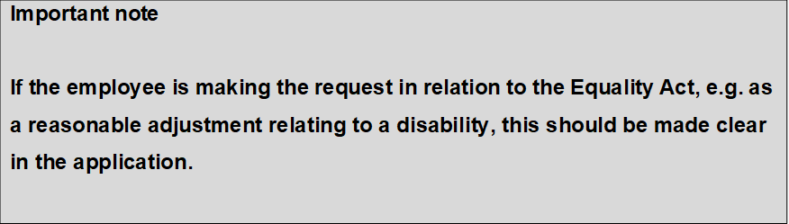

If an application does not contain all of the required information the manager will explain to the employee what additional or amended information they need to provide and ask the employee to resubmit the request.

Meeting to discuss a flexible working request

Upon receiving a written request for flexible working the manager will usually seek to arrange a meeting with the employee to:

  - discuss the request;
  - find out more about the proposed working arrangements;
  - consider how it could be of benefit to both the employee and organisation.

If a meeting is arranged, it will be held within a reasonable timescale of the manager receiving the request. Any delays must be discussed and agreed between the employee and the manager. Managers should approach this meeting openly and creatively and agree with the staff member and how any proposals are discussed with colleagues.

The employee will be given advance notice of the time, date and place of the meeting. If the initial date is problematic, then one further date will be proposed. If a face to face

meeting is difficult to arrange then, if agreed by the employee and the manager, the meeting may be held over the telephone or virtually.

At the meeting the employee may, if they wish, be accompanied by a workplace colleague or a trade union representative.

If the employee fails to attend a meeting and then fails to attend a rearranged meeting without good reason, their application will be deemed to have been withdrawn. In these circumstances, the manager must confirm in writing to the employee that they consider the application withdrawn.

A meeting may not be required if the request can be approved as stated in the employee's application. The employee will be informed of their manager’s agreement

to the request by a confirmation letter as outlined in section 8. All applications must be dealt with within a reasonable timescale and any delay must be agreed with the employee.

The line manager is not able to decline a request at this stage.

Responding to a flexible working request

The manager will consider the proposed flexible working arrangements, looking at the potential benefits, and potential impact, to the employee and to the Trust in implementing the proposed changes. If the manager needs support to implement agreed solutions efficiently, they should contact their HR representative.
Each request will be considered on a case-by-case basis. Agreeing to one request will not set a precedent or create the right for another employee to be granted a similar change to their working pattern.
If a line manager has not been able to reach agreement with the staff member on a solution within 14 days of receiving the flexible working request, they should escalate this to a more senior manager within their business unit who will consider the request and check for other possible solutions including whether the form of flexibility the individual is seeking could be accommodated in a different team, location or role. Requests should be agreed at the lowest level possible and line managers should inform employees what will happen when their request is escalated.
The line manager should contact their HR representative and the senior manager outlining why an agreement on a solution has not been reached.

It may be appropriate for the staff member to consider internal vacancies for prior consideration as well as review vacancies across the wider Leeds system on NHS Jobs. If required, an extension to the three-month time scale can be agreed between the employee and their line manager to allow further options to be explored in detail within the organisation.

Solutions agreed after exploratory or escalation stage will need to be documented appropriately. The employee will be informed in writing (appendix 3) of the organisation’s decision as soon as possible. If the individual has any protected characteristics under the Equality Act that are relevant to their flexible working request, the decision should include how these have been considered. Written reasons should record an assessment of the potential impacts of declining the request.
The request may be granted in full, in part or refused. The manager may propose a modified version of the request, the request may be granted on a temporary basis, or the employee may be asked to try the flexible working arrangement for a trial period. If the request is agreed then the employee will be sent a confirmation letter which will include details of the new arrangements. This should be returned to HR to be stored on the employee personal file.
The line manager should consider:

- the provisions agreed and what is changing: for example, change to number of hours, work pattern, work location, role and/or team
- any contractual changes which require HR and/or payroll processes
- how to log informal arrangements
- the duration of a temporary arrangement or whether it is a permanent change
- any agreed trial period – and how success of the trial will be determined any agreed review dates about how well the flexible working arrangement is working

Right to appeal
Employees have the right to appeal the decision if their request is refused or is only agreed in part. The employee must lodge an appeal within 7 days of being notified of a decision on their application. This should be done in writing and clearly state the grounds on which they are appealing. The appeal must be made to the next level of management within their department. The appeal should be heard within 14 days. The employee will then be informed of the outcome to their appeal within 14 days. These time limits may be extended with the agreement of both the employee and the manager. Appeals should

consider process compliance and whether all options have been fully considered as well as reviewing evidence on other options considered and all relevant background information.

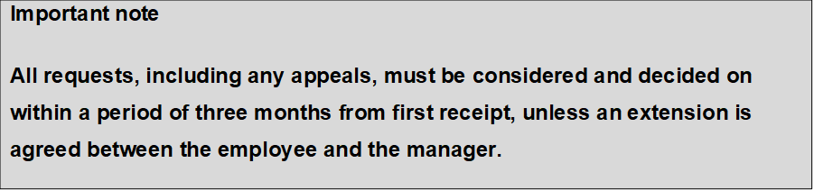

Appendices

APPENDIX 1 – Flexible Working Request Process
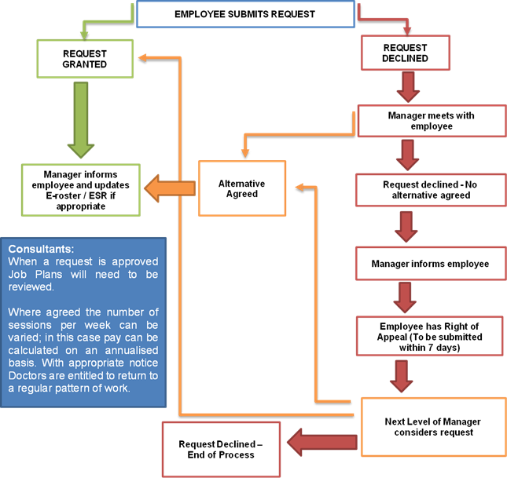



APPENDIX 2 – Flexible Working Application Form

Employee’s name: |  | Team/Dept:
Manager’s name: |  | Team/Dept:
I would like to apply to work a flexible working pattern that is different to my current working pattern under my right provided under section 80F of the Employment Rights Act 1996. I confirm I meet each the eligibility criteria as follows:
*this may be waived if applying for reasonable adjustments under the Equality Act 2010
Current working
pattern:
Proposed working
pattern:
I would like the new working pattern to
commence from:
Impact of the new working pattern
I think this change in my working pattern will affect me, service delivery and my colleagues as follows:
Accommodating the new working pattern
I think the effect on me, service delivery and my colleagues can be dealt with as follows:

Supporting information
Include any information that may help your manager understand the reason for the request e.g. caring responsibilities, adjustments related to a disability, flexible
retirement
Employee signature:
Date:
Date of receipt by manager:

APPENDIX 3 – Flexible Working Manager Responses Form

Applicant’s
name:
Job title: |  | Team/Dept.:
Decision maker /
line manager:
Request granted (see section A below):
I am unable to grant your request and propose an alternative (see
section B below):
Request declined (see section C below):
Section A - request granted
The contractual change/s listed below have been granted and will take effect from

… (date):
Contractual change/s:

I accept the above changes as an amendment to my existing contract of employment: | Signature of employee:  Date:

Section B – original request declined, alternative proposal
It has not been possible to agree to the exact terms of your flexible working request. The following suggestion is proposed as an alternative:
I do / do not accept the proposed changes to my existing contract of employment: | Signature of employee:  Date:
Section C – request declined
Your request to work flexibly has been declined and no alternative has been
proposed / agreed. The reason for the refusal is:
The costs associated with the proposed arrangement
Unable to reorganise work amongst existing staff
Unable to recruit additional staff
Detrimental impact on quality
Detrimental impact on performance
Detrimental impact on ability to meet client demand
Insufficient work for the periods the employee proposes to work
Planned structural change to the service

Further explanation:
Manager’s  signature: |  | Date:
You have the right to appeal this decision. If you wish to do so, please put the
reasons for your appeal in writing and return to me within 7 days of receiving this notification. I will ensure that it is passed to my manager for consideration.

APPENDIX 4 - Compressed Hours

Compressed hours allow an employee to work their hours over fewer days, for example a 9-day fortnight. An advantage of working compressed hours is that this allows an employee to retain their hours but allows them time off during the working week. A disadvantage may be that working longer days could be stressful for the employee.

When considering compressed hours, managers must ensure that the employee gets their statutory breaks in line with the Trust’s Working Time Regulations Policy. The non-working day would normally remain the same; however, this will depend on the needs of the service. This should be agreed between the manager and the employee before agreeing to the change in terms and conditions.

Annual leave and public holidays
Annual leave and public holidays are calculated in hours for staff who work non- standard shifts. When taking annual leave the actual amount of hours that would have been worked that day must be deducted from the annual leave allowance, e.g. if an employee works a 9-day fortnight the hours worked each day will be 8 hours 20 minutes. When taking annual leave 8 hours 20 minutes must be deducted from the employee’s annual leave allowance rather than the standard 7 hours 30 minutes.

When entering the annual leave onto ESR, 8 hours 20 minutes would equate to 8.33. This also applies when bank holidays fall on a working day.

APPENDIX 5a – Flex-Time

The aim of flexi-time is to provide a degree of freedom for staff to determine the pattern of their working day. All patterns of working must be discussed and agreed with the manager since the needs of the service are the main consideration. Flexi-time is available to full- time and part-time staff.

Those teams of staff working under a flexi-time arrangement should each take an equitable share of responsibility for covering the service during normal working hours. All core hours must be worked. Core hours will be determined locally by departmental managers. When considering flexi-time, managers must ensure that the employee gets their statutory breaks and working patterns are in line with the Trust’s Working Time Regulations Policy. Flexi-time does not permit a member of staff to permanently adjust their start/finish times if this means the service will be left without cover during normal service hours.

Whilst flexi-time can be used to flex start and finish times, it is not the purpose of flexi- time to enable staff to routinely accrue additional time off. Being required to work beyond the

normal working hours to meet service demand on an ad-hoc basis should be dealt with as lieu time (appendix 9).

Accrual of hours
The flexi-time system is based on a four-weekly cycle. For full-time staff, up to 7.5 hours credit (pro-rata for part-time staff ) can be accrued in each four-week cycle. No more than 15 hours credit (pro-rata for part-time staff) can be accrued in total and taken within a 4- week cycle. The employee must seek approval from their manager before taking accrued flexi-time back.

Employees cannot carry forward a minus hours figure of more than 7.5 hours for more than one 4-week cycle. Any deficit must be worked back before the end of the next four- week cycle. Annual leave should not be used retrospectively to ‘pay back’ deficit hours accrued under the flexi-time arrangement.

All staff utilising flexi-time must keep an up to date record of hours worked on a daily basis, using the flexitime record (appendix 5b). The manager must check and approve the sheet on a monthly basis. The manager will store forms electronically for 3 years. The manager will use these to monitor patterns of work.

APPENDIX 5b – Flex Time Record Sheet

Name: |  |  |  | Job Title: |  |  |  | Dept:
Date | Month Day | H/T/S | Start | Lunch Depart | H/T/S | Lunch Return | Finish | AM | PM | Total | Total Weekly | Total  in Period
 | Mon.
 | Tues.
 | Wed.
 | Thurs.
 | Fri
 | Sat.
 | Sun.
 | Mon.
 | Tues.
 | Wed.
 | Thurs.
 | Fri.
 | Sat.
 | Sun.
 | Mon.
 | Tues.

Wed.
Thurs.
Fri.
Sat.
Sun.
Mon.
Tues.
Wed.
Thurs.
Fri.
Sat.
Sun.

APPENDIX 6 – Home Working

Home-working is when an employee regularly carries out all, or part of, their duties from home rather than from a Trust base. Home-working can be considered as an occasional agreed day, a mix of home and office-based work each week or a full- time arrangement.

Considerations for homeworking
Management of staff Supervising homeworkers can be more difficult than overseeing staff in an office or base. A supervisor and home-worker may have to work harder to build trust between them. Managers must ensure that an agreement is in place for regular contact and agree when the employee must attend work, e.g. to attend team meetings, appraisals, one to one meetings. Serious consideration needs to be given to prevent isolation.

Development Managers should ensure that home-workers are given the same development opportunities as other employees, for example promotion opportunities and training.

Employee wellbeing Managers should ensure they take responsibility for assessing health and safety of home-workers. A work-station assessment may be required as for a member of staff who works from a Trust base. Home-workers can still access, and should be made aware of, staff support services.

Caring responsibilities It is assumed that, when working from home, an employee will not have responsibility for a dependent. Any domestic and/or caring emergencies should be managed in line with the Trust’s Special Leave Policy.

Ill health It is assumed that, when working from home, an employee is fit to work. Ill health should be managed in line with the Trust’s Managing Attendance Policy.

Maintaining confidentiality Employees who request to work from home should provide assurances that confidentiality will not be compromised by other people within the home. Employees need to ensure that non-work related distractions are minimised.

Working hours The manager will need to be clear about what core hours the employee will be required to work. This may be a standard working day, or may have some flexibility to allow working during weekends and evenings for instance.

Equipment and resources The use of mobile phones and laptops has made working from home more accessible, however, consideration should be given to any other equipment the employee may require.

APPENDIX 7 – Job Sharing

A job-share is where two individuals on the same grade carry out the full range of duties and responsibilities associated with one full time post. This could occur when an existing member of staff wishes to work on a part-time basis, following maternity leave or as a flexible retirement option, for instance, and where it is not possible to reduce the number of hours required for that post. Job-sharing can also be an excellent way in which to retain and attract high quality employees who would not otherwise be available for work.

Job-sharing differs from part-time working in the sense that the duties of the role are shared between the job-sharers. For instance, they may share a full-time clinical caseload whereas two part-time employees will have separate clinical caseloads.

For a position to be deemed a job-share the following conditions must be adhered to:

- Both members of staff must be on the same salary scale, although they can be on different incremental points.
- The hours of work can be shared in a number of ways, the most popular being 2.5 days each or 3 days and 2 days. This should be negotiated with the individuals concerned and the manager and any agreement must meet the operational needs of the service. It is essential, where possible, to have a short period of overlap to ease communication and ensure continuity.
- Annual leave and bank holidays should be aggregated and allocated on a pro- rata basis.

Any post in the Trust, whether vacant, new or established, may be considered eligible for job-sharing if service needs can be met. Managers should therefore consider applications for vacancies and requests for conversion to job-sharing of established posts on a case by case basis, using the criteria laid out within this policy.

Where the manager agrees to consider a request for job-sharing from an existing full- time postholder, the post should move to advertisement and single job share applications invited as appropriate. It would be reasonable to advertise the post no more than twice in a twelve-month period.

Only when a compatible candidate is appointed will the existing employee be able to commence job sharing.

Two existing employees, who carry out the same role, may approach their manager to make a flexible working request as a joint application to job-share either of the posts held by them.

If one employee makes a job-share request that the manager wishes to consider, the manager should advertise the post as one half of a job-share and any appointment will be on the basis of suitability for the role. In determining the suitability of a job-share partnership, the selection panel must also be satisfied that the proposed pattern of working meets the demands of the post. It is advisable that prospective job-sharers meet each other before the selection stage, preferably after short-listing.

Each job share partner will have an offer letter and Statement of Particulars. The post holders’ job titles will be that given to the full time job with the endorsement “job share”. The recruiting manager must ensure the Recruitment Team are aware that the post appointed to is a job-share.

Job-share staff have the same employment rights as an equivalent full-time post holder –
e.g. promotion, access to training and development. However some rights will be on a pro rata basis e.g. annual leave.

Job-share partners may be asked not to take leave at the same time to ensure continuity of service.

If for any reason one partner in a job share arrangement leaves, discussions will take place with the remaining post holder as to hours to be worked. If the remaining job

share partner does not wish to work full- time, the single job share post will be advertised following normal procedures.

When, after all reasonable efforts, another suitable job share partner cannot be found and it is necessary to cover the post full- time, the remaining job share partner will, wherever possible, be redeployed to another suitable post accommodating as far as possible the hours of work already agreed.

APPENDIX 8 – Term Time Working

An employee working on a term-time contract is contracted to work for 39 weeks per year. All work is carried out during the school term. All annual leave must be taken during school holidays. Annual leave must be booked through ESR and allocated to school holidays.

The employee’s salary is calculated pro rata for 39 weeks per year and is paid in 12 equal monthly instalments throughout the year. The salary includes a payment for pro rata annual leave and bank holidays. All other terms and conditions remain the same.

Sickness
If an employee reports as sick during a period of allocated annual leave they must report in line with the Trust’s Managing Attendance Policy. The annual leave can then be claimed back but must be reallocated to another period within the school holidays.

Payment of Term Time salary
The following example is based on a member of staff working 20 hours a week and who has 27 days annual leave.

N = Contracted weekly hours = 20

T = Number of weeks to be worked (52 minus 13 weeks school holidays) = 39

Y = Standard holiday entitlement in weeks including general and Public Holidays = 7
(27 days annual leave plus 8 days general Public holidays)

F = Number of weeks in the year less annual leave entitlement = 52-Y = 45

Using the above data and the formula N x T x Y this gives an annual leave
F
entitlement of:

20 x 39 x 7 = 121 hours

This can then be added to the 39 weeks of actual working time (39 x 20 = 780 hours) to produce a total of 780 + 121 which comes to 901 paid hours over a period of 45 weeks.

This means that the member of staff will be paid for working the equivalent of 45 weeks on a part-time basis over the period of one year, inclusive of annual leave.

Payment will be made in twelve equal payments. This payment is calculated on the average number of hours worked per week i.e. 901 hours per annum divided by 52.143 (weeks in the year).
This comes to an average of 17.25 hours per week.

APPENDIX 9a – Time Off in Liew (TOIL)

Staff may accrue time owed to them when there is an organisational requirement for them to work beyond their normal contracted hours. As managers have a duty of care to those within their teams, working additional time should normally be with the prior agreement of the line manager. It is recognised, however, that sometimes additional work can arise unexpectedly and urgently. In such cases, staff should inform their manager of the additional working time needed and utilised, as soon after the occurrence as possible.

Time owing does not attract any proportional increase for time owed during periods that attract an enhanced payment.

Time owing should not normally be accrued for a period greater than one standard working day at any one time. Owed time should be taken within 4 weeks of its accrual where operationally possible.

A time owing sheet must be completed each time a person accrues time owing or takes time back. See Appendix 9b for the record sheet.

The time owing sheet must be authorised by the manager. Time owing cannot be claimed back without the manager’s authorisation.

APPENDIX 9b – The Owing Sheet (Individual Record)

Name………………………………………………………………………………

Department………………………………………………………………………

TIME OWING |  |  | TIME TAKEN BACK
DATE | HOURS | REASON | DATE | HOURS | BALANCE | AUTHORISED SIGNATURE
 | BROUGHT FORWARD FROM LAST SHEET

CARRIED
FORWARD………………………………………………………………………

APPENDIX 10 – Flexible Retirement

Flexible retirement is defined as flexibility regarding the age at which an employee retires, the length of time an employee takes to retire or the nature and intensity of work in the lead up to final retirement. Flexible retirement arrangements will deliver one or more of the following benefits:

- retention of experienced staff with valuable skills;
- greater choice for employees;
- the creation of a wider pool of expertise for recruitment;
- a strategic and effective response to demographic change;
- equality of opportunity and fairness for all employees.

The options for flexible retirement will depend on which pension scheme you are part of but can include:

Step down Employees opt to step down to a less demanding and lower banded post to reduce the level of pressure and responsibility whilst remaining an employee of the Trust.

Wind down Employees can opt to wind down by working fewer days and/or hours in their current post.

Retire and return Employees who have reached the minimum retirement age can opt to retire, take their pension benefits and return to work within the NHS.

Draw down Employees can take part of their pension benefits whilst continuing to work for the Trust.
Late retirement enhancement Employees can choose to retire later than the normal pension age and have their pension benefits increased by the application of late retirement factors.

Early retirement reduction buy out Employees can choose to pay additional contributions to buy out the reduction applied to their pension if they choose to retire before their normal pension age.

Available options are dependent on the Pension Scheme you are a member of. Anyone wishing to explore possible flexible retirement options is strongly advised to contact the Pensions Department on 0113 2066289 for further advice.

