

Appendix 4

Information to be sent to Managers on the testing procedure for Drugs/Alcohol

Dear Colleague

The attached information and consent form (pages 1 and 2) is a copy of the one we give to all clients for whom we are testing either for Drugs or Alcohol. In either case, this is part of the Occupational Health Service (OHS) commitment to support staff through a programme of rehabilitation and is being undertaken with your knowledge and in line with the Trust’s Alcohol, Drug and Solvent Abuse Policy.

Unfortunately, on occasion, the testing process is bound to have a detrimental effect upon your service, one which we will endeavour to minimise, but it is not one we can remove altogether. This will be caused as a result of our need to call the staff member to attend OHS for either drug or alcohol testing under random conditions which by default means very short notice. As it has to be completely random without any pattern the sampling can take place at any time of the day and on any day of the week, it could happen several times in the same week or weeks apart according to individual circumstances. The particular pattern will not denote a problem, just how the testing has been programmed.

In the event we cannot contact the individual staff member via a previously agreed number we will notify you of this via email. This will have already been made known to the individual through the consent process (see above)

The purpose of contacting you is both to inform you but also to enable you to confirm or otherwise the individuals actual availability, i.e. short term sickness, pressure of work etc.

We apologise in advance for any inconvenience this may cause you and, in the event of a real problem, you can notify us yourself that the staff member who may be willing is unable to attend due to the needs of the service. We do hope however that in an attempt to support your member of staff this should not happen too often.

Our commitment is to keep supporting your staff as long as is required and feels necessary and to keep you notified in the event of any problems.

Random testing should always be viewed as only one part of the supportive rehabilitation process that should be taking place within the workplace - it is not a substitute for management decision-making. In the event an individual attends for work and appears to be under the influence of either drugs or alcohol, management /HR action needs to be taken as per the existing Trust policies.

On behalf of the Occupational Health Service

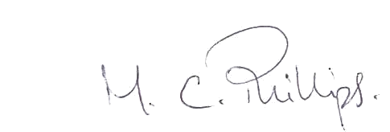

Margaret Phillips
Clinical Services Manager
Occupational Health Service

