Health Equity report 2025-6

- Annual health equity statement

This is our response to the Statement on Information on Health Inequalities, outlining the extent to which we have exercised our functions in line with the 5 domains:
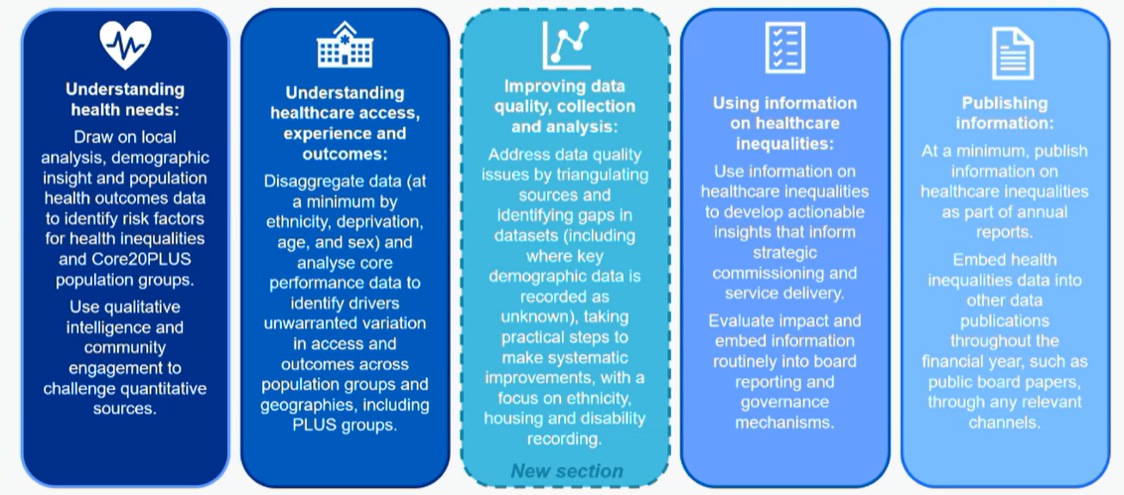

It also demonstrates how we meet our statutory duties relating to health equity:
- Public Sector Equality Duty to have due regard to the need to eliminate discrimination, advance equality of opportunity and foster good relations between different people when we carry out activities. Our Equity and Quality Impact Assessment goes beyond the removal or minimisation of disadvantages on the basis of protected characteristics to align with NHSE Equality and Health Inequality Assessments, including focus on deprivation, health inclusion and other groups at risk of worse health outcomes. These are also included in equity impact assessments in policy development and review.
- Accessible Information Standard to identify, record, flag, share, meet and review the communication needs of people with disabilities and sensory impairments which is being delivered through our ‘About Me’ project and a range of communication improvements, supporting Leeds-wide commitment to improving “the 3Cs” – communication, compassion and coordination.
- Equality Delivery System (EDS22), the national framework for assessing equality in the NHS, with Domain 1 focussed on commissioned services and this year included 0-19 service, Long Covid Rehabilitation Services and, Seacroft and Crossgates respiratory pilot, rated as ‘Achieving’ and with associated improvement plans relating to data availability and analysis, cultural competency and 3rd sector engagement.
- Patient and Carer Race Equality Framework (PCREF), the anti-racism framework for mental health services, which in LCH relates directly to Leeds Mental Wellbeing Service and Children and Young People’s Mental Health Services although our own Racial Equity in Care improvement work has been extended across all services, with improvements focussed on lived experience, data and analysis, culturally appropriate service delivery including interpreting and translation.
- Armed Forces Covenant to have due regard to the principles of the covenant for currently serving members of the UK Armed Forces (regular and reserve), veterans and family members and ensure they are not disadvantaged as a result of their service. This work is aligned to our VCHA accreditation and associated workplan, focussed on raising awareness of the needs of the Armed Forces community and data quality improvements to enable analysis of key performance metrics.

- LCH’s commitment to identifying and addressing inequity in care and pathways
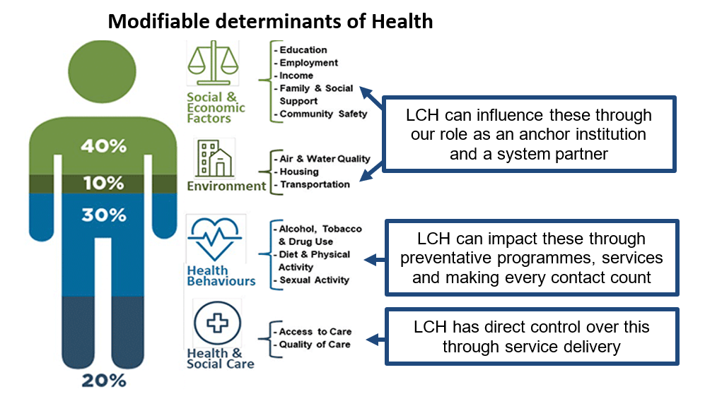
Our Health Equity strategy and plans are LCH’s response to how we address unfair and avoidable differences in the health of different groups and communities, by working with communities and partners to create equitable care and pathways. We recognise the range of modifiable determinants of health and contribute where we are able, for example Making Every Contact Count conversations can contribute to improvements in social, economic and environmental factors, working with partners as a Marmot city to create a fairer, healthier Leeds, and our equity improvement in children’s services contributing to addressing inequity in educational attainment. This report, however, focusses on our priority to identify and address inequity in care and pathways, being the areas over which we have direct control.

Equitable approaches in care are dependent on culturally diverse and competent workforce, policies and processes. As inclusion objectives are already in place in the workforce strategy, this work is therefore not duplicated within our Health Equity strategy, plans and reporting.

Our first Health Equity strategy ran from 2021-4, extended with two additional annual plans. In 2025, we developed a new five-year tactical plan for health equity, to sit under the developing trustwide five-year plan.

In 2021 LCH determined that, due to the importance of the health equity agenda in everything that we do, Board should have direct oversight of the health equity programme. Aligned to the decision to make this a fifth strategic goal in 2023, equity risks (BAF7) are managed by Quality Committee and an equity question has been added to the Board and committee cover paper template to support chairs to monitor their committee performance and content against equity. Delivery of statutory equity requirements are reported through Quality Assurance and Improvement Group (QAIG), to Quality Committee and onto Board.
Alongside the inclusion of equity in governance mechanisms, equity is considered in other workstreams. For example, in each Quality and Value Board agenda there is an ‘equity, quality and finance pause’, adapted from the Virginia Mason Institute Equity Pause tool that specifically asks attendees to raise any equity implications that haven’t been discussed or addressed yet in the meeting.

- Understanding our population and its health needs

We work with public health colleagues, statutory and third sector providers and communities to develop and use a shared understanding of population needs. This year, this has included a joint presentation to Leeds Adults, Health and Active Lifestyles Scrutiny Board, and using the Director of Public Health Annual Report ‘Heat in our city – our health in a warming Leeds’ to focus advice and support for patients most vulnerable to the impact of heat on health. Using national and local data sets such as Leeds Observatory along with our own equity dashboards, which can be analysed at service, business unit and trust-wide levels, we are able to identify population groups at risk of worse access, experience and outcomes. This quantitative data is triangulated with qualitative insight through our own feedback and engagement mechanisms, along with sources of existing insight such as West Yorkshire Insights Library and Healthwatch Leeds, including the How Does It Feel For Me videos and engagement and partnerships with FRESH (the Forum for Race Equality in Social Care and Health), Synergi Leeds and its Exhibition - Remembering What's Forgotten and partnership Boards such as Leeds Migrant Health Board. This year we also commissioned Healthwatch for a community engagement project on the future of community health services in Leeds. In this work, they intentionally oversampled people who are seldom heard, including ethnically diverse communities.

As a result of this work, we take an intersectional approach to equity improvements, but with an initial focus on improvements to access, experience and outcomes for:
 | Supporting us to deliver
People living in deprivation, incorporating inclusion health groups | Leeds ambition to improve the health of the poorest the fastest  Core20PLUS5 (Adults and Children)
Racialised communities | PCREF  NHSE interpreting and translation improvement framework  NHSE ethnicity recording improvement plan
People with disabilities, sensory impairments and Learning Disabilities | Accessible Information Standards  Reasonable Adjustments  Learning Disability Standards
Armed Forces community | Armed Forces Covenant

Alongside targeted work with these populations, our improvement work also addresses common risk factors such as digital exclusion and health literacy. An ongoing programme of health literacy awareness training supports this improvement work.

- Using data and insight to understand access, experience and outcomes

We have developed a suite of equity reports and equity lenses within performance dashboards. This enables us to routinely disaggregate our data to identify variation across population groups at service, business unit and trust levels. It is a self-service model, enabling services and trust leads to understand our baselines, and track changes across time. Due to the range of equity improvement being delivered at the same time, it is not possible to use this data to identify the impact of individual changes but does help us identify where changes to existing improvements or additional changes are required.

Deprivation data being used in the trust and presented in this report is based on IMD 2019. We are currently planning the implementation of IMD 2025.

4.1 Integrated Performance Report
Disaggregated data is embedded into the effective domain for our performance reporting on average length of wait for consultant-led 52-week and 18-week standard, and non-consultant led 18-week standard services, as an odds ratio for people in IMD1 compared to IMD2-10.

This data has driven equity considerations in operational priorities including the Access LCH work on improving waiting times and associated resource for improvements, such as admin phone calls with people in IMD1 who have missed appointments.

4.2 Patient Safety Incident Response Plan
Patient safety incidents relating to Trust priorities around falls, pressure ulcers and medication are analysed by IMD, ethnicity, Learning Disability and interpreter requirements with escalations reported through QAIG into Quality Committee and onto Board. Consideration of this equity data has driven improvements in person-centred care, for example, the development of Easy Read leaflets on what to do if you have a fall, preventing falls in a care setting and at home.

- Improving data quality, collection and analysis

  - About Me
Preparation for the implementation of the Reasonable Adjustments Digital Flag, internal audits, data analysis, learning from patient safety incidents and delivery of health equity, learning disability and digital workplans identified a range of improvements needed around the recording and timeliness of demographic/equity data. Previously, this was collated through multiple different templates and did not include parent or carer communication needs separately to the needs of the person receiving care.

We therefore identified the need for a co-ordinated approach to collating and reporting on completion of this information and the point at which it was being recorded. This has led to the development of the new ‘About Me’ template on our Electronic Patient Record. Launched in January 2026, it is accessed through a one-page visualisation tool (screenshot below), with additional templates linked to it. We are therefore now recording:
- Language (spoken and read) and interpreter requirements
- Reasonable Adjustments
- Literacy and numeracy
- Digital ability
- Equality and Diversity
- Armed Forces status
- Personal Emergency Evacuation Plans
- Carers’ needs

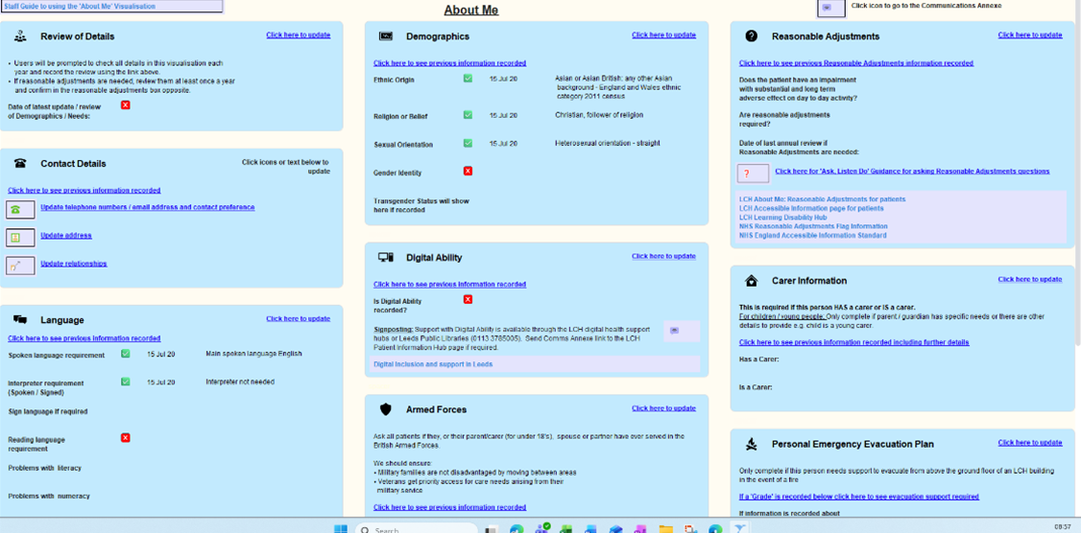

The new additions of information about digital inclusion, literacy and numeracy support recording of socioeconomic risks. The template includes links to further guidance and indicators of the date it was last completed and whether information is missing. We are working towards completion as soon as possible after referral and reminders will prompt staff at future contacts such as phone calls or appointments, of missing information, or when a review is required.

The next phase of development is the introduction of a digital patient questionnaire, where patients or carers will be able to complete this themselves, so that staff can target support for completion with patients who are digitally excluded. This is being developed to improve the timeliness of recording, so that communication and digital needs can be met from the beginning of a patient’s journey, and data quality and therefore analysis of waiting list data is improved. This is hampered when details are not recorded until an appointment is made or only asked at the first appointment. We also anticipate the questionnaire will lead to an improvement in data quality and accuracy, as this introduces direct patient self-reporting and removes the risk of inaccuracies in transposing data from one source to another.

5.1 Ethnicity
Our ethnicity data (fig 1) shows that at 94.2% we are significantly above the national benchmark (71.6%) for community trusts in ethnicity data with valid ethnic group codes. We have no patient records with null or blank ethnicity codes. However, we want to continue to increase the level of recording and are aligning our improvement work to the national Ethnicity Recording Improvement Plan, using the 5 domains for improvement and assessing ourselves against the high impact actions for providers. Our Cultural Conversations programme supports staff to be more confident and skilled in talking about ethnicity and our About Me project increases patient and carer awareness of the purpose of recording data and trust in how it is used.

Figure 1 Percentage of records with valid and residual ethnicity codes
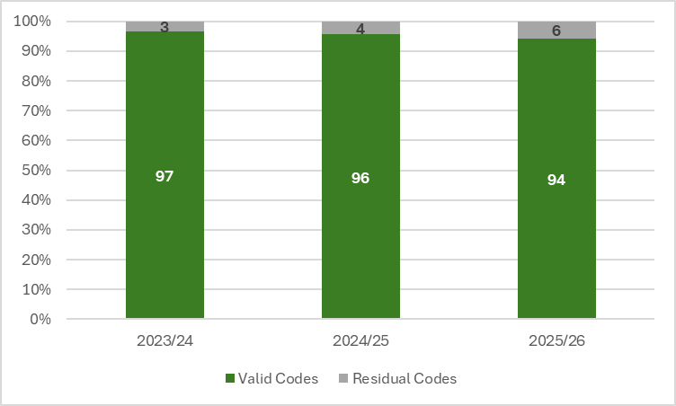

5.2 Interpreter requirements
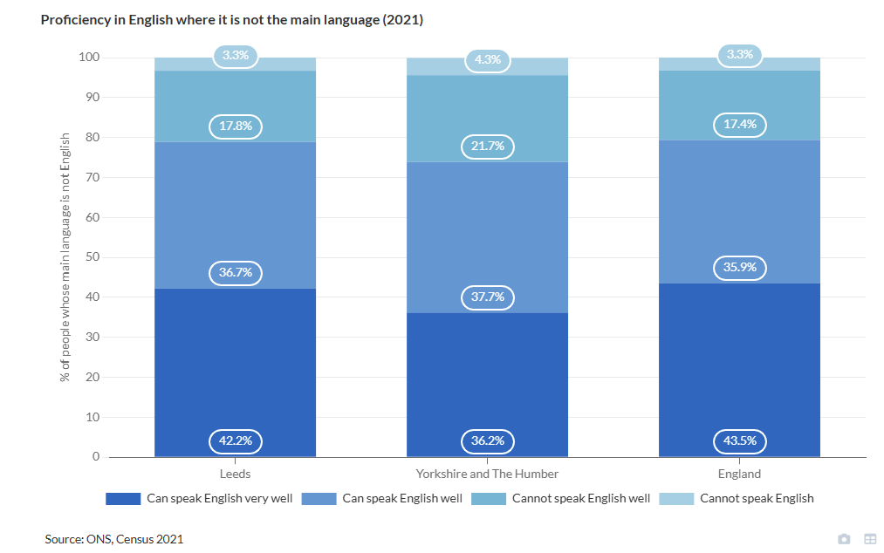
9% of the population of Leeds does not have English as their main language, with 1.9% (14.9k people) of the Leeds population who cannot speak English or cannot speak English well (Population - UTLA | Leeds | Report Builder for ArcGIS).

Aligned to delivery of the national improvement framework for community language, translation and interpreting services, we continue to improve our recording of interpreter requirements, including differentiating between spoken and read language. The reporting currently being developed will enable us to triangulate our recorded interpreter requirements with the Leeds population and interpreting provision. Improved data quality will also increase confidence in disaggregation of other data by interpreter requirements, which in turn will help us improve access, experience and outcomes for people with limited English proficiency.

5.3 Development of other equity lenses
We have also started to explore recording and analysis of other equity lenses including housing status. This is planned to align with changes being made by SystmOne making it possible to remove read codes when they no longer apply.
5.4 Data processing and analysis
Data on patient characteristics is collected in our clinical information systems. Patient characteristic data is processed through our warehouse and made available as filters on many reports published via our internal reporting functionality PIP (Performance Information Portal). Completeness of these data is examined via our data quality dashboard where it is monitored and action take to improve completeness started where needed. There is ongoing work to improve the quality, completeness and scope of these data as described in section 5.1.

Some groups at risk of worse health outcomes are not available in trust or local data sets, for example inclusion health groups. To mitigate the risk of being driven solely by quantitative data, where some groups are not visible, this is supplemented by partnership working and qualitative insight from communities. For example, membership of the Migrant Health Board helps us understand and address inequity for vulnerable migrants, including refugees and people seeking asylum.

5.5 Health Equity Index
Despite the increased availability of data broken down by a range of equity lenses, analysis of equity data continues to be challenging, particularly in knowing where to focus our energy, attention and resource to improve equity and in understanding how we are doing as a healthcare system on addressing inequity.

Currently, analysis involves examining multiple variables with multiple categories. This can make it challenging to understand the impact of intersectionality, to monitor changes or improvements over time, and to understand the significance of the differences we observe within the data. It is also inherently difficult to get an overview of progress and compare across different types of metrics. We are therefore working with other healthcare system partners in Leeds to implement the Health Equity Index. This will simplify equity data reporting and make interpretation, comparison and tracking progress over time more accessible.

The Health Equity Index is a strategic tool for measuring and embedding equity in healthcare performance. This tool was initially developed by the London Northwest University Healthcare NHS Trust and Imperial College London, as a statistical methodology that supports users to have a measure of equity embedded within clinical performance metrics. The health equity index analyses inequity within a measure against a range of selected variables. It provides a score between 0 (equity) and 1 (inequity) and can be applied to a wide range of clinical performance metrics to give end users a sense of equity within that measure as well as across multiple measures.

- Using information on equity to develop actionable insights

  - Operational priorities
Over the past year, LCH has made significant progress in reducing the number of patients experiencing the longest waits. In January 2025, more than 6,000 patients were waiting over 40 weeks for an appointment across LCH services. By March 2026, this has reduced to around 1,300 patients – representing a reduction of almost 80%. An interim evaluation in March 2025 of the Access LCH initiative to reduce waiting list sizes, identified that there had been an 8% reduction in IMD2-10, but 5% in IMD1. Targeted work has therefore been undertaken this year to improve access through reducing missed appointments and supporting attendance. Our end of year position (fig 2) now shows a decrease in likelihood of patients in our most deprived areas (IMD1) waiting longer for consultant-led services, although non-consultant led services remain above target, with patients in our most deprived areas still likely to wait longer than the rest of the population. We continue to monitor the impact of our equitable access work and will complete a deep dive in Q1 2026/7 to understand if improvements are being sustained and identify further areas of focus.
Fig 2
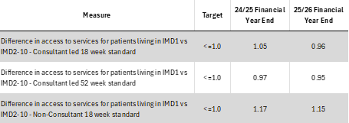

In our Access LCH programme, through our focus on the average length of wait for people in IMD1, what is causing this and what can be done to address it, we identified that higher rates of missed appointments in IMD1 (fig 3) were contributing to longer waiting times, rather than differences in the rates of being invited to appointments.

Fig 3
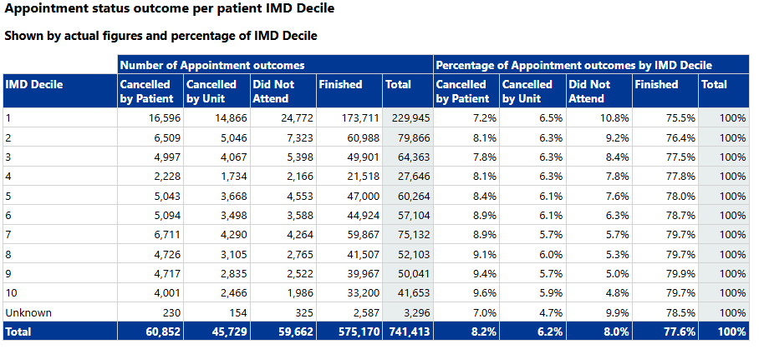

There is intersectionality between deprivation, ethnicity and English-language proficiency, with IMD1 areas being more ethnically diverse than the Leeds average. We have therefore undertaken analysis by aggregated ethnicity and begun to identify further improvements that specifically address the barriers for people in minority ethnic groups and people with limited English proficiency.

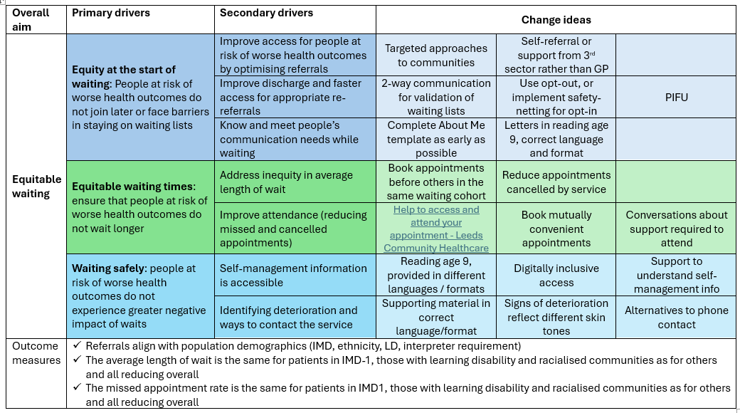

  - Core20PLUS5 (Adults)
Our health equity commitment is to embed equity in everything we do. This means that all services are included in equity analysis and consider equity in service planning and delivery. Alongside this, there are some services which contribute to the key clinical areas in the national Core20PLUS5 approach for adults.

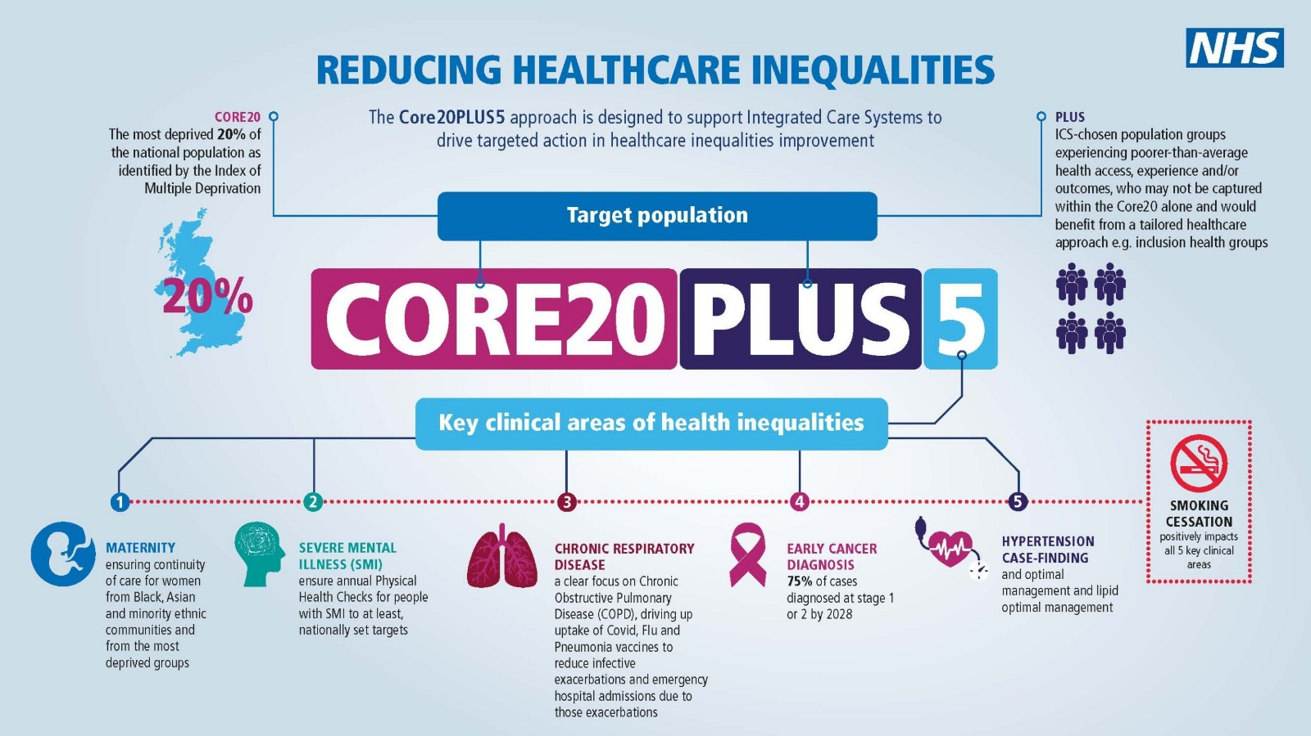

    - Mental health

Equity data up to Q3 can be viewed on the interactive visualisation of the quarterly data for NHS Talking Therapies Services. The full annual data set will not be available until the national data is published later in 2026.

In addition to LMWS delivery of their service-specific equity improvement plan, this year we also held an engagement event around Black men’s mental health, particularly focussed on ‘how do you know if care is taking your culture into account?’. This brought together community members and health services to understand what makes a good, culturally competent conversation about mental health. The learning applied not only to mental health services, it also related to other services who may be in a position to signpost people to mental health support, and this would be more effective with more culturally appropriate conversations.

    - Respiratory disease

To support equity in access, experience and outcomes for people with Learning Disabilities, the Community Respiratory Service has developed a range of Easy Read leaflets including ‘How I look after my COPD’, Respiratory Team Service, Home Oxygen Service, Home Ward Respiratory, Pulmonary Rehab and ‘What happens after pulmonary rehab’. These can also be used to support people with low levels of literacy, and the simplified language can support accuracy of translation.

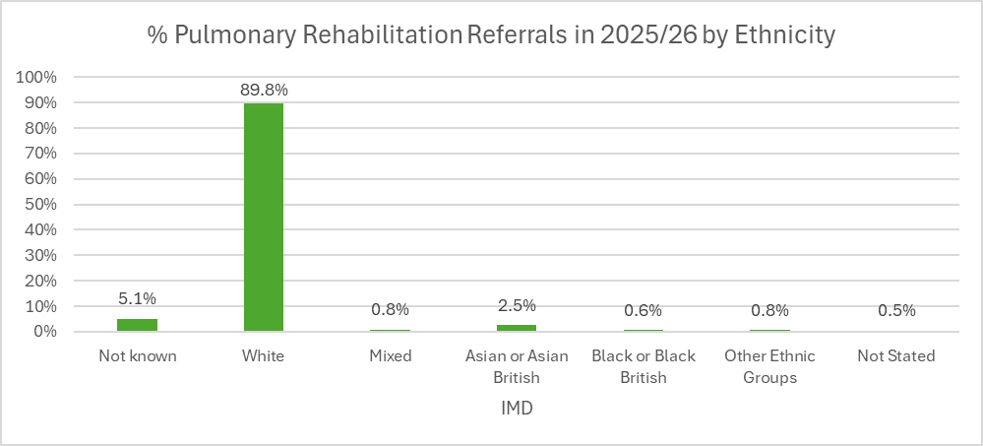

    - Cardiovascular disease
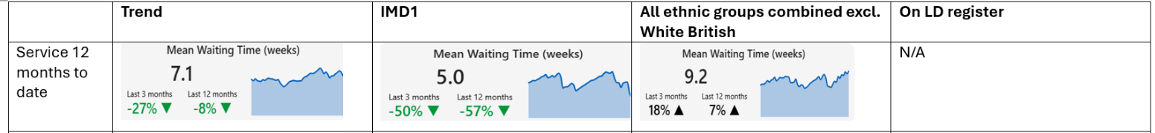
Mean waiting times across the service have improved, with a significant reduction in the last three months following the use of locum staff. Waiting times for patients living in IMD1 areas have also reduced significantly over the past year and are now well below the service average. The service is currently exploring ways to better prioritise patients from IMD1 areas on the waiting list, with the potential to offer appointments ahead of others within the same clinical priority cohort.

Patients from non-White British ethnic groups currently have a mean waiting time around two weeks longer than average. Ethnicity is recorded at the point of assessment, and the service is exploring whether patients from BME backgrounds could be prioritised within the same clinical priority cohort. The service is also reviewing ways to reduce appointments cancelled by the service for this group. There is insufficient data to identify trends for patients on the LD register; however, due to the small size of the service, the team will look to prioritise appointment booking for these patients where possible.

DNA rates have remained largely stable overall, reflecting ongoing work within the service to reduce missed appointments. However, rates have increased slightly for those living in IMD1 areas. As part of the Quality and Value programme, the service is exploring different methods of communication and will begin working with patients from these groups to book mutually convenient appointments to better understand what works for them. The service is also reviewing the potential for more flexible appointment options, including the introduction of additional out-of-hours clinics where feasible. In addition, the service plans to engage with patients from IMD1 areas, non-White British backgrounds and those on the LD register to better understand potential barriers to attendance and inform future improvements

To support equity in access, experience and outcomes for people with Learning Disabilities, the Community Cardiac Service has developed a range of Easy Read leaflets including Heart Failure Nurse Service information, Cardiac Rehabilitation, ‘what is a heart attack’ , ‘how to use a GTN spray’, ‘exercises for your heart, cardiac occupational therapy and a heart failure traffic light tool. These can also be used to support people with low levels of literacy and the simplified language can support accuracy of translation.

    - Learning disability and autism

The organisation continues to strengthen care for people with a learning disability through a structured workplan for the Learning Disability Improvement Standards, with progress reported through the Safeguarding Committee. Improvements include:
- inclusion of a dedicated section on considerations for people with a learning disability deterioration policy in the deterioration policy
- securing access to suction equipment for people with a learning disability
- updates to the “What Makes Good Care” chart to enhance signposting for people, families, and carers
- a dedicated nail surgery pathway for people with a learning disability within the Podiatry service

Learning from the lives and deaths of people with a learning disability and autistic people (LeDeR) is fully embedded within the organisation’s mortality reporting and review processes, leading to improvements in practice through:
- Availability of Restore2 training to staff within community teams
- Mapping and production of easy-read materials against all documentation
- Prompts on the clinical system for staff to alert the Named Nurse for Learning Disabilities to support mortality reviews and promote organisational learning

  - Core20PLUS5 (Children and Young People)

Our focus on equity for children and young people is supported by partnership working in Leeds’ Best Start and Beyond Alliance and the 0-5 years priority in the Marmot city work. This strategic framework drives improvement actions relating to:
- Preparation for parenting, and parenting support
- Healthy preconception and the first 1001 days
- Speech language and communication
- Oral health
- Healthy weight
- Early years education attainment
- Housing

Targeted approaches that address inequity for children and families at risk of worse health outcomes are integral to our universal children’s services, such as the delivery of the national Healthy Child Programme by the 0-19 service. The team now also has a direct referral route to Leeds City Council’s Financial Inclusion team to support families who would not seek help directly themselves, resulting in over £133,000 of income generated through benefits entitlement advice and grant applications, and 67% of clients being from culturally diverse communities.

Alongside this focus in all our children’s services, there are some services which contribute to the key clinical areas in the national Core20PLUS5 approach for children and young people.

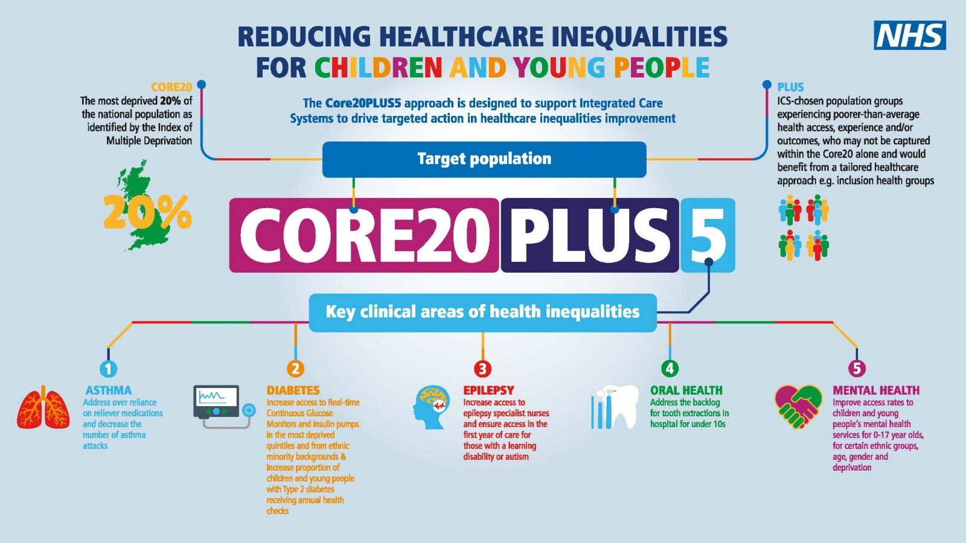

    - Community dietetics
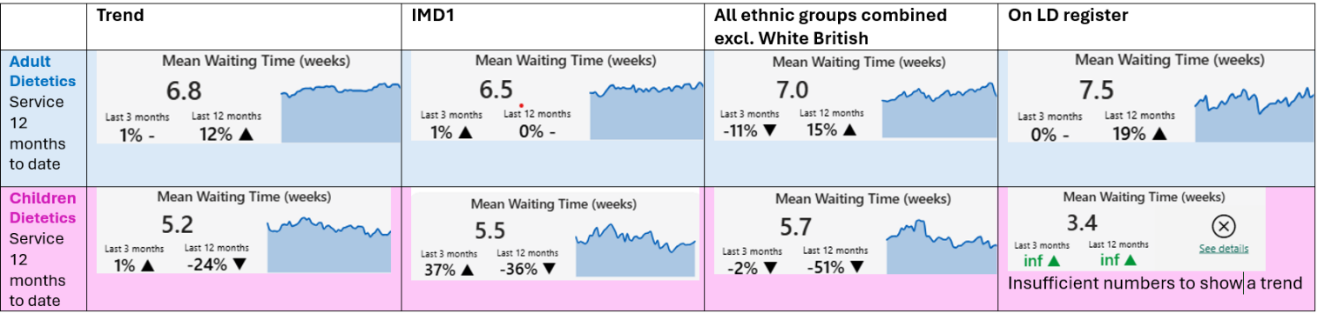
Mean waiting times show that patients from IMD1 areas and those from non-White British ethnic groups are accessing the Dietetic Service within a similar but slightly longer timeframe to the overall service mean waiting time. Due to insufficient numbers, meaningful trends cannot currently be identified for those on the LD register. The service operates city-wide and has consciously located a higher proportion of face-to-face clinics within areas of higher deprivation to support access.
As an opt-in service, the team has recently reviewed opt-in rates by deprivation and ethnicity. Analysis shows that the proportion of patients not opting in has reduced at a similar rate for IMD1 compared with all areas, indicating that the health inequalities gap is not widening. Additionally, a larger reduction has been seen in the number of non-White British patients discharged due to not opting in, suggesting that more people from these groups are engaging with the service and that accessibility may be improving.
Non-attendance rates have increased slightly over the past year across both Adult and Children’s services, with a more notable increase among adults from IMD1 areas and non-White British backgrounds. No clear trend is currently seen in children. Reducing missed appointments is therefore a focus within the service’s Quality Challenge Plus improvement plan for 2026/27.
To support engagement, the service uses two-way communication to validate waiting lists, provides letters written to a reading age of around 9, and arranges mutually convenient appointments where possible. Patients may also be prioritised for earlier appointments within their cohort where appropriate. The service offers alternatives to phone contact and provides materials in multiple languages and formats. In addition, the “About Me” template is currently being implemented across both adult and children’s services, and the service is exploring the potential introduction of an opt-out approach for adults to further support access.

    - SEND, learning disability, autism and epilepsy

 | Trend | IMD1 | All ethnic groups combined excl. White British | On LD register
PND average length of wait | 47.5 weeks | 47.1 weeks | 49.2 weeks | 44 weeks

Paediatric neurodisability mean waiting times have reduced by 16% over the past 12 months, indicating that overall children are being seen more quickly. Children living in IMD1 areas are being seen slightly quicker than the overall average, suggesting the service is reaching families in more deprived areas when support is needed. Children from non-White British ethnic groups are waiting longer to be seen, which may indicate potential communication barriers where English is not the first language. Children on the LD register are seen more quickly, which is expected given the service supports children with complex medical needs who may require more urgent or prioritised care.

Overall non-attendance rates across the service have reduced significantly, from 10.9% in February 2025 to 2.3% in February 2026. Non-attendance has also reduced slightly for those living in IMD1 areas, potentially reflecting clinics targeted in lower income areas. Non-attendance rates have reduced significantly for those on the LD register, falling from 25% to 6.7%, which is likely linked to more timely access to appointments for this group.
However, non-attendance has increased slightly for non-White British ethnic groups, rising from 5.9% in February 2025 to 6.7% in February 2026. The service will therefore review communication with non-English speaking families and explore the development of supporting materials in additional languages and accessible formats to better meet patient needs. The service is also looking to implement the “About Me” template as soon as possible to improve the capture of relevant information. Appointment communications are currently sent via both text message and letter, with translated information available.

    - Oral health

Community Dental is not on S1 so does not have the same breakdown of data available as other services.
The service has a range of approaches in place to support equitable access and engagement. All patients on the waiting list are triaged based on individual need, with mechanisms in place to prioritise those where inequities or additional needs are identified. Safety-netting arrangements allow health or social care professionals to expedite referrals where required, and patients receive regular holding letters advising how to contact the service if their needs change.
To support attendance, the service offers flexible appointment times and locations where possible, alongside reminder phone calls and texts to reduce digital exclusion. Proactive recall systems are used for vulnerable groups, and reasonable adjustments are considered from the point of referral, including longer appointments, quieter clinic times, interpreter support, and coordination with carers, advocates and learning disability teams. Tools such as hospital passports and social stories are also used to support patients with learning disabilities.

The service takes a proactive approach to reducing missed appointments, with all missed appointments followed up by telephone or letter rather than immediate discharge. Communication is designed to be accessible, with letters rewritten to an appropriate reading level using the Flesch–Kincaid readability tests and information available in easy-read formats, multiple languages and culturally appropriate formats where needed. Easy read leaflets include service information and a leaflet about ‘At my dentist appointment’.

The service is considering a number of approaches to strengthen its focus on health inequalities. As IMD data is not currently available through the Responsiveness Dashboard for Dental services, the team is exploring whether deprivation data could be incorporated into triage processes within the Dental EPR system and whether waiting lists could be monitored by IMD quintile to identify any inequities.

The service is also considering using deprivation data to inform targeted outreach and engagement with community groups to better understand barriers to access. More broadly, the team is exploring embedding equity considerations within digital systems, providing staff training on health inequalities and inclusive communication, reviewing appointment booking processes to ensure they do not unintentionally disadvantage particular groups, and co-producing service improvements with patient groups representing diverse backgrounds and cohorts

As well as our direct provision of community dental services, that focus on delivery to groups at risk of worse health outcomes, oral health champions training has been delivered to LCH staff working with children, young people and their families.

6.3.4 Mental health
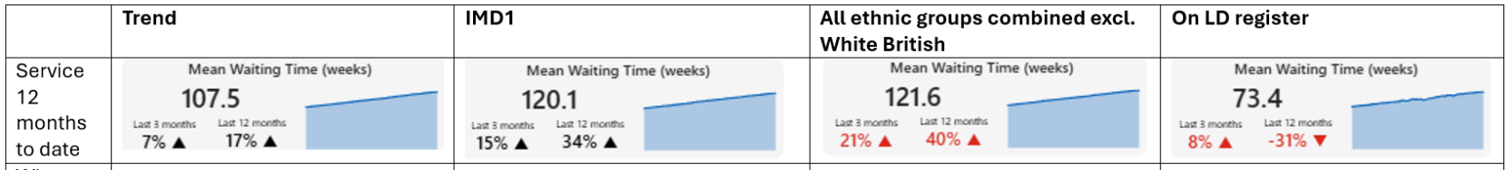
The data for CYPMHS shows a higher mean waiting time for those in non-White British ethnic groups and for those living in IMD1. However, it shows a lower mean waiting time for those on the LD register, which is expected given the nature of the service and the prioritisation for this group. It is also important to note that the data represents a combined waiting list across all CYPMHS pathways, which can mask differences between pathways. This means patients requiring more complex assessments or longer diagnostic pathways (e.g. ND assessments or ADHD medication reviews) may remain on the waiting list for longer.

Non-attendance rates have broadly decreased across all groups within the service. However, the service continues to see increases in non-attendance during school holiday periods across all groups. This suggests that appointment flexibility may influence engagement for families and could contribute to longer waits where appointments are missed or need to be rebooked. To help address inequity in waits the service is looking at their planning within school holiday periods and offering greater flexibility to families, helping them understand the impact of missed appointments and identifying adjustments that may support improved attendance. The service is also exploring actions to reduce missed appointments within the ADHD pathway, where DNA rates remain around 15% despite pre-appointment contact and has a higher number of families from IMD1. Through the CYPMHS Quality and Value programme, the pathway will be reviewed to improve engagement with families, including targeted contact with those living in more deprived areas. Families will be offered greater flexibility where possible, such as choice of clinic location, alongside clearer information on how to re-establish contact with the service if appointments are missed.
In addition, the service is seeking approval for an additional LD nurse to support capacity and help improve mean waiting times for this client group. Whilst safety-netting mechanisms are already in place, the service will review this to ensure information on how to contact the service is clear and accessible to all client groups

- Priorities for 2026-7

Based on this analysis, our priorities for 2026-7 include:
- reduction in average length of wait for people in IMD1 compared to IMD2-10, and reduction overall
- reduction in missed appointments for people in IMD1 compared to IMD2-10, and reduction overall
- further analysis of waiting times and missed appointments by disaggregated ethnicity with targeted improvement activity related to those findings
- continued delivery of the ‘About Me’ project, including the use of Read codes aligned to national implementation of Reasonable Adjustments Digital Flag and digital patient questionnaire
- implementing and testing the use of the Health Equity Index with waiting time measures in the Integrated Performance Report
- further development of the equity question on Board and committee cover papers to improve analysis of data and inclusion of equity considerations

- Publishing information

We publish equity data and updates on improvement work annually through our Annual Report, Quality Account and Equality Delivery System results. In addition to these annual publications, equity data in our Integrated Performance Report is published quarterly in Board papers and equity strategy updates three times a year. Equity considerations that have been escalated through Committees are also published in Board papers on an ad hoc basis. These can all be viewed on our website.

